**101.** **TRELLO_GET_LISTS_BOARD_BY_ID_LIST**

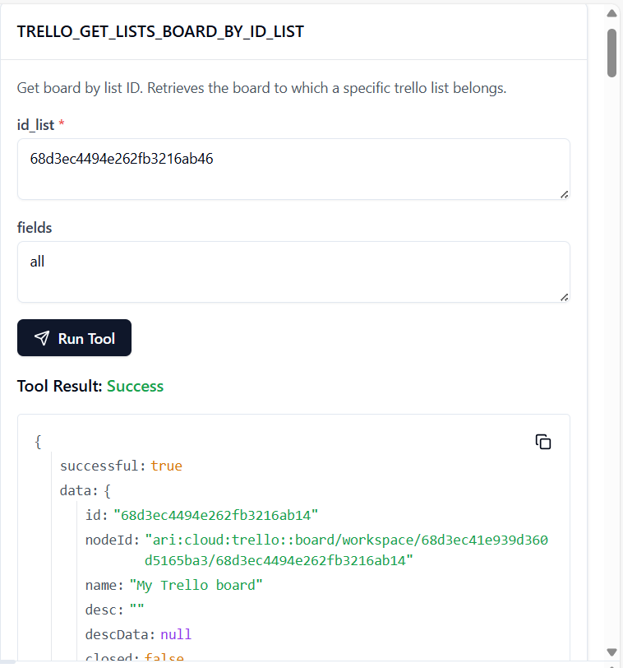

102. **TRELLO_GET_LISTS_BOARD_BY_ID_LIST_BY_FIELD**

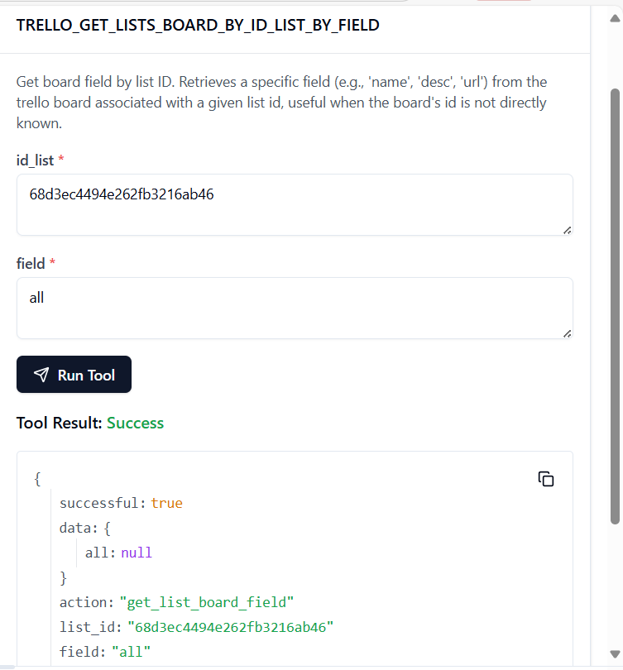

103. **TRELLO_GET_LISTS_BY_ID_LIST**

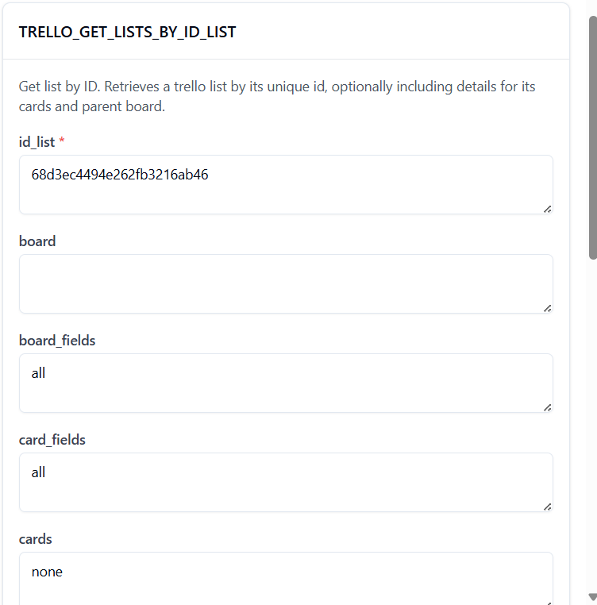

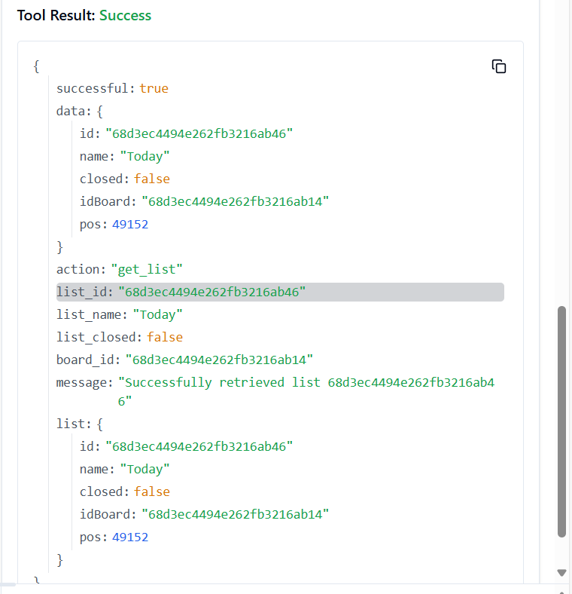

104. **TRELLO_GET_LISTS_BY_ID_LIST_BY_FIELD**

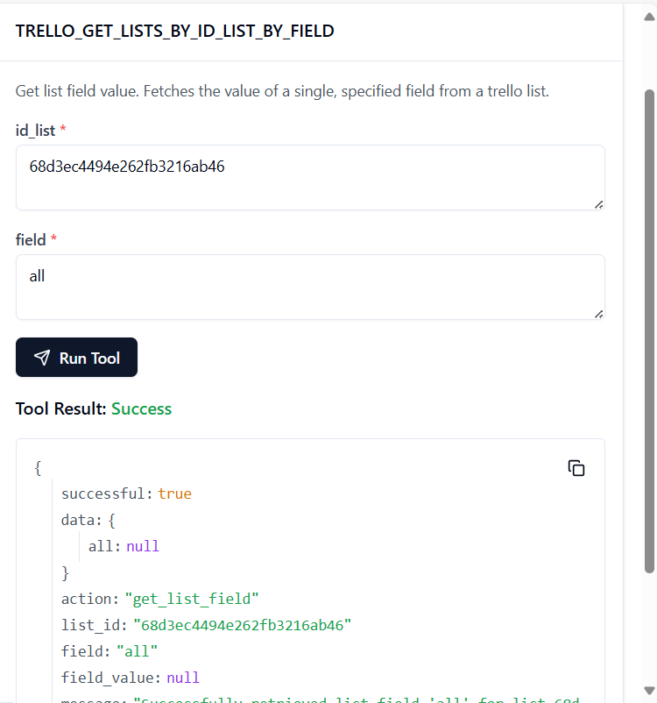

105. **TRELLO_GET_LISTS_CARDS_BY_ID_LIST_BY_FILTER**

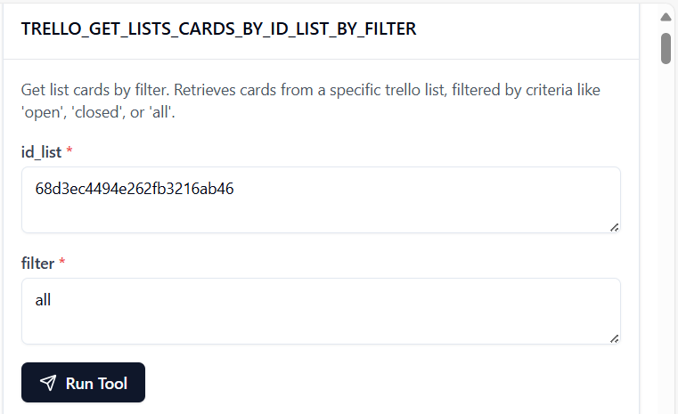

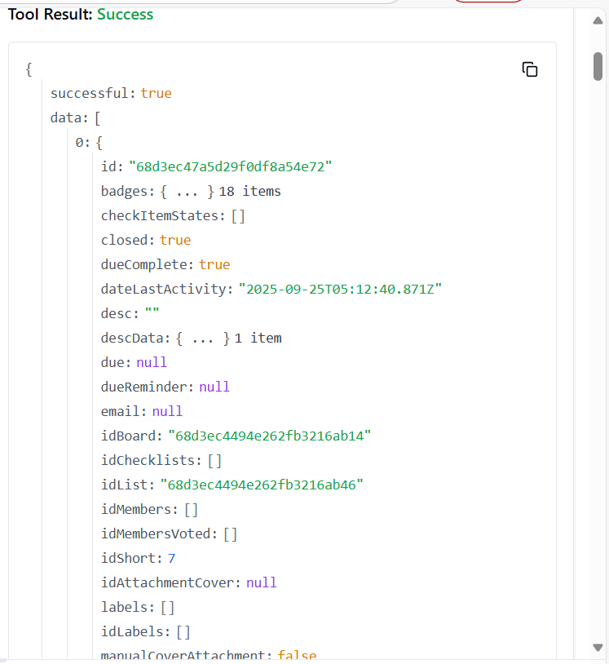

106. **TRELLO_GET_MEMBERS_CUSTOM_BOARD_BACKGROUNDS_BY_ID_MEMBER**

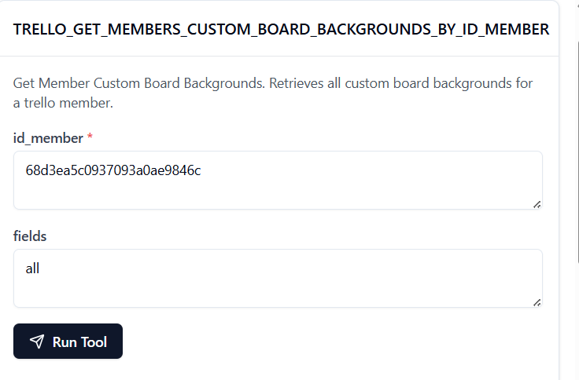

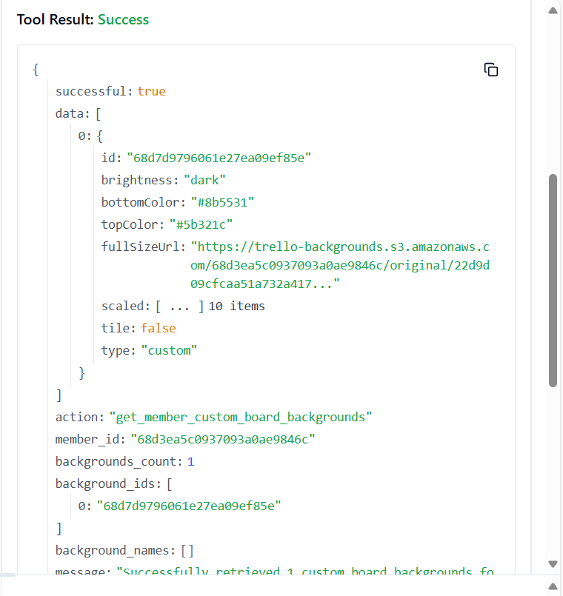

107. **TRELLO_GET_MEMBER_BOARD_BACKGROUND**

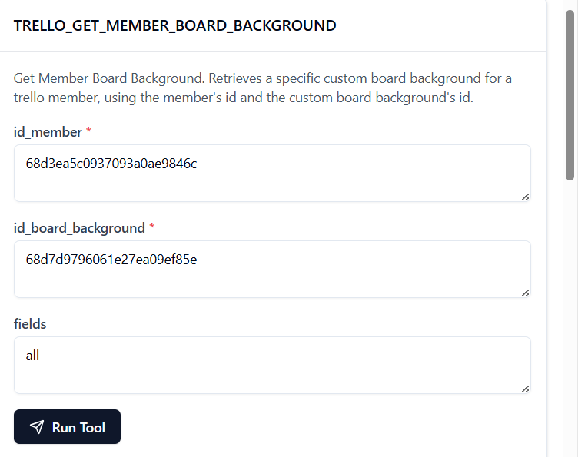

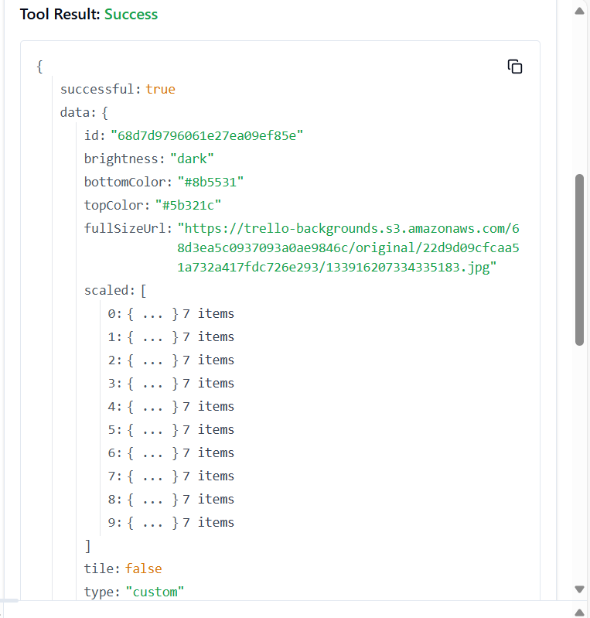

108. **TRELLO_GET_MEMBER_CUSTOM_BG**

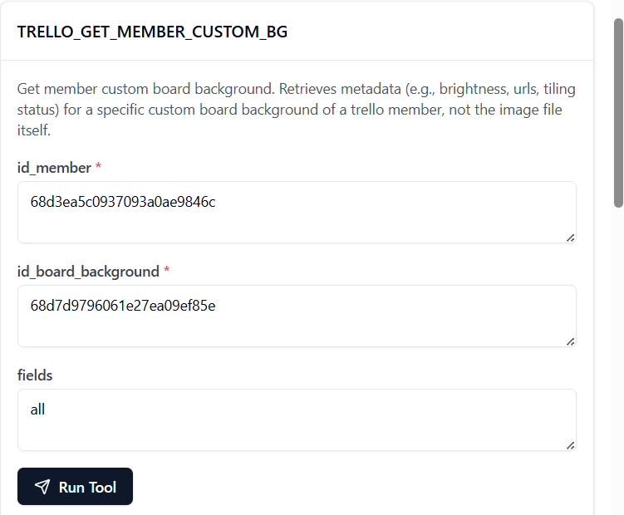

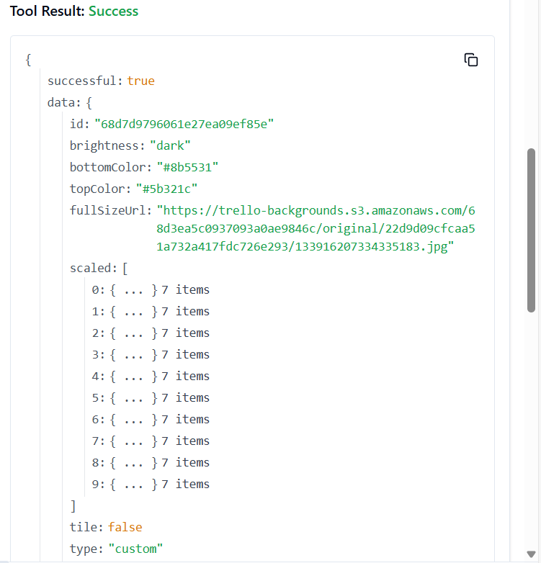

109. **TRELLO_GET_MEMBERS_CUSTOM_STICKERS_BY_ID_MEMBER**

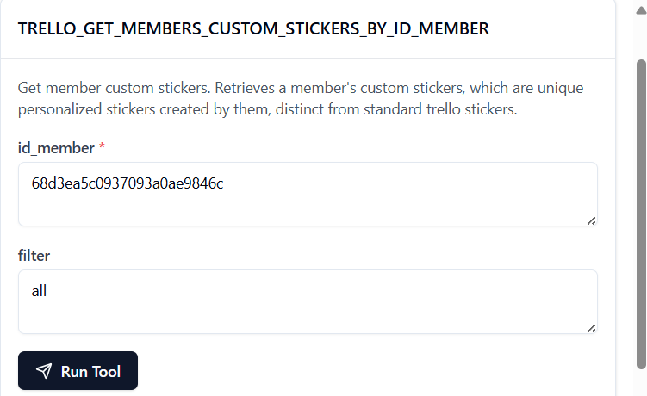

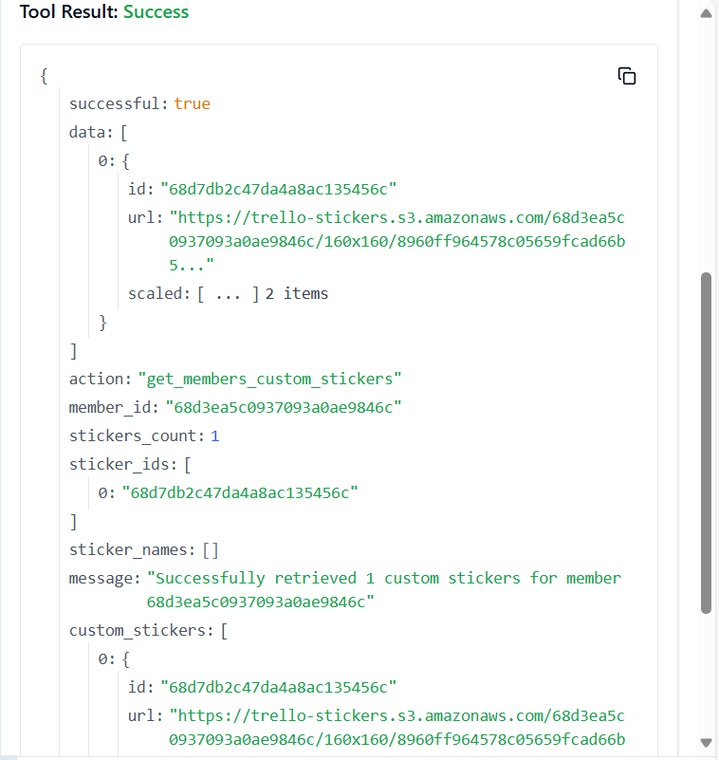

110. **TRELLO_GET_MEMBER_CUSTOM_STICKER**

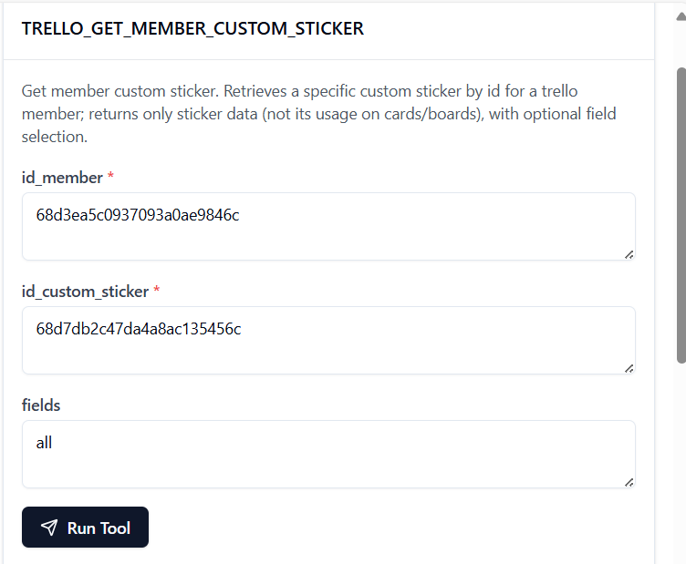

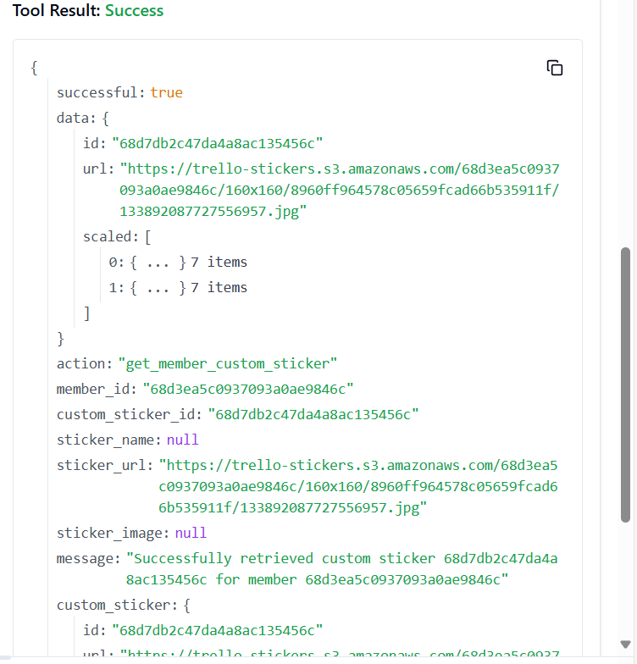

111. **TRELLO_GET_MEMBERS_ACTIONS_BY_ID_MEMBER**

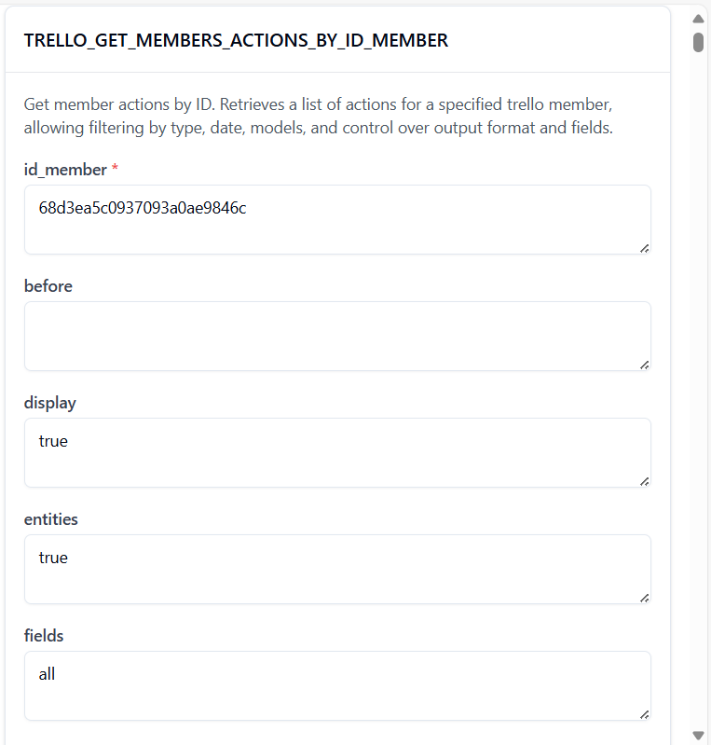

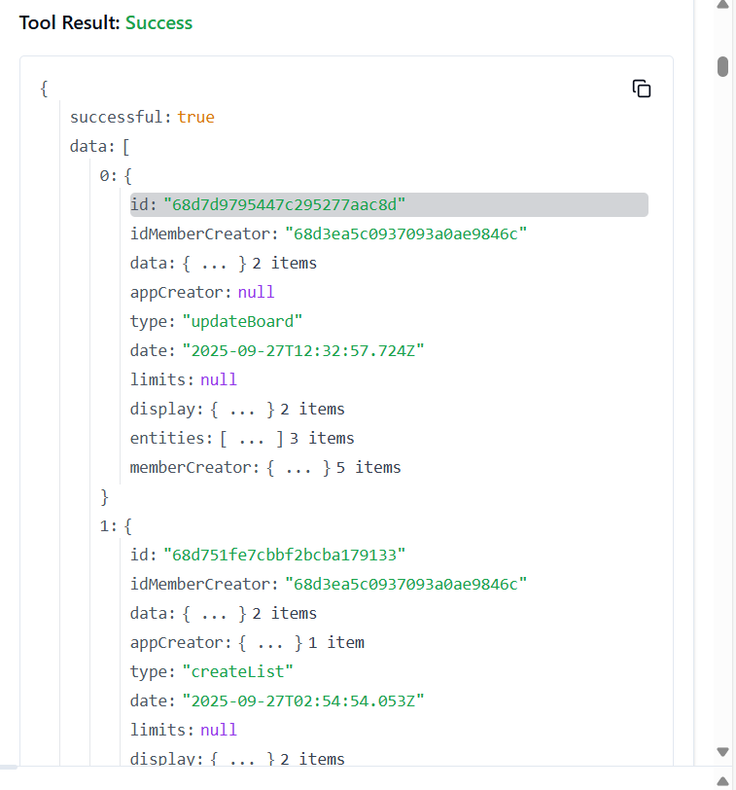

112. **TRELLO_GET_MEMBERS_SAVED_SEARCHES_BY_ID_MEMBER**

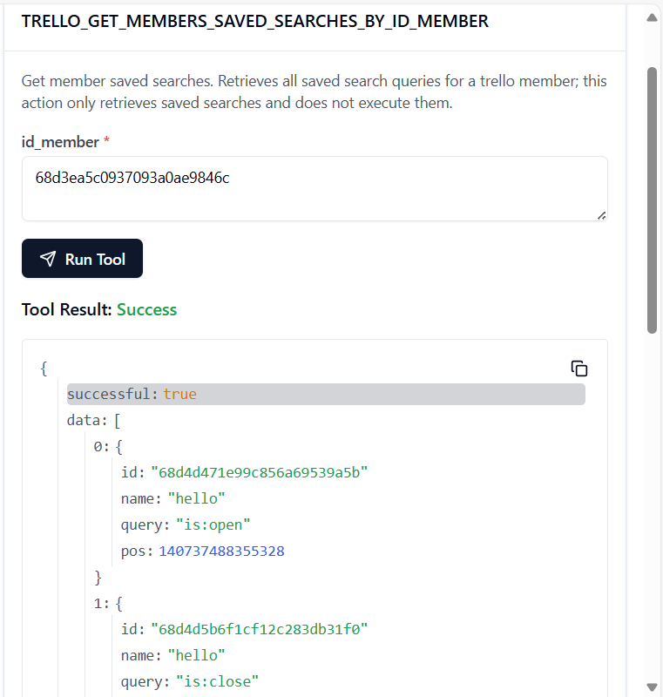

113. **TRELLO_GET_MEMBER_SAVED_SEARCH**

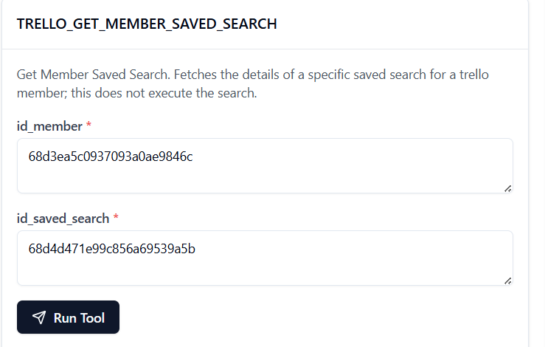

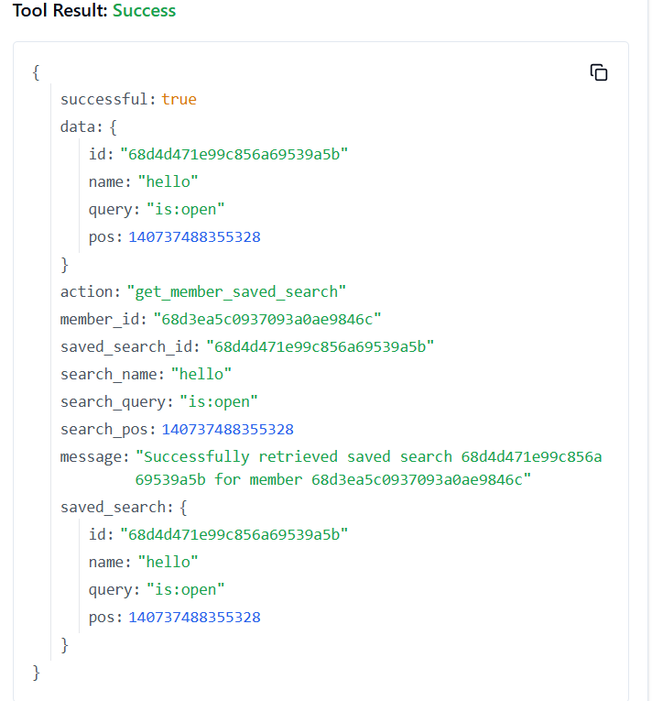

114. **TRELLO_GET_MEMBERS_BOARD_BACKGROUNDS_BY_ID_MEMBER**

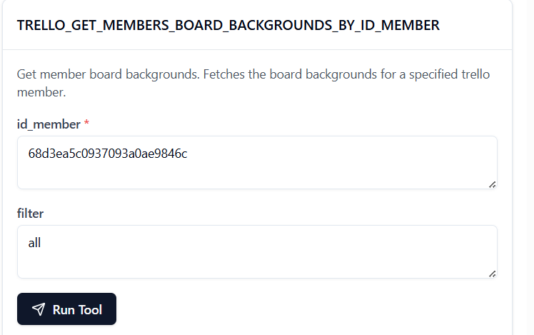

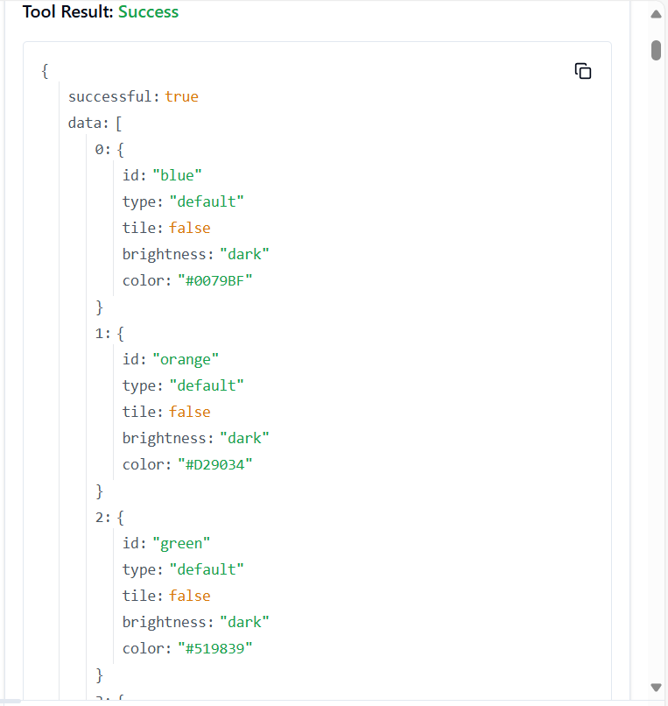

115. **TRELLO_GET_MEMBERS_BOARDS_BY_ID_MEMBER**

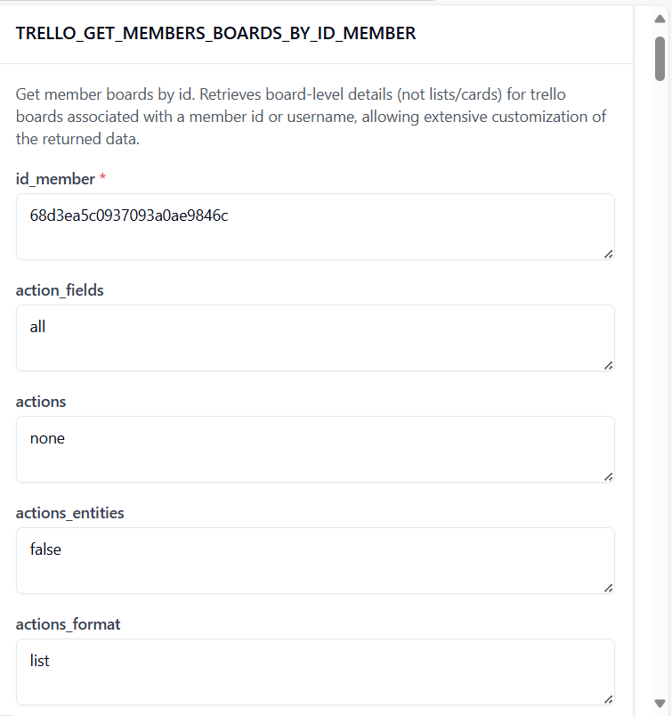

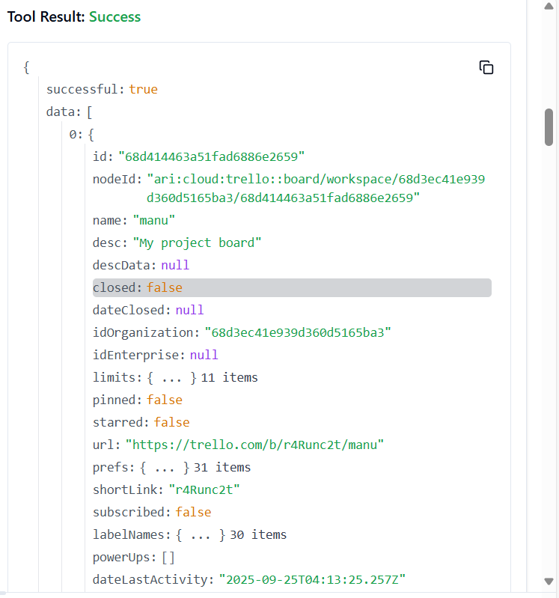

116. **TRELLO_GET_MEMBERS_BOARDS_BY_ID_MEMBER_BY_FILTER**

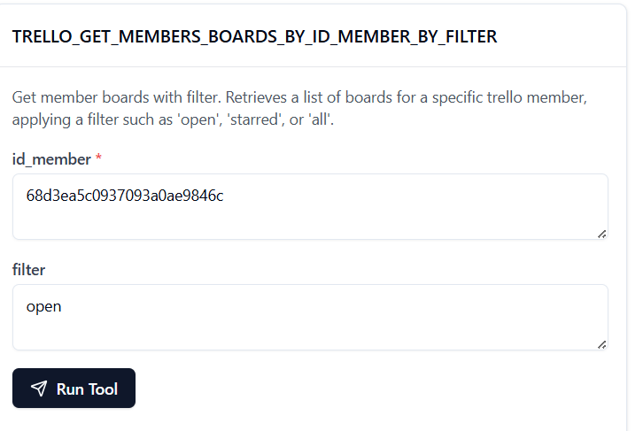

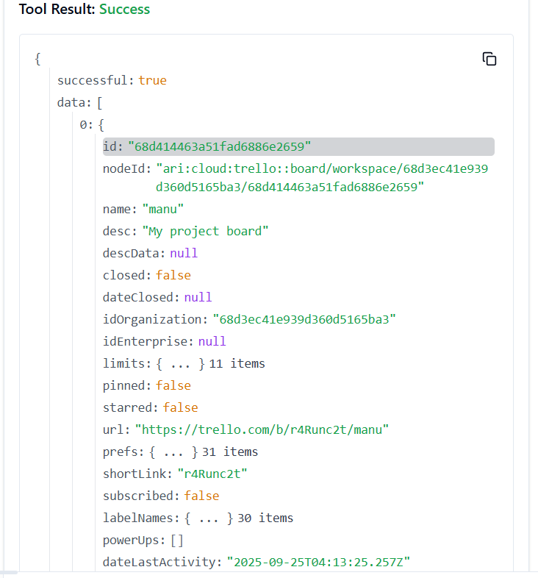

117. **TRELLO_GET_MEMBERS_BOARDS_INVITED_BY_ID_MEMBER**

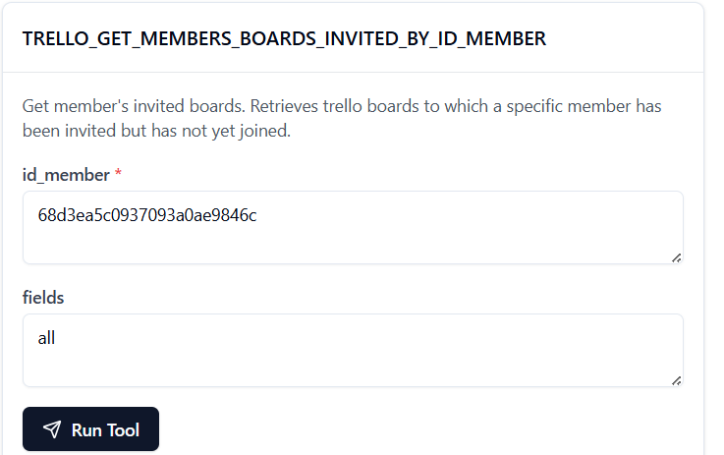

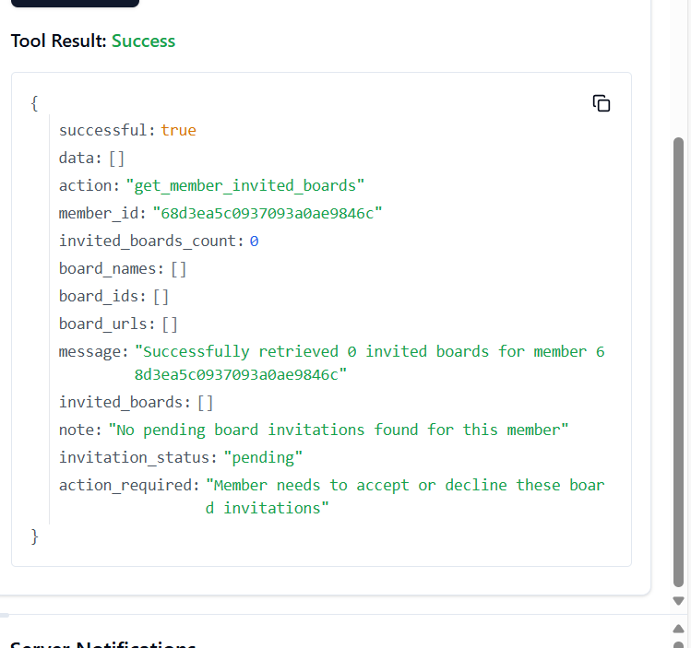

**118. TRELLO_GET_MEMBERS_BOARDS_INVITED_BY_ID_MEMBER_BY_FIELD**

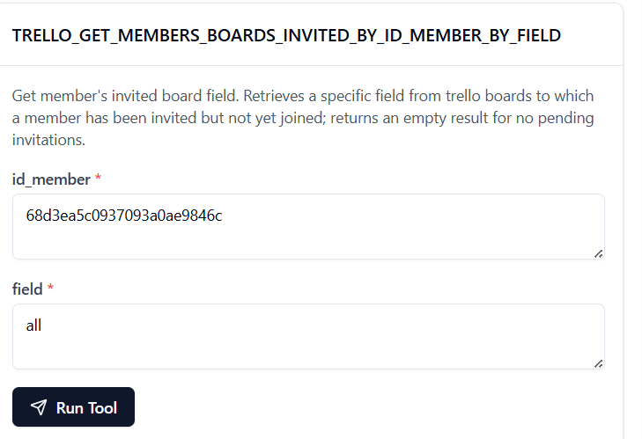

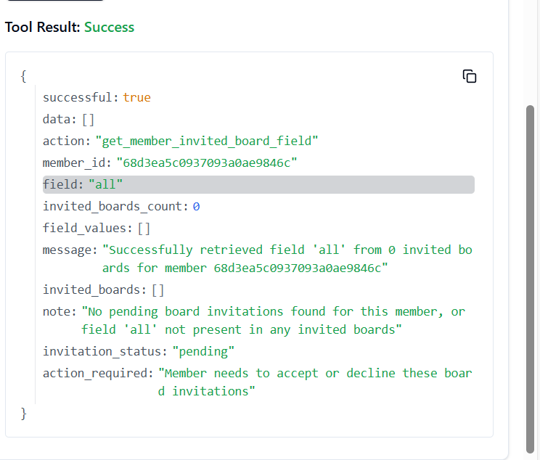

**119. TRELLO_GET_MEMBERS_BOARD_STARS_BY_ID_MEMBER**

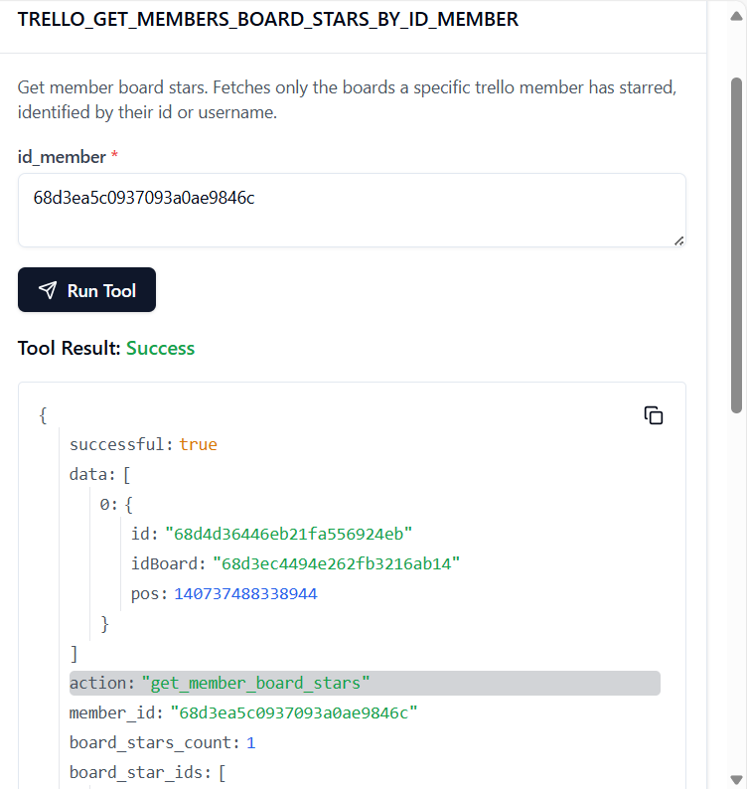

**120. TRELLO_GET_MEMBERS_BOARD_STARS_BY_ID_MEMBER_BY_ID_BOARD_STAR**

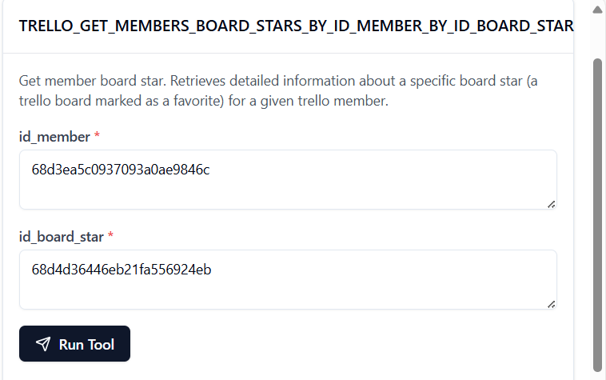 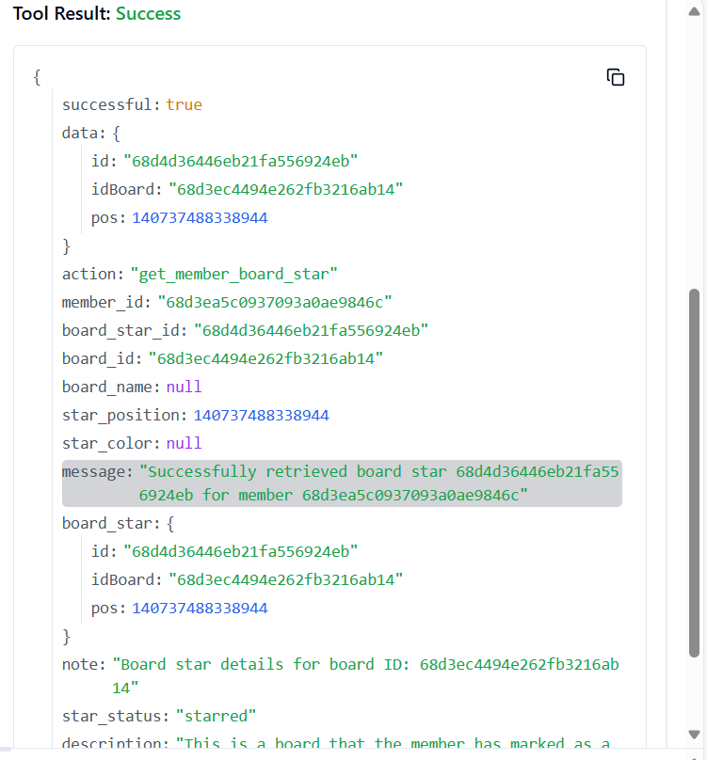

**121. TRELLO_GET_MEMBERS_BY_ID_MEMBER_BY_FIELD**

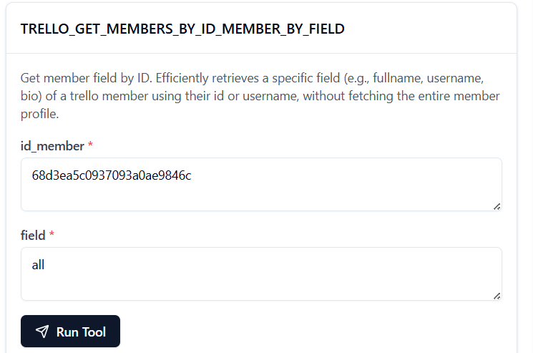

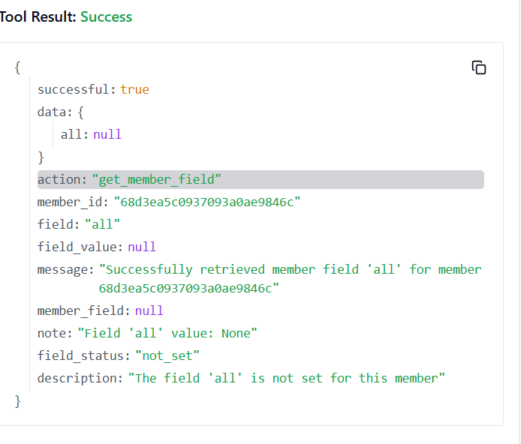

**122. TRELLO_GET_MEMBERS_CARDS_BY_ID_MEMBER_BY_FILTER**

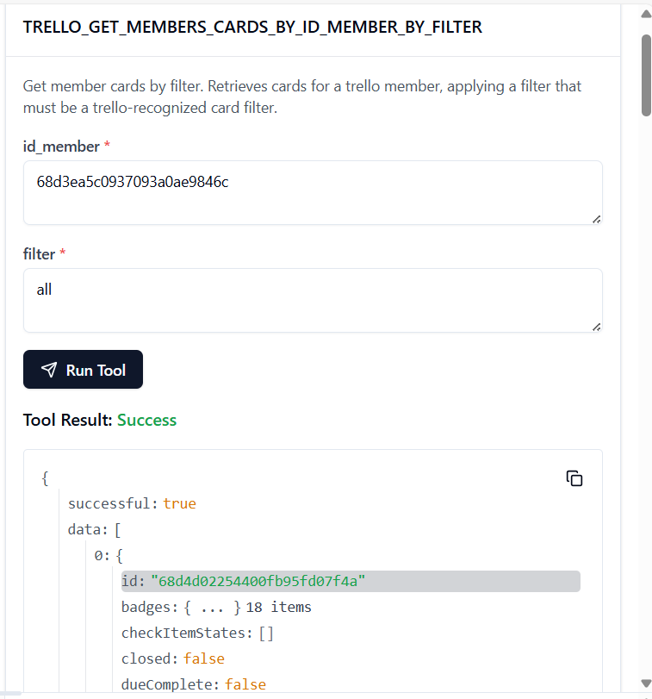

**123. TRELLO_GET_MEMBERS_DELTAS_BY_ID_MEMBER**

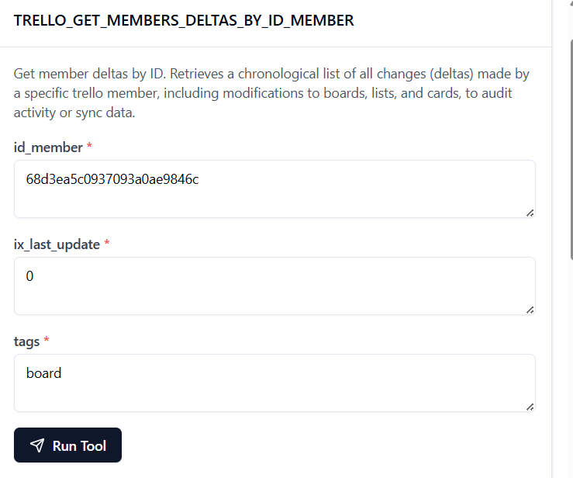

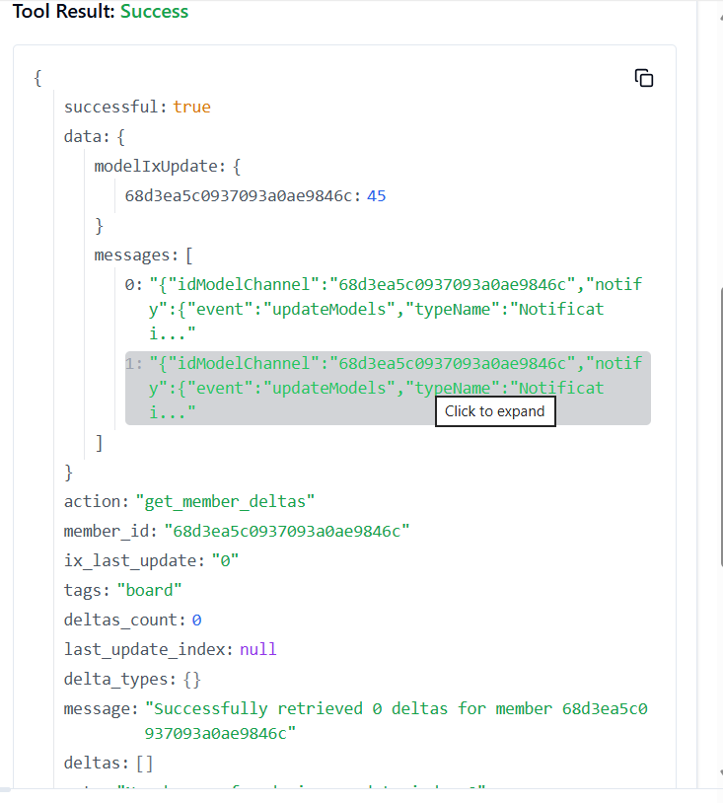

**124. TRELLO_GET_MEMBERS_NOTIFICATIONS_BY_ID_MEMBER**

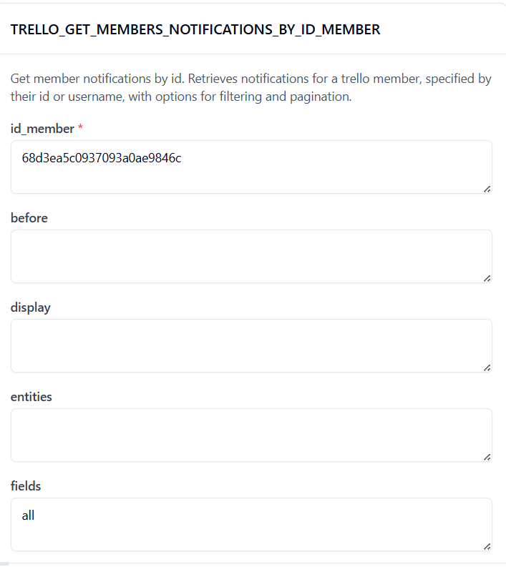

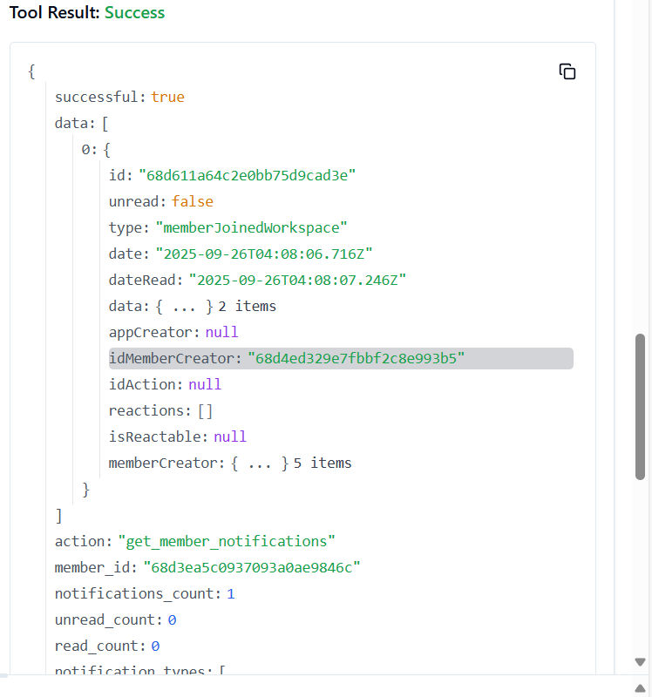

**125. TRELLO_GET_MEMBERS_NOTIFICATIONS_BY_ID_MEMBER_BY_FILTER**

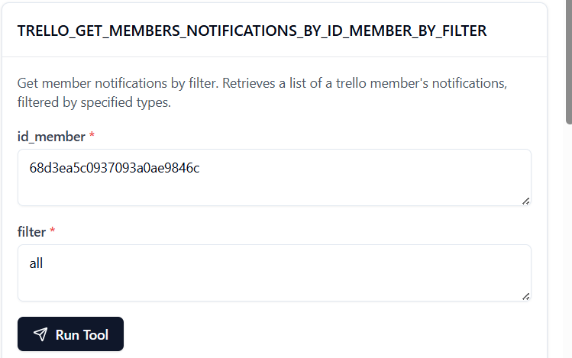

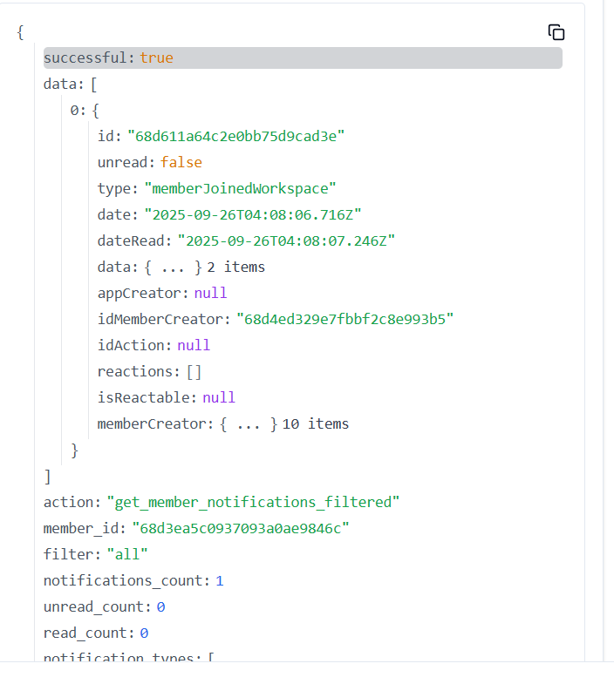

**126. TRELLO_GET_MEMBERS_ORGANIZATIONS_BY_ID_MEMBER**

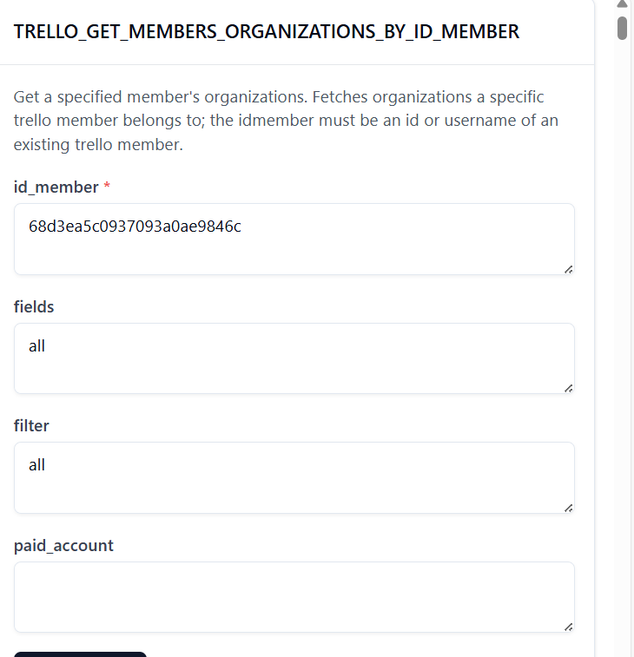

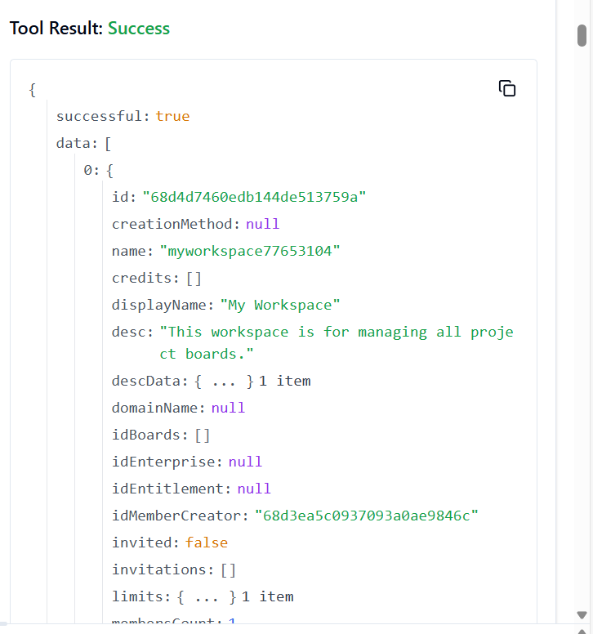

**127. TRELLO_GET_MEMBERS_ORGANIZATIONS_BY_ID_MEMBER_BY_FILTER**

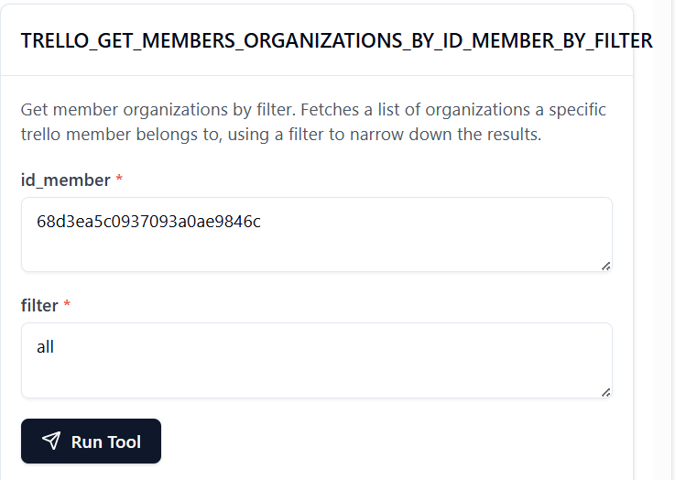

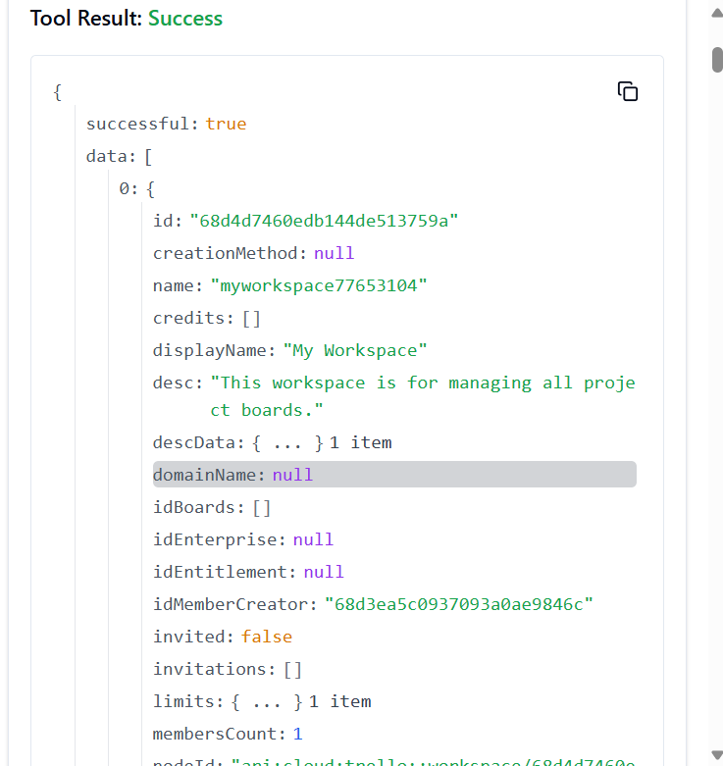

**128. TRELLO_GET_MEMBERS_ORGANIZATIONS_INVITED_BY_ID_MEMBER**

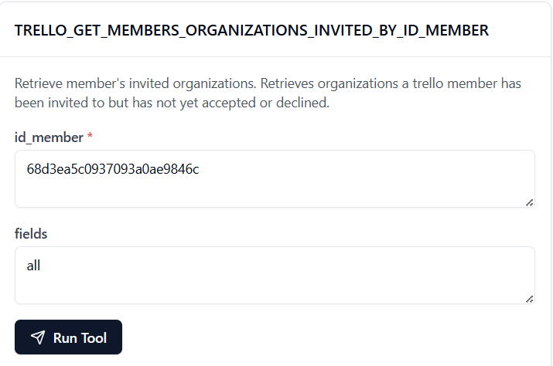

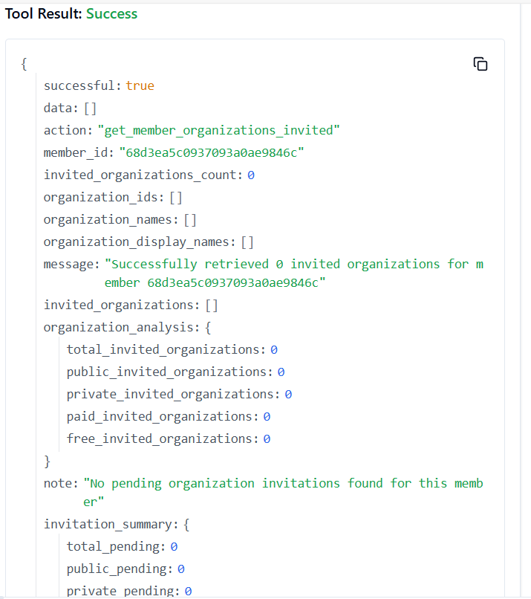

**129. TRELLO_GET_MEMBERS_ORGANIZATIONS_INVITED_BY_ID_MEMBER_BY_FIELD**

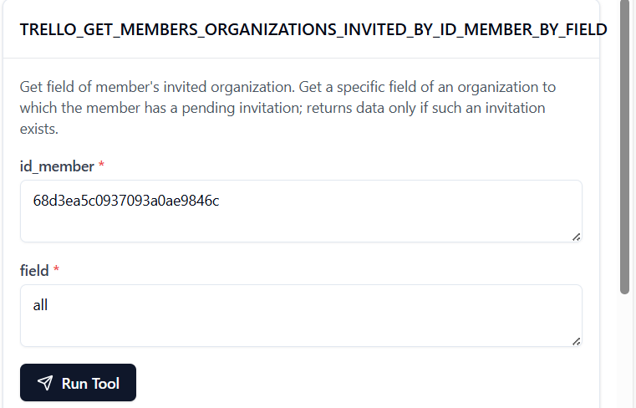

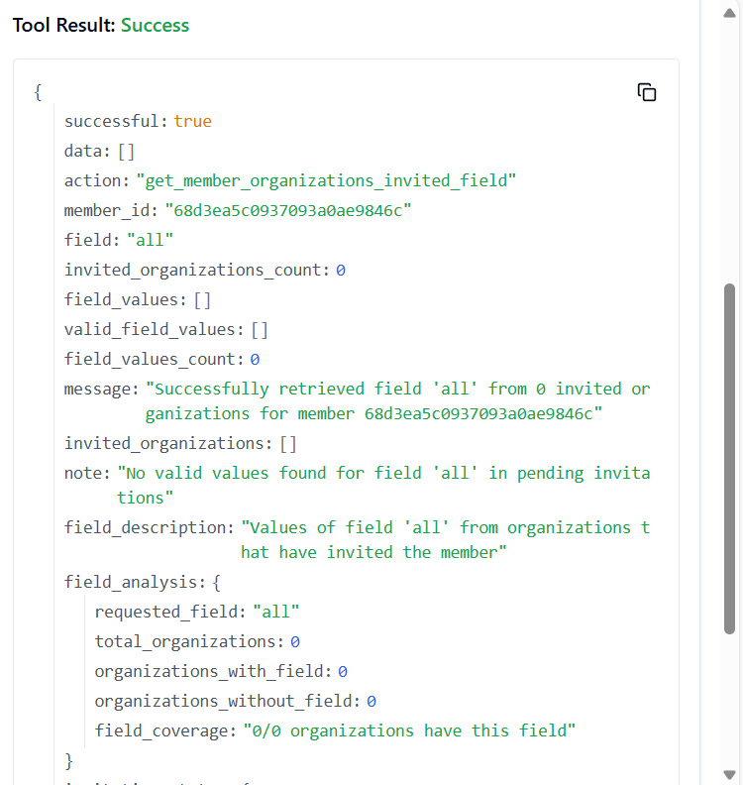

**130. TRELLO_GET_MEMBERS_TOKENS_BY_ID_MEMBER**

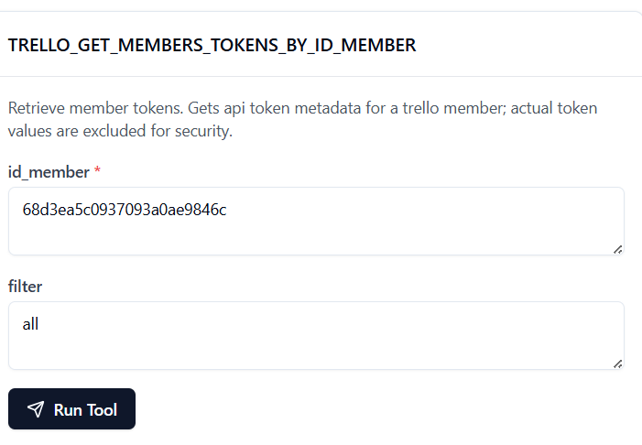

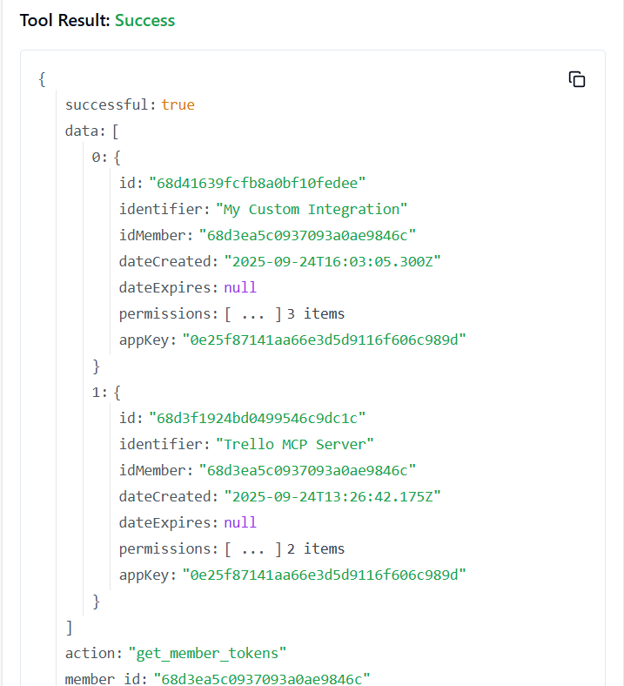

**131. TRELLO_GET_NOTIF_CREATOR_FIELD**

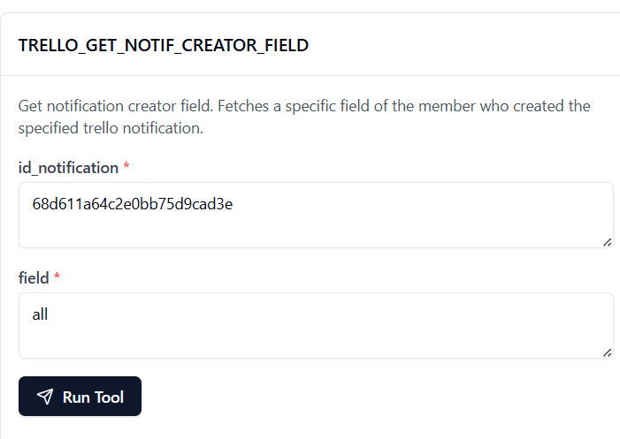

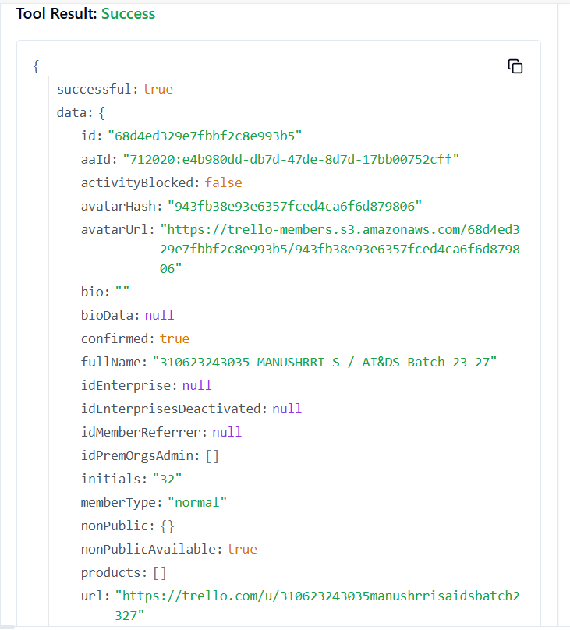

**132. TRELLO_GET_NOTIFICATION_ORG_FIELD**

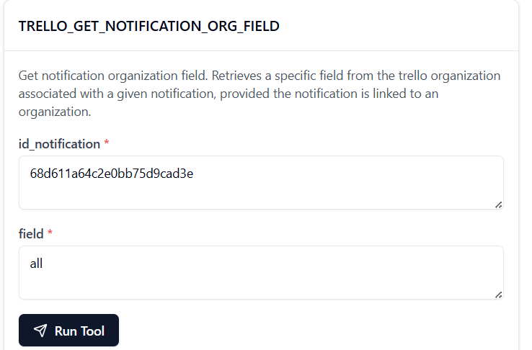

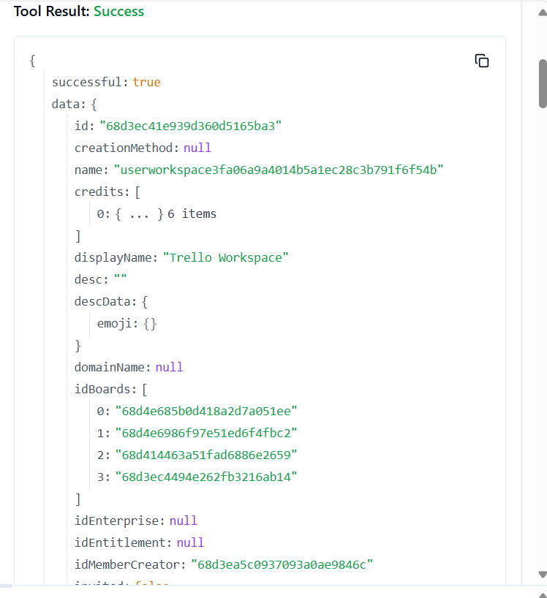

**133. TRELLO_GET_NOTIFICATIONS_BOARD_BY_ID_NOTIFICATION**

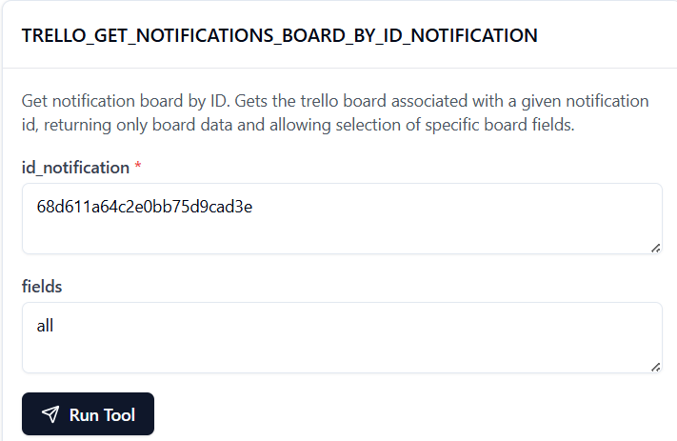 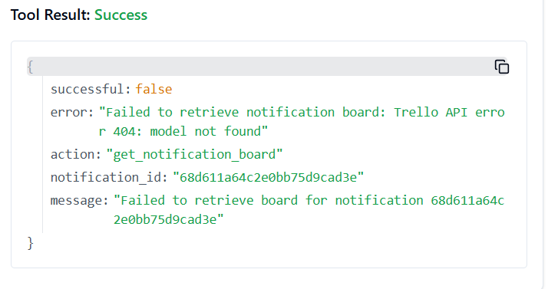

TOOL IS WORKING PROPERLY I COULD NOT ADD ASSOCIATIVE BOARD

134. **TRELLO_GET_NOTIFICATIONS_BOARD_BY_ID_NOTIFICATION_BY_FIELD**

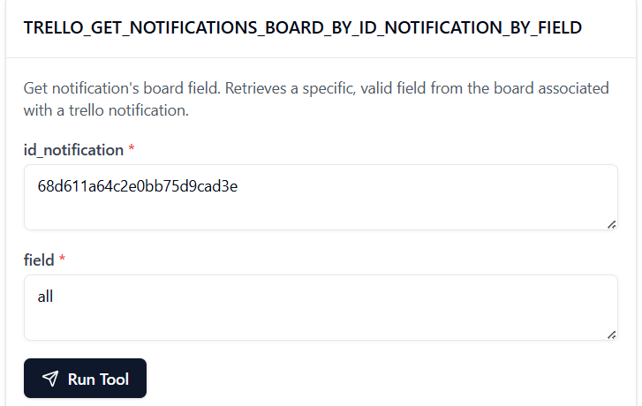 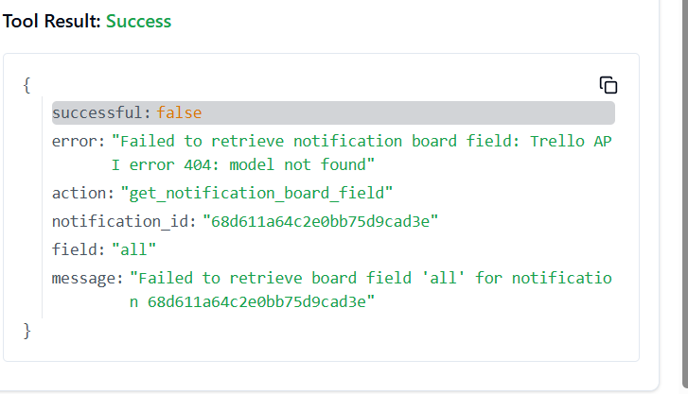

135. **TRELLO_GET_NOTIFICATIONS_BY_ID_NOTIFICATION**

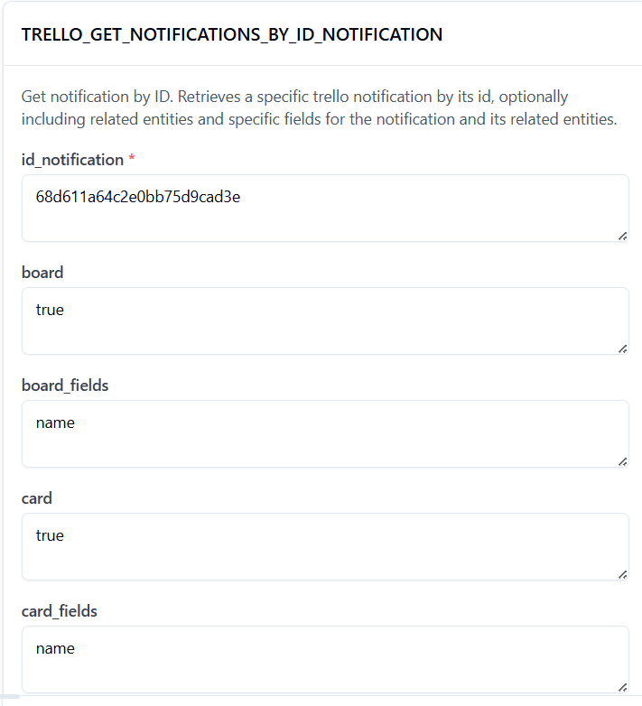

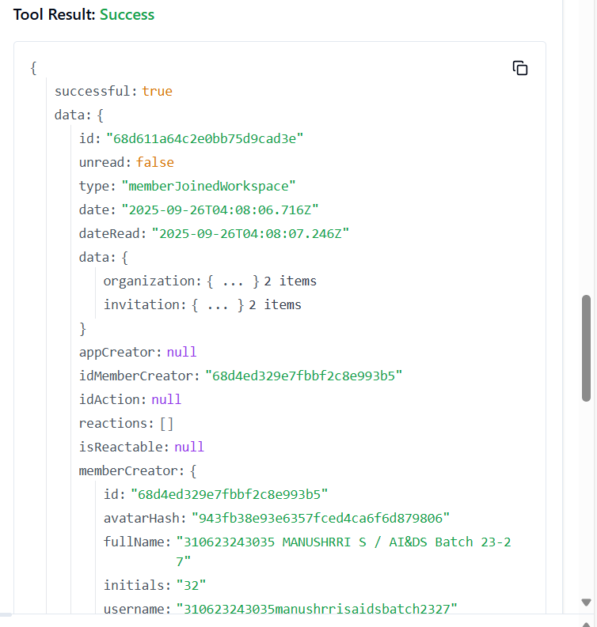

**136. TRELLO_GET_NOTIFICATIONS_BY_ID_NOTIFICATION_BY_FIELD**

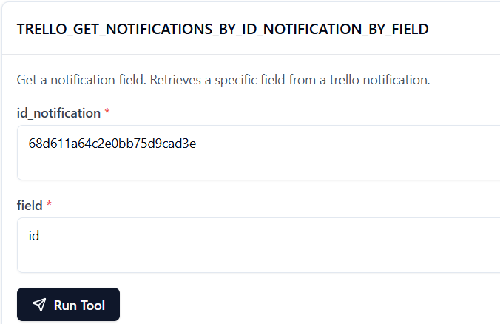

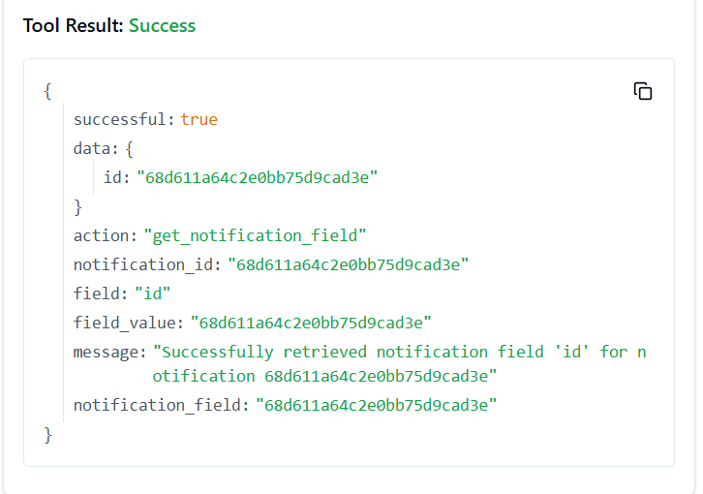

**137. TRELLO_GET_NOTIFICATIONS_DISPLAY_BY_ID_NOTIFICATION**

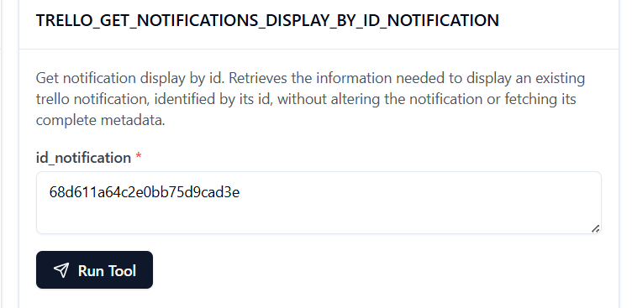

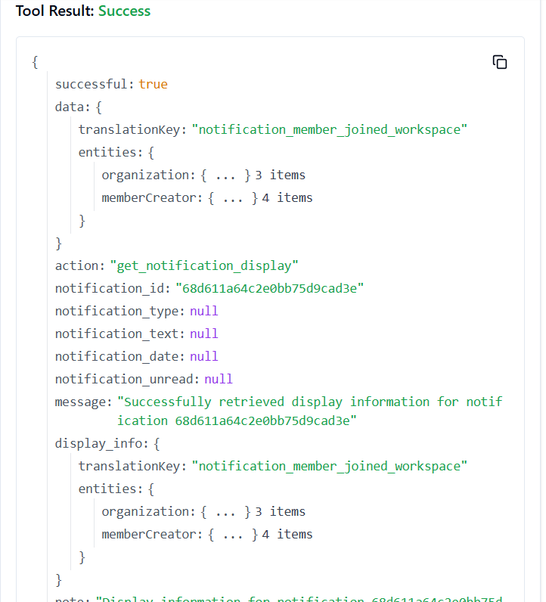

**138. TRELLO_GET_ORGANIZATIONS_ACTIONS_BY_ID_ORG** 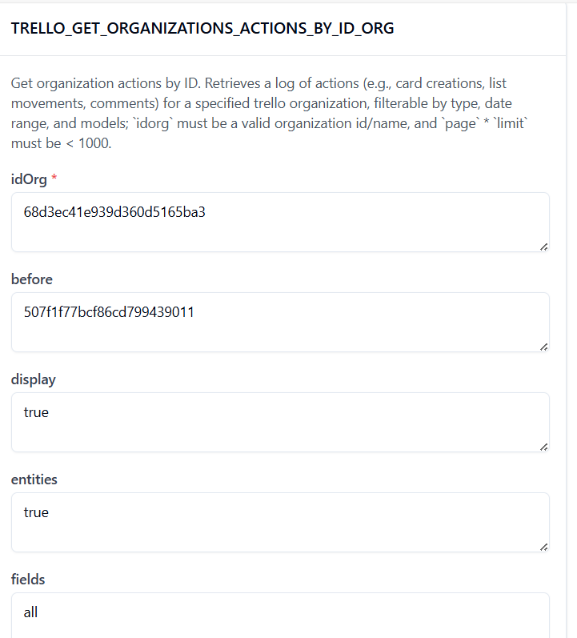

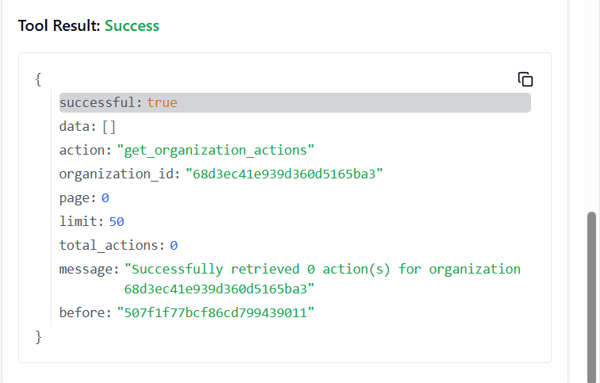

**139. TRELLO_GET_ORGANIZATIONS_BOARDS_BY_ID_ORG_BY_FILTER**

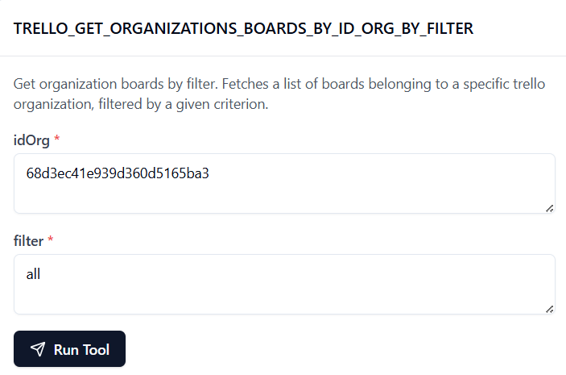

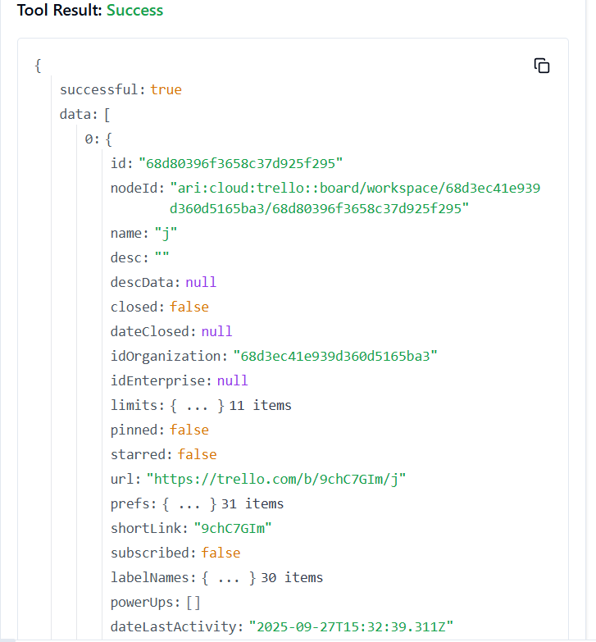

**140. TRELLO_GET_ORGANIZATIONS_BY_ID_ORG**

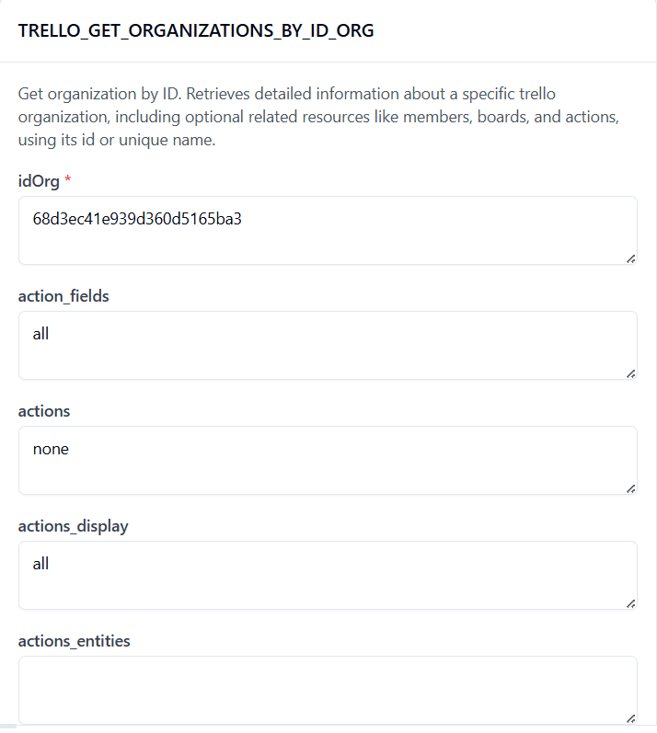

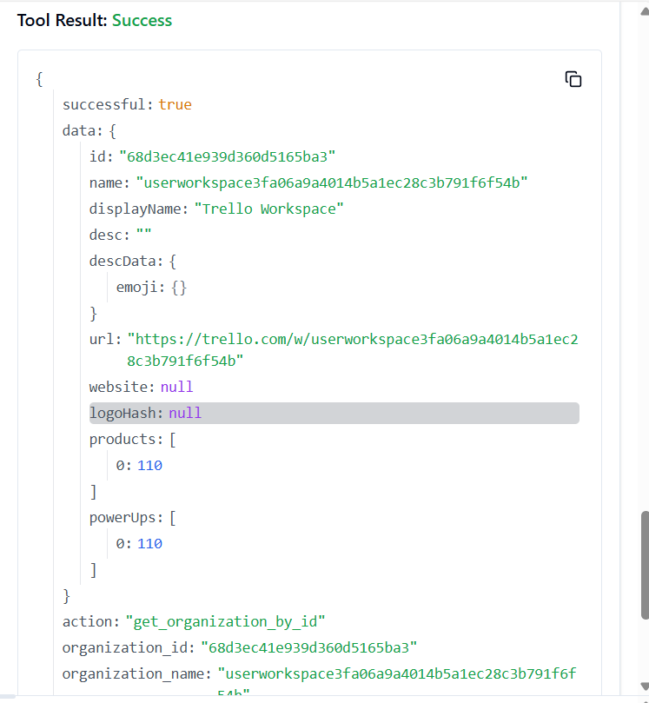

**141. TRELLO_GET_ORGANIZATIONS_BY_ID_ORG_BY_FIELD**

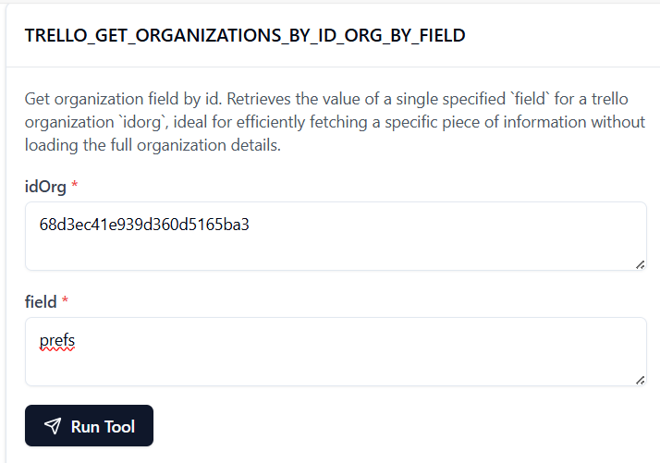

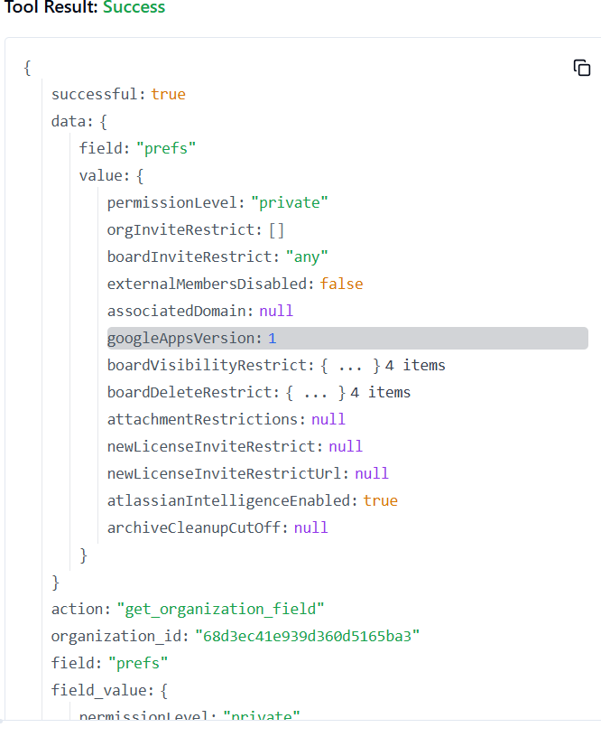

**142. TRELLO_GET_ORGANIZATIONS_DELTAS_BY_ID_ORG**

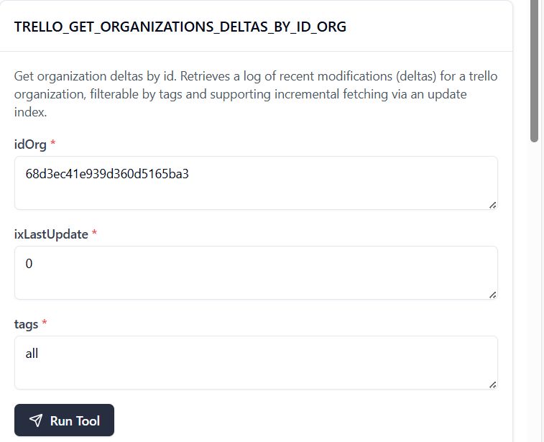

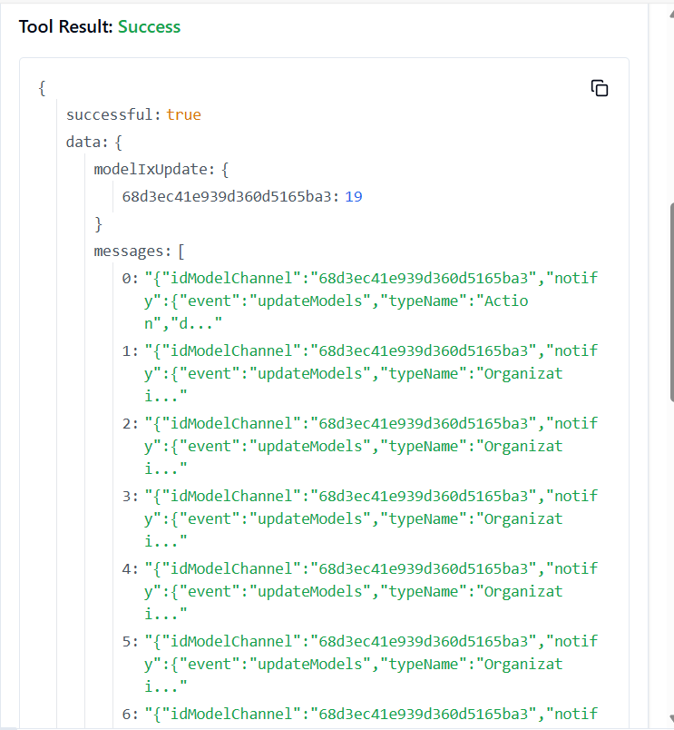

**143. TRELLO_GET_ORGANIZATIONS_MEMBERS_BY_ID_ORG**

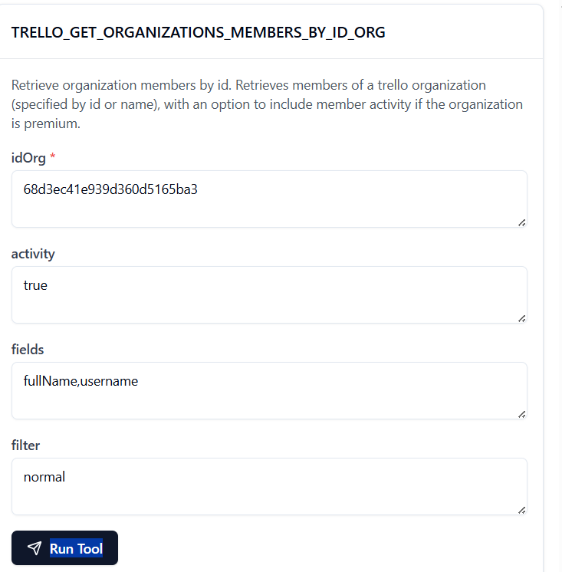

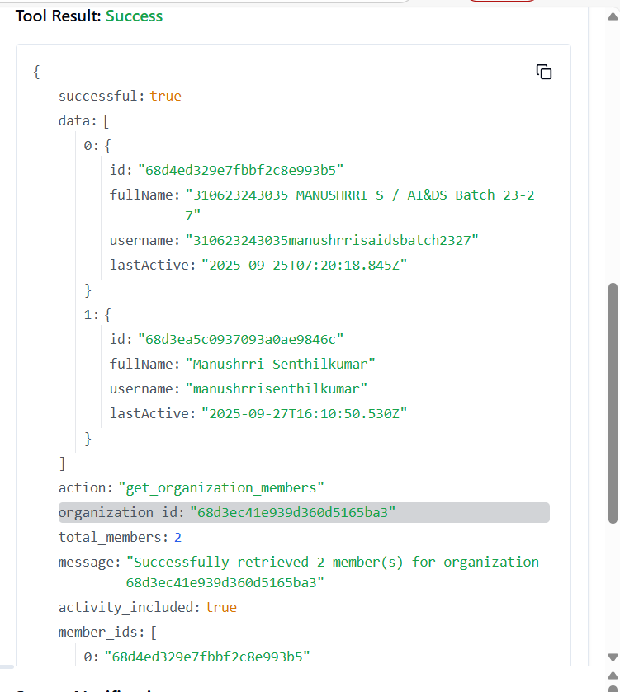

**144. TRELLO_GET_ORGANIZATIONS_MEMBERS_BY_ID_ORG_BY_FILTER**

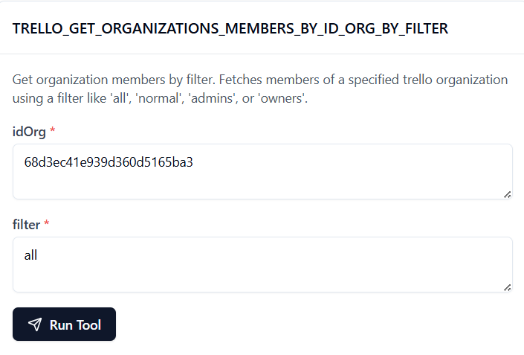

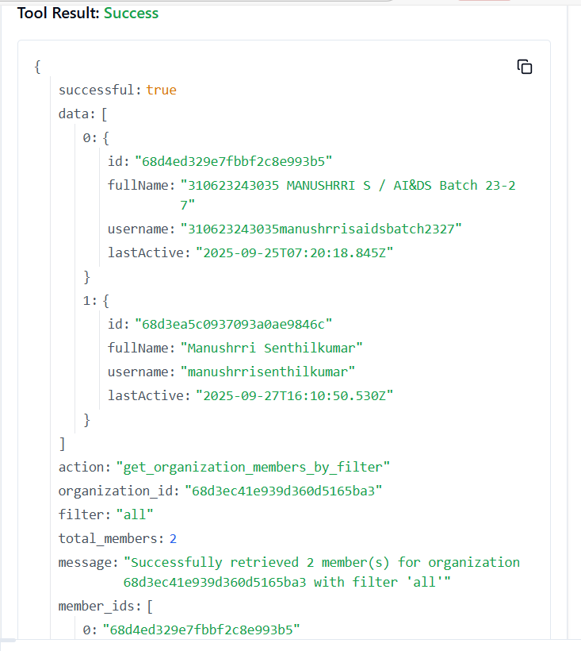

**145. TRELLO_GET_ORGANIZATIONS_MEMBERSHIPS_BY_ID_ORG**

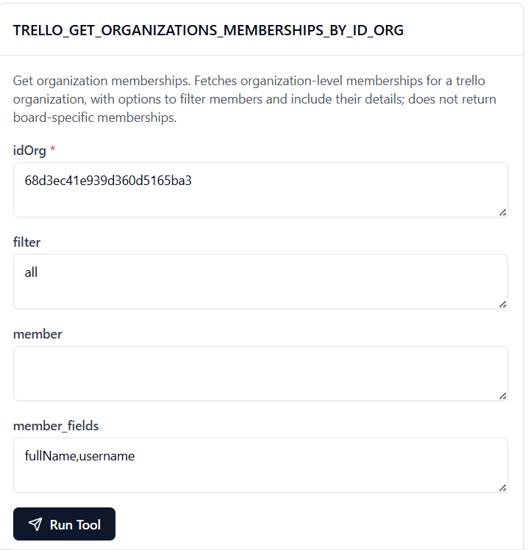

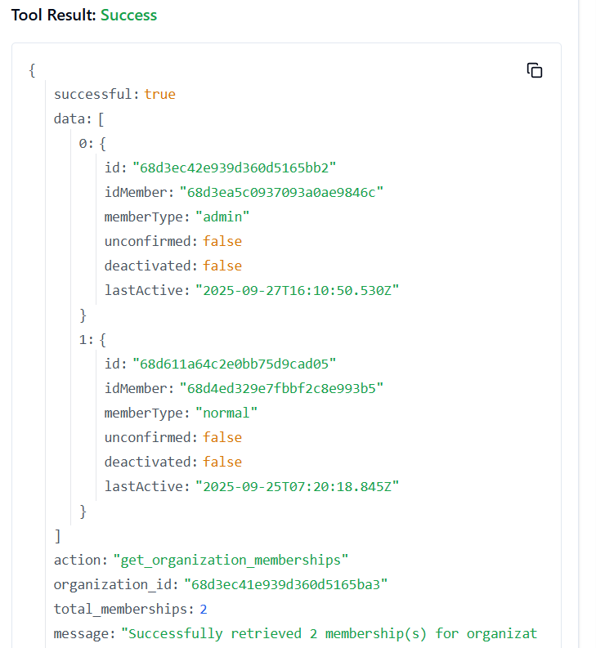

**146. TRELLO_GET_ORGANIZATIONS_MEMBERSHIPS_BY_ID_ORG_BY_ID_MEMBERSHIP**

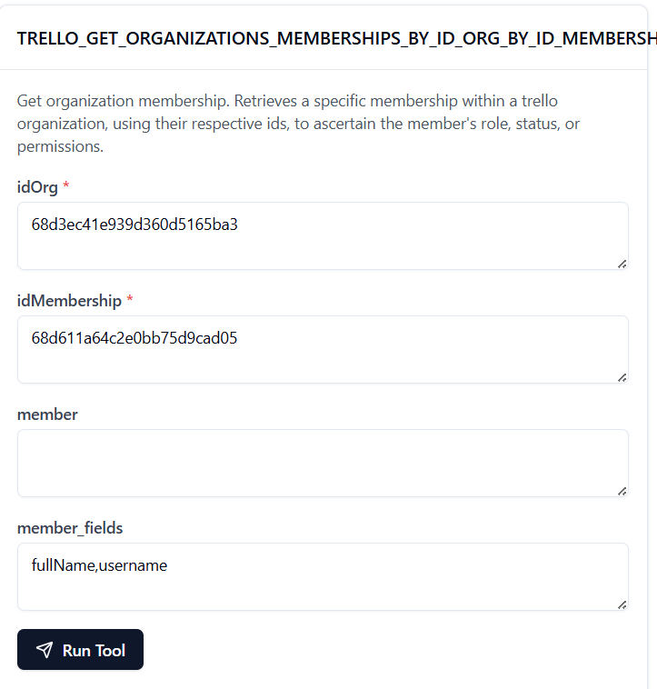

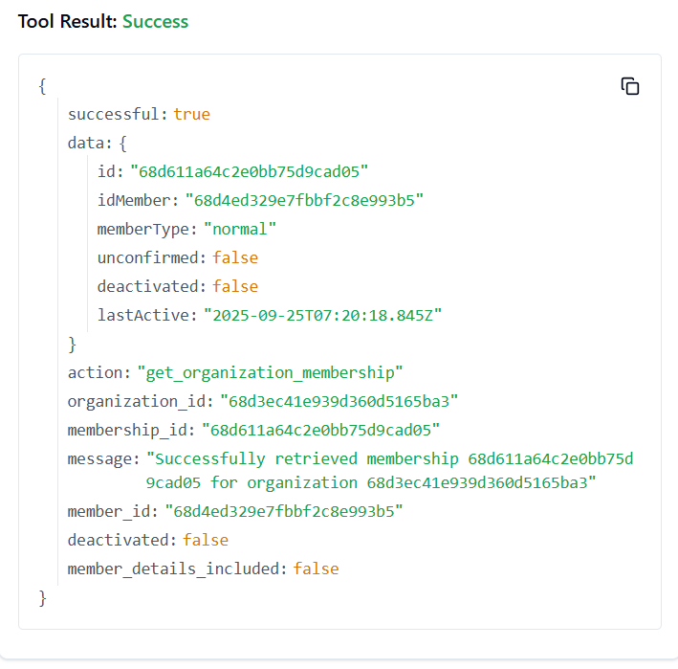

**147. TRELLO_GET_ORGANIZATIONS_MEMBERS_INVITED_BY_ID_ORG**

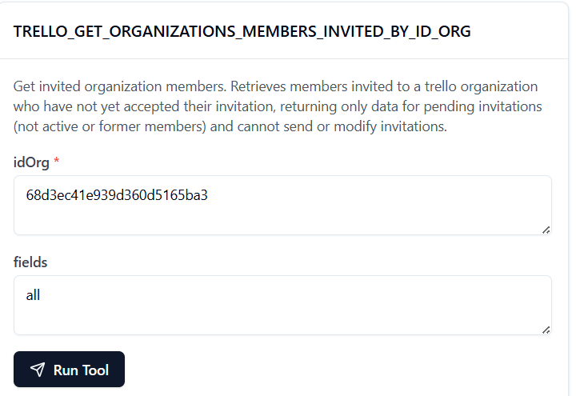

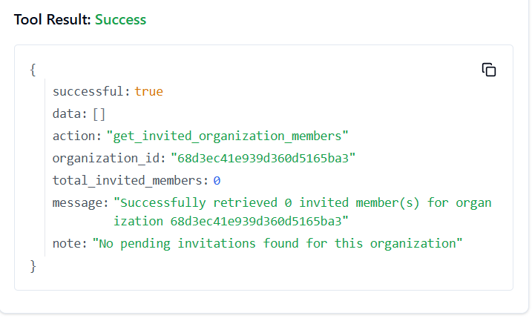

**148. TRELLO_GET_ORGANIZATIONS_MEMBERS_INVITED_BY_ID_ORG_BY_FIELD**

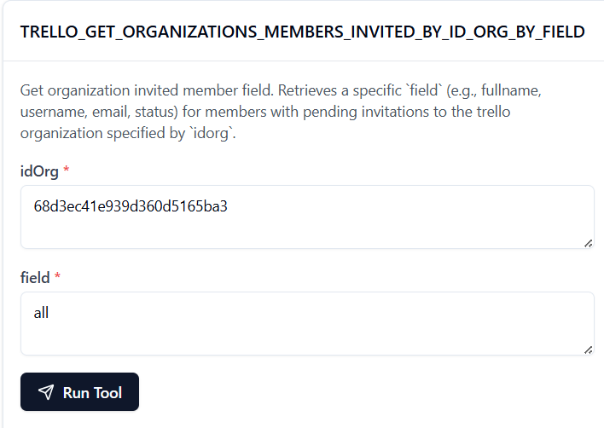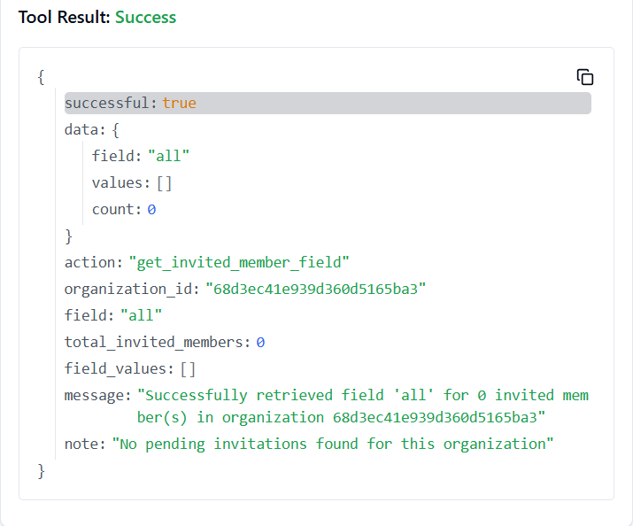

**149. TRELLO_GET_SEARCH_MEMBERS**

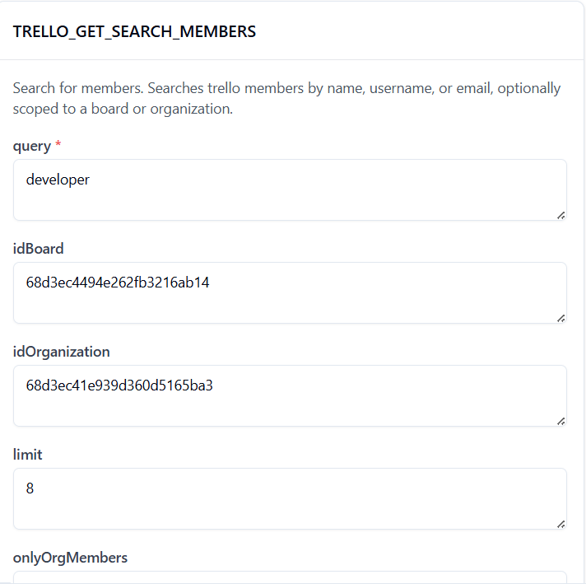

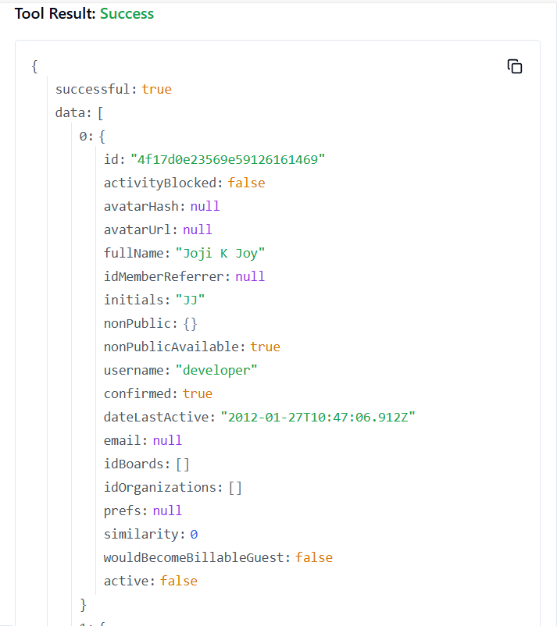

**150. TRELLO_GET_SESSIONS_SOCKET**

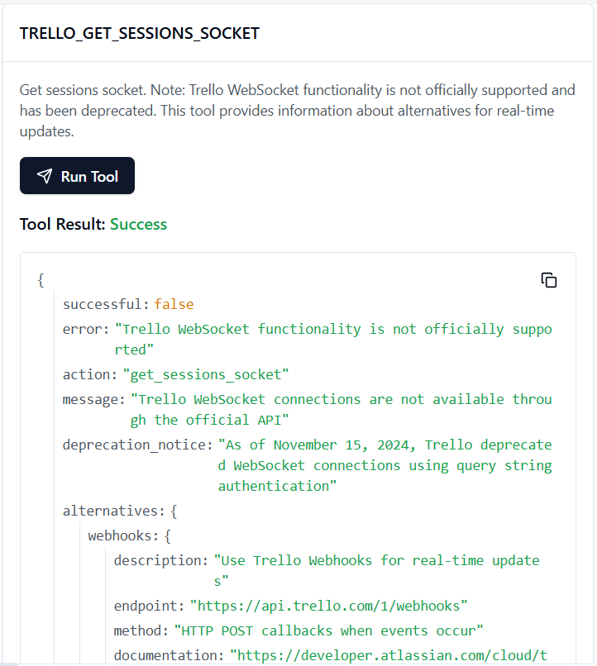

**151. TRELLO_GET_TOKENS_BY_TOKEN**

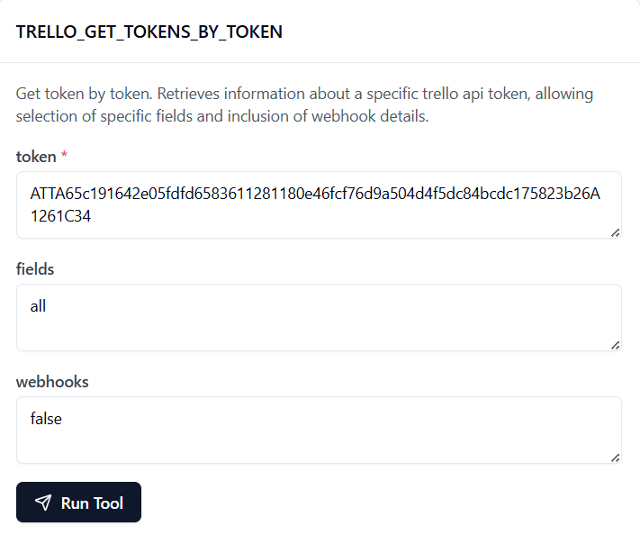

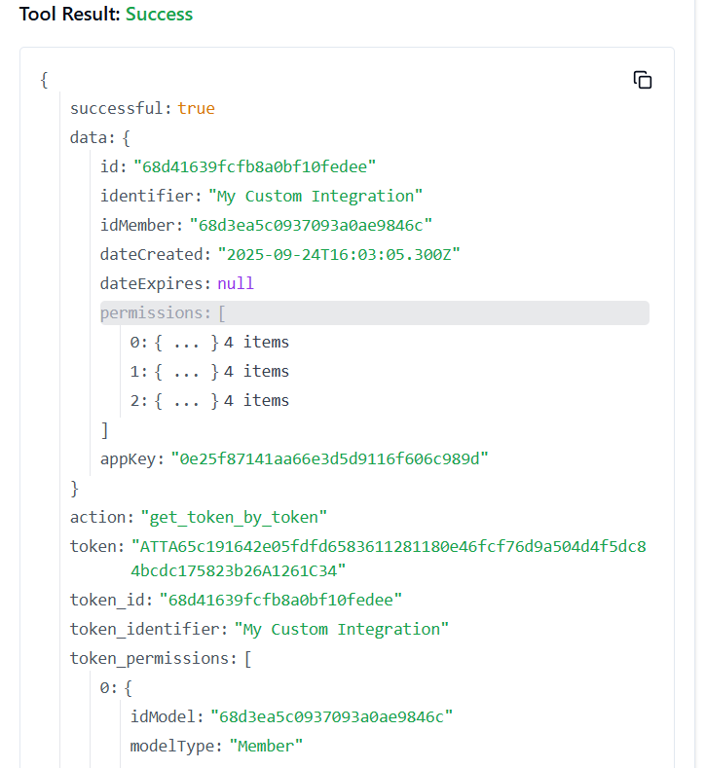

**152. TRELLO_GET_TOKENS_BY_TOKEN_BY_FIELD**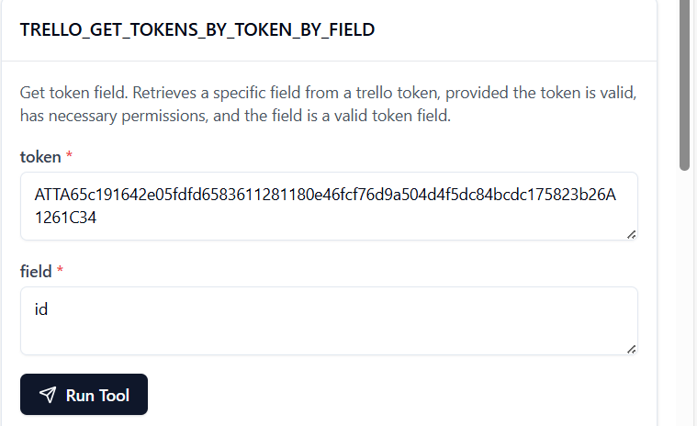

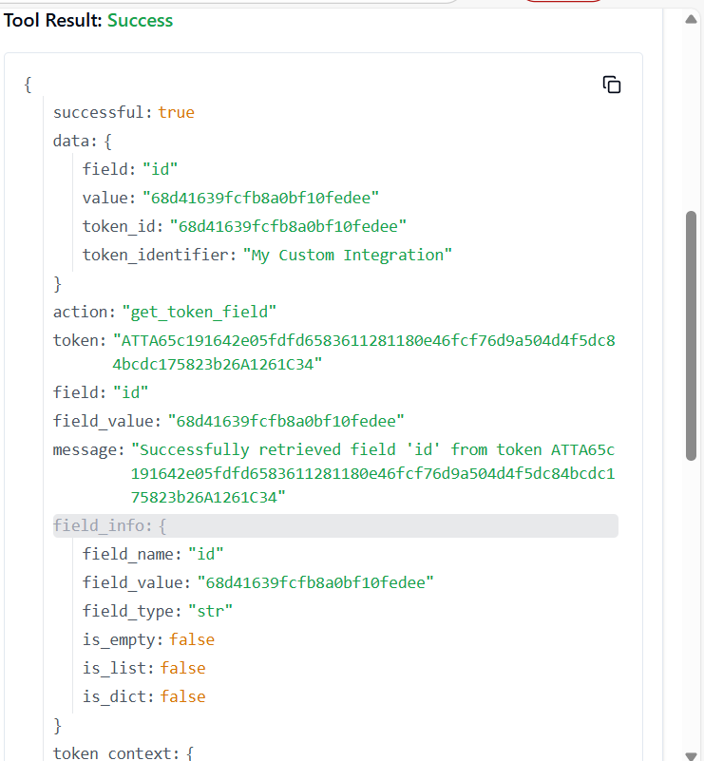

153. **TRELLO_GET_TOKENS_MEMBER_BY_TOKEN**

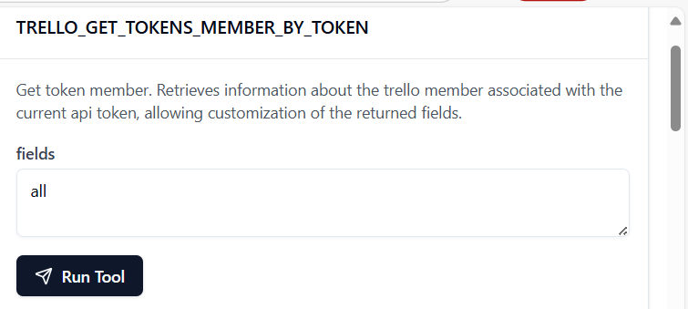

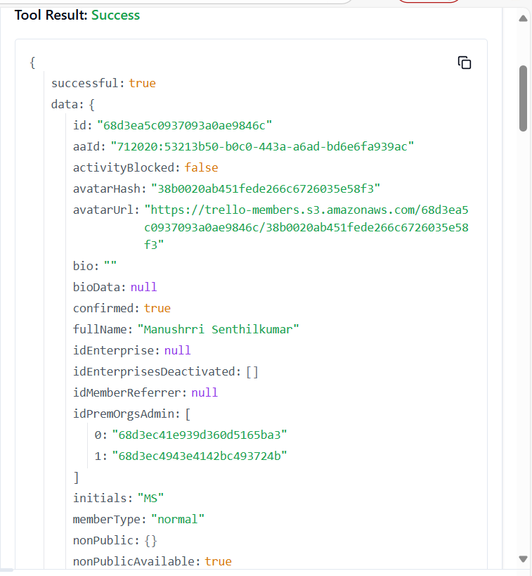

**154. TRELLO_GET_TOKENS_MEMBER_BY_TOKEN_BY_FIELD**

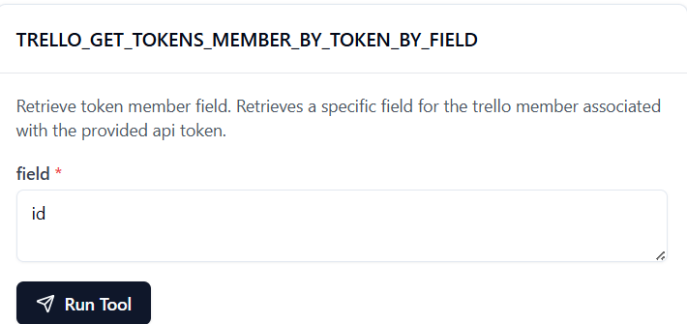

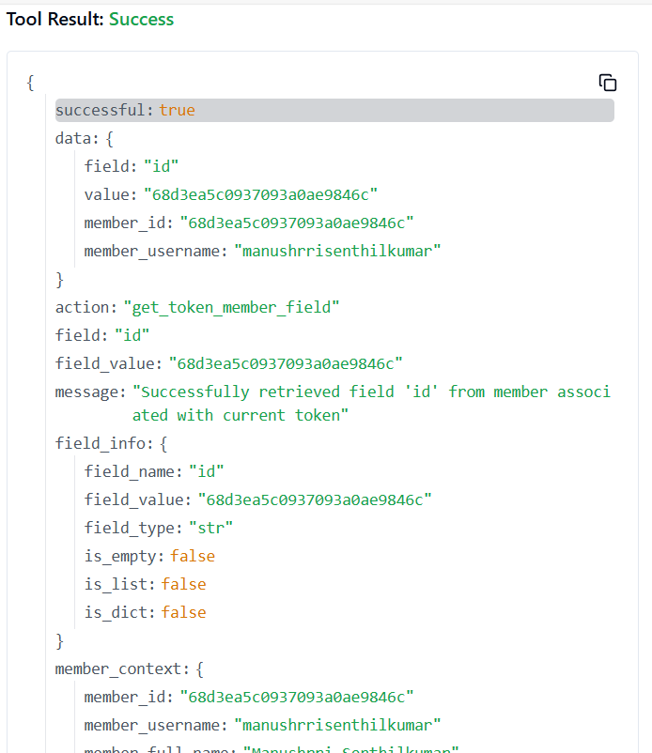

**155. TRELLO_GET_TOKENS_WEBHOOKS_BY_TOKEN**

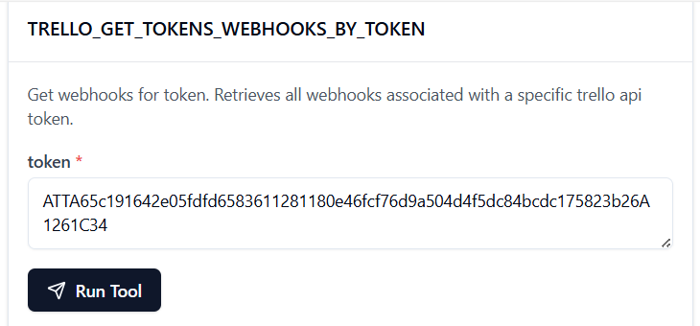 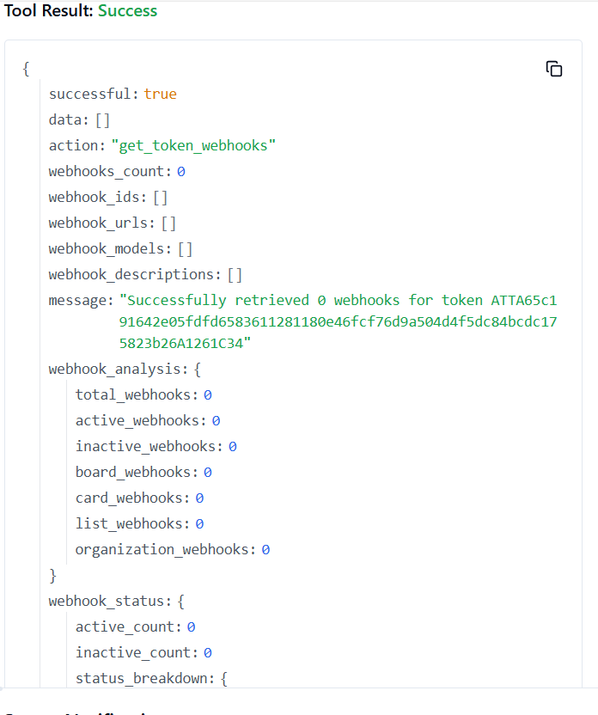

156. **TRELLO_ADD_TOKENS_WEBHOOKS_BY_TOKEN**

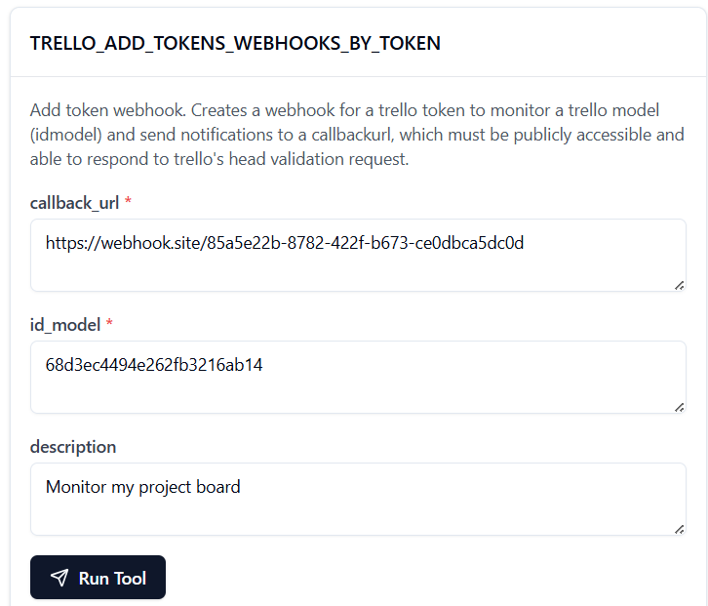

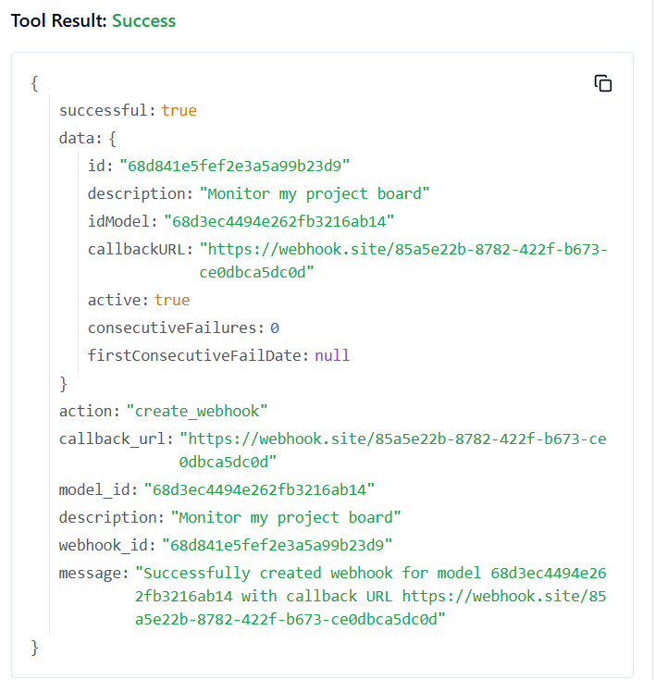

**157. TRELLO_GET_TOKENS_WEBHOOKS_BY_TOKEN_BY_ID_WEBHOOK**

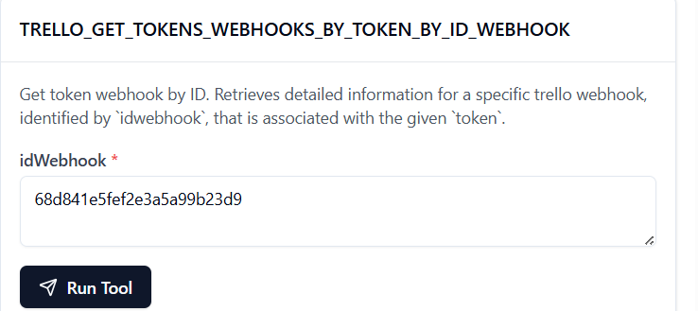

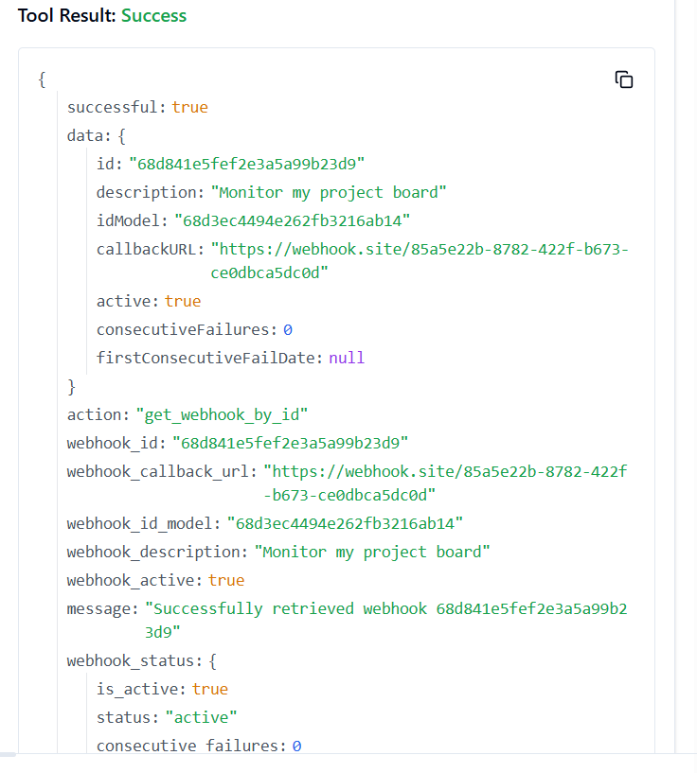

**158. TRELLO_GET_TYPES_BY_ID**

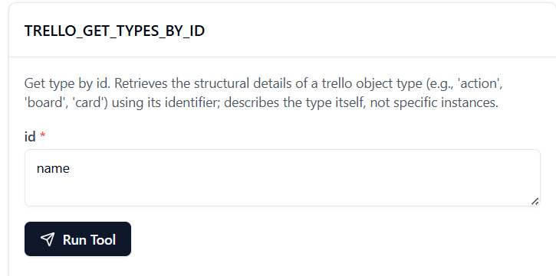

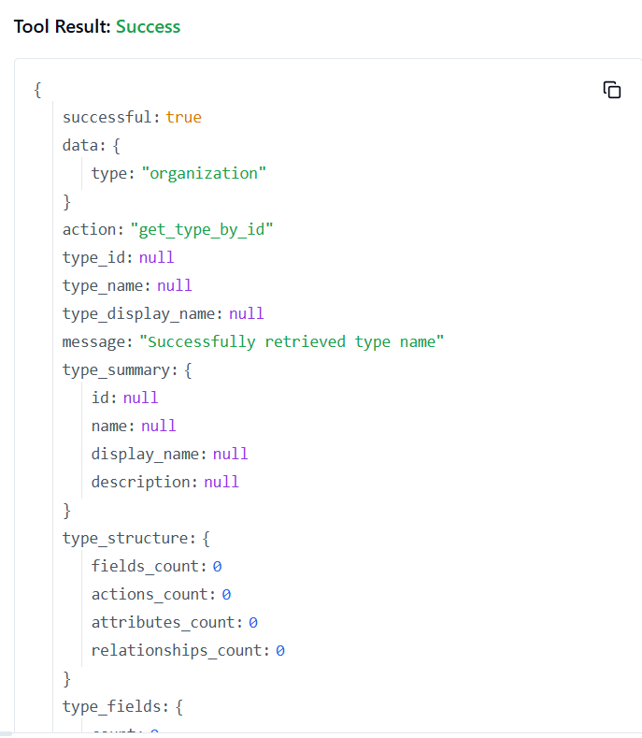

**159. TRELLO_GET_WEBHOOKS_BY_ID_WEBHOOK**

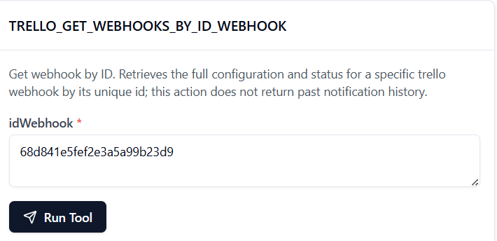

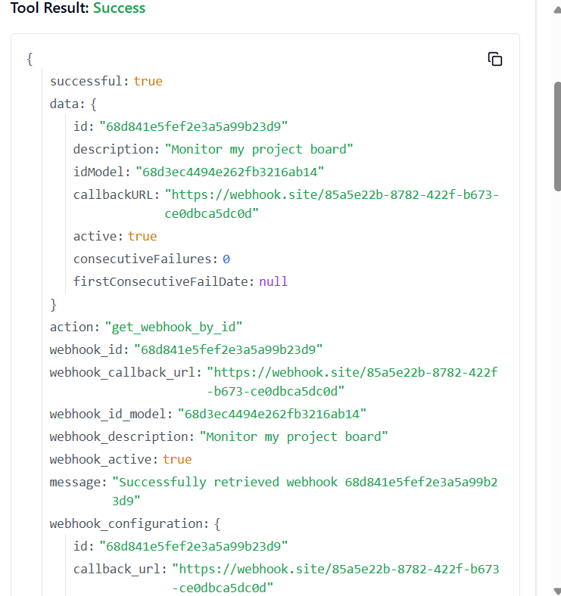

**160. TRELLO_GET_WEBHOOKS_BY_ID_WEBHOOK_BY_FIELD**

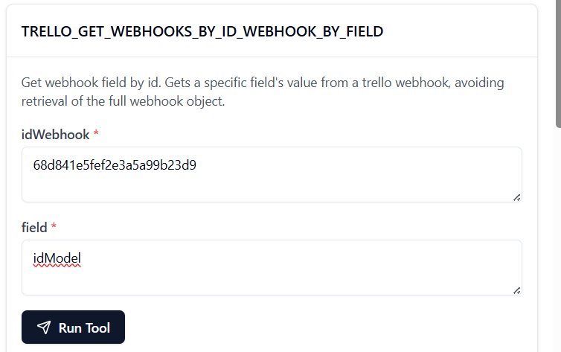

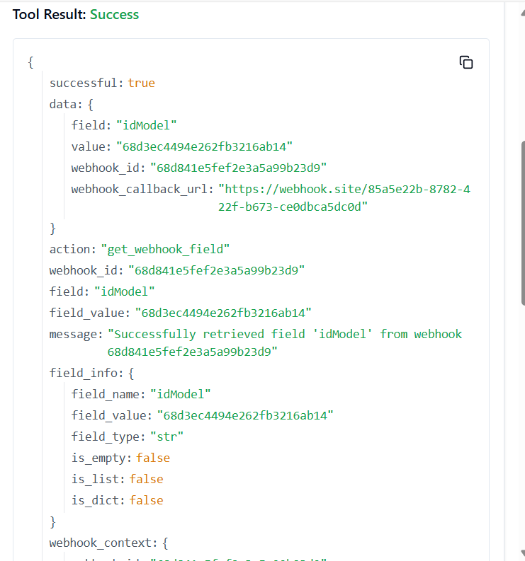

**161. TRELLO_LIST_CREATE_LIST**

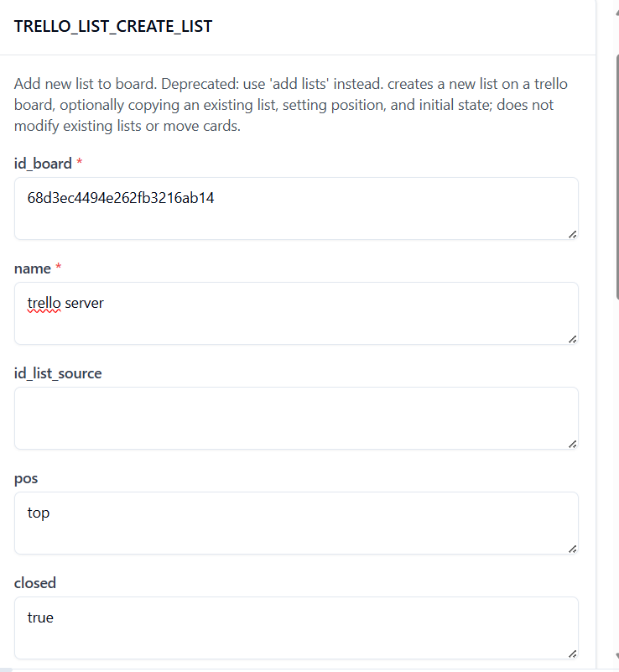

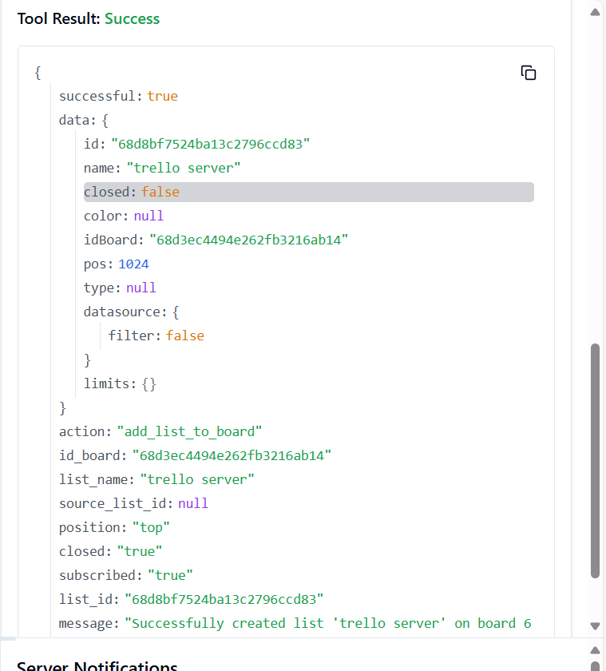

**162. TRELLO_LIST_GET_BY_ID_LIST**

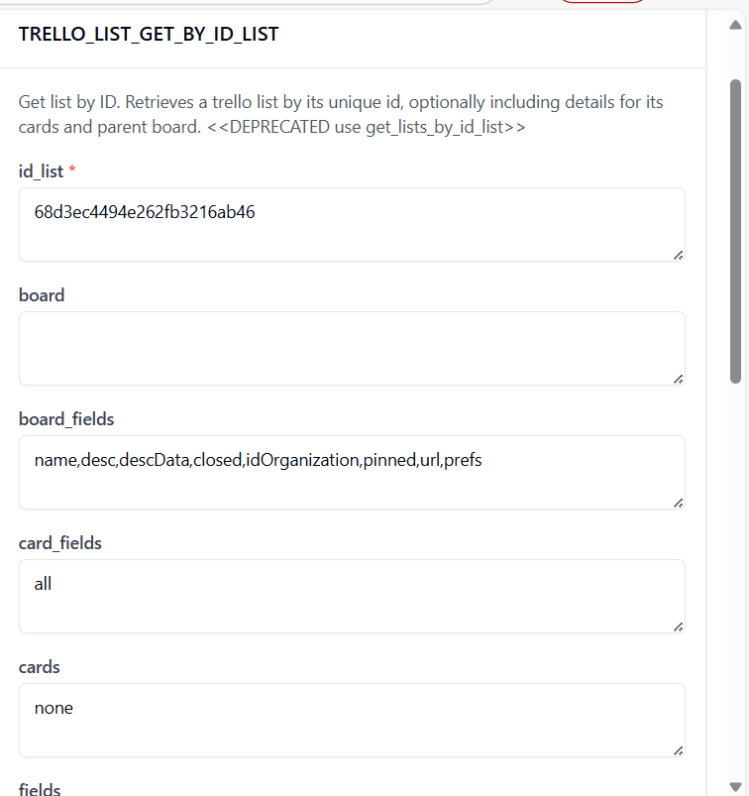

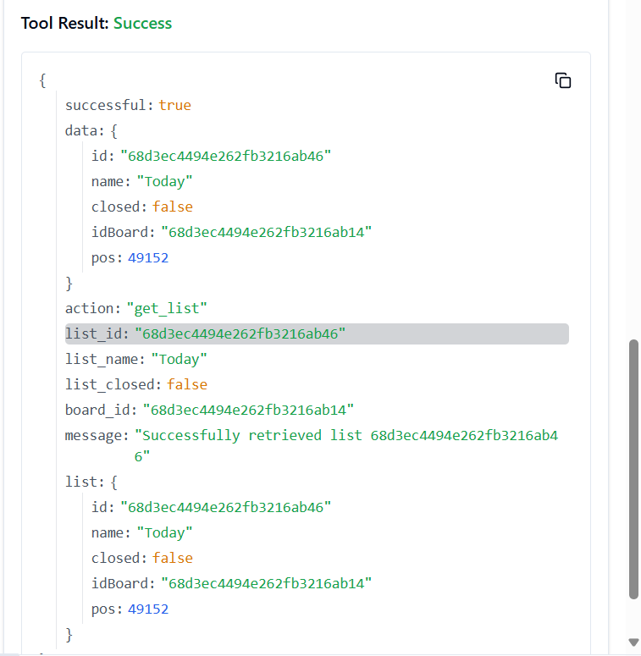

**163. TRELLO_LIST_ID_BOARD_GET**

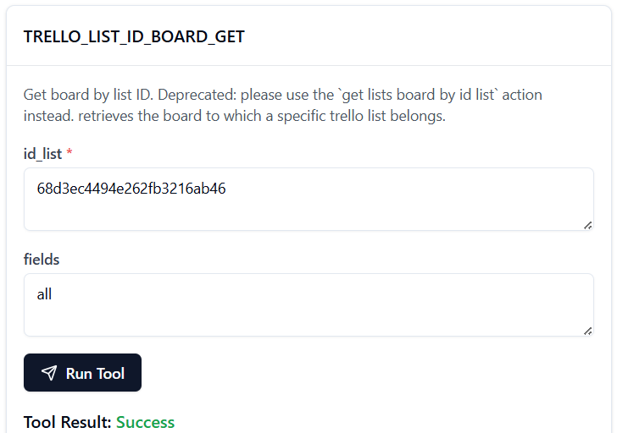

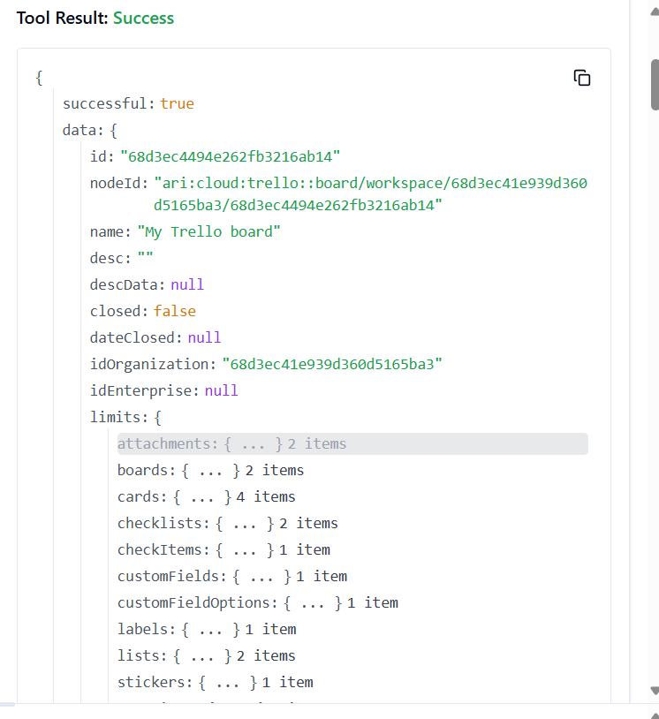

**164. TRELLO_MARK_CARD_NOTIFICATIONS_READ**

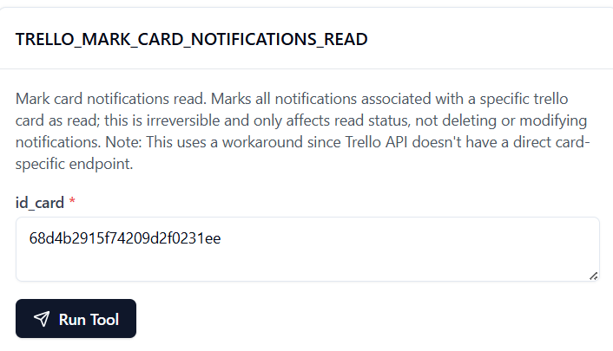

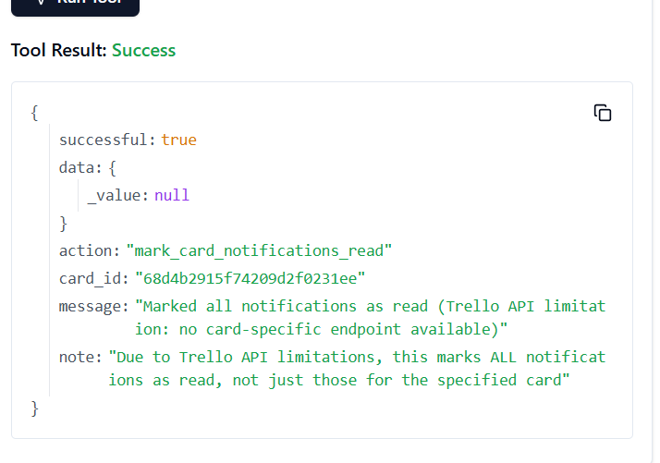

**165. TRELLO_MEMBER_GET_BOARDS**

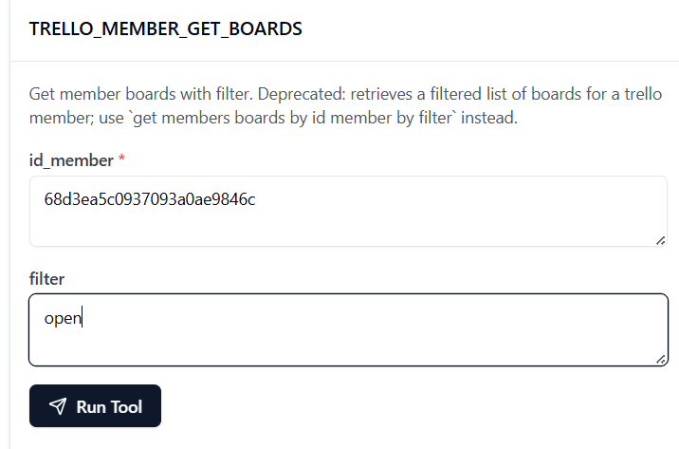

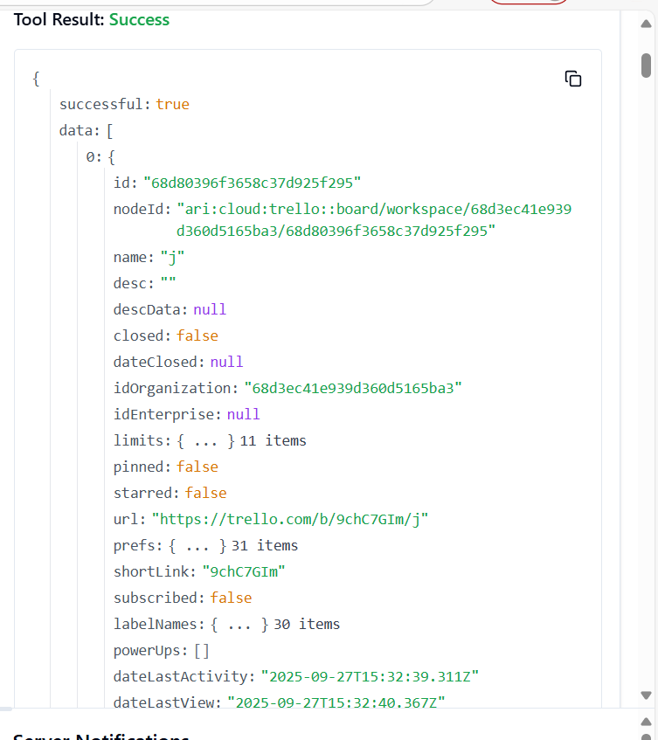

**166. TRELLO_MEMBER_GET_BOARDS_BY_ID_MEMBER**

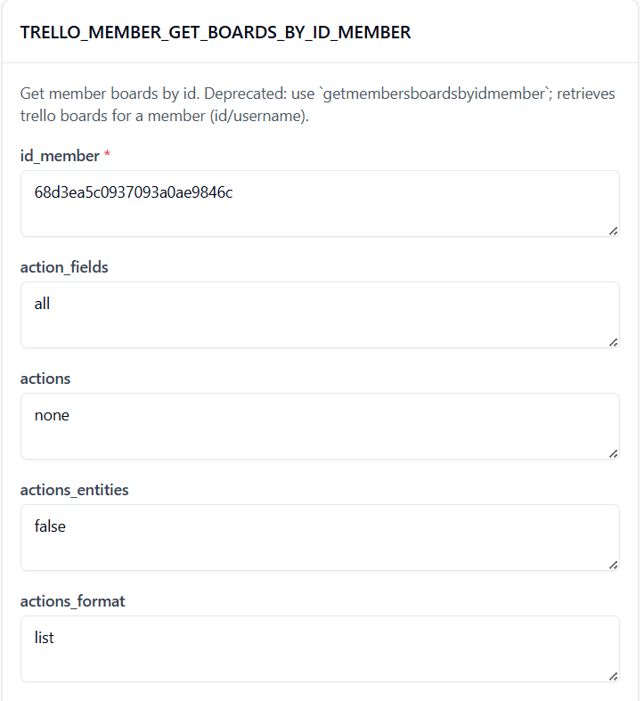

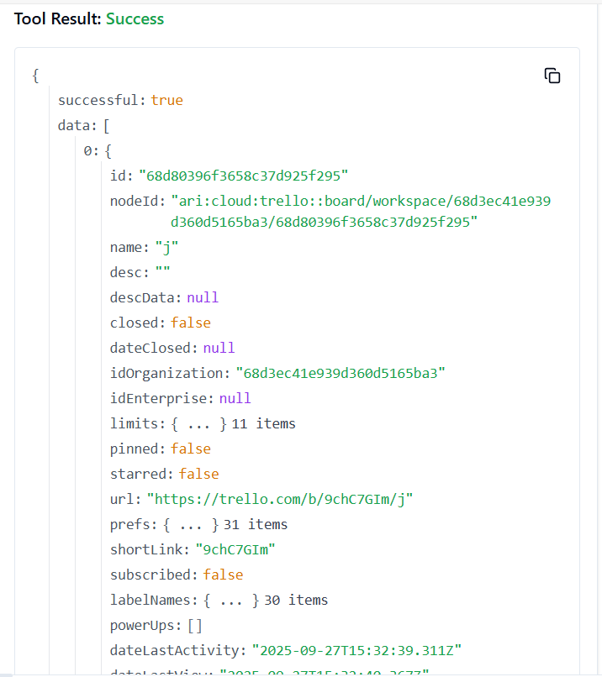

**167. TRELLO_TOKEN_GET_MEMBER_BY_TOKEN**

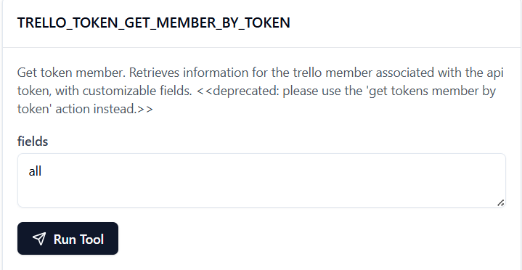

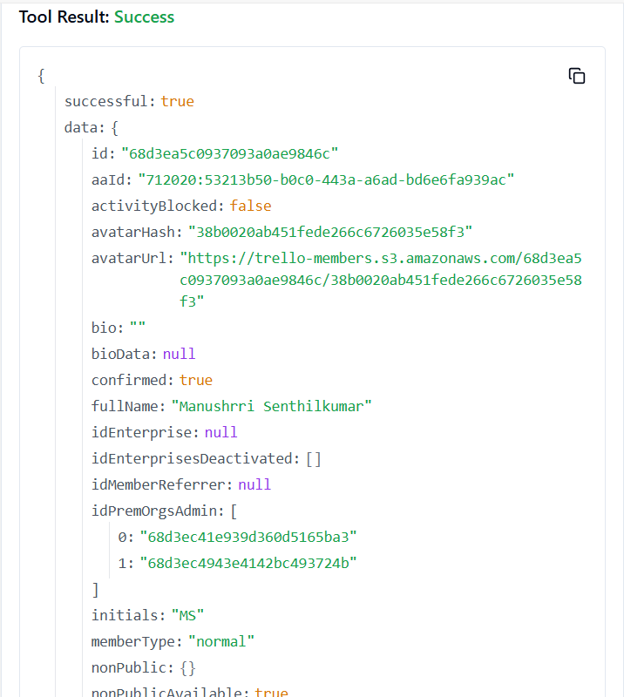

**168. TRELLO_TRELLO_UPDATE_MEMBER_BOARD_STAR**

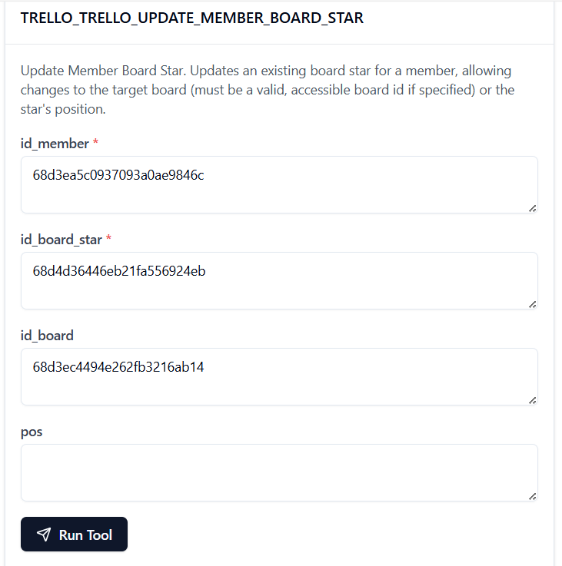

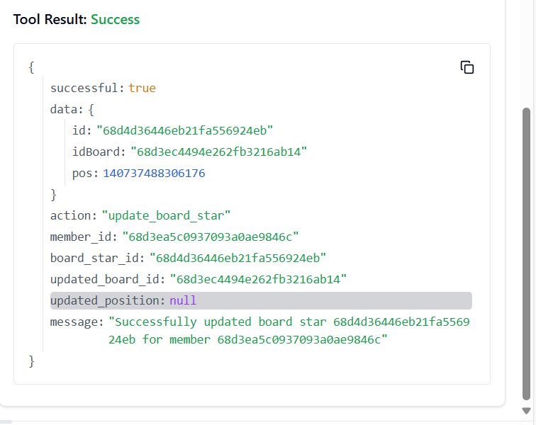

**169. TRELLO_UPDATE_ACTIONS_BY_ID_ACTION**

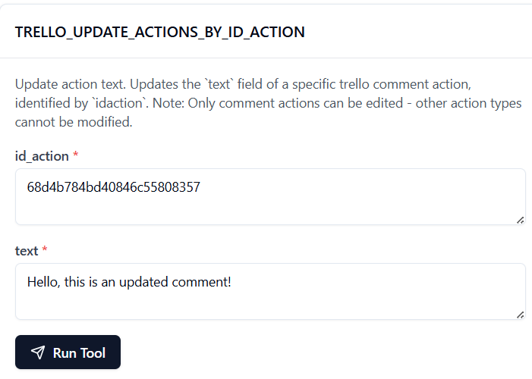

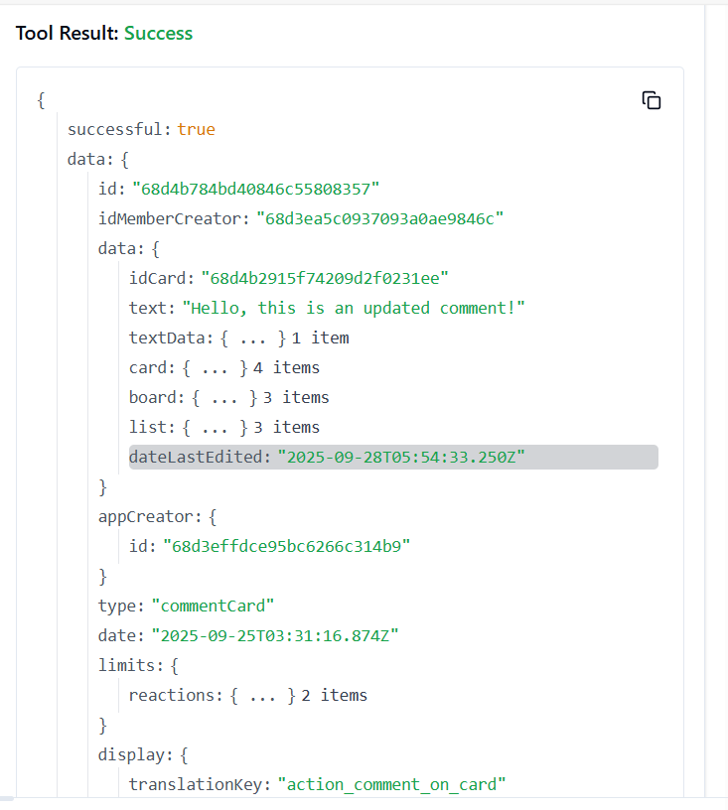

**170. TRELLO_UPDATE_ACTIONS_TEXT_BY_ID_ACTION**

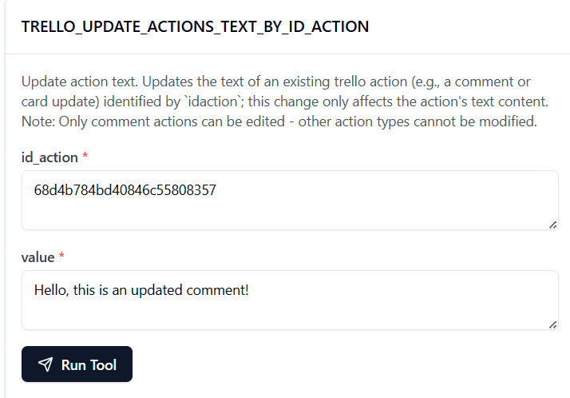

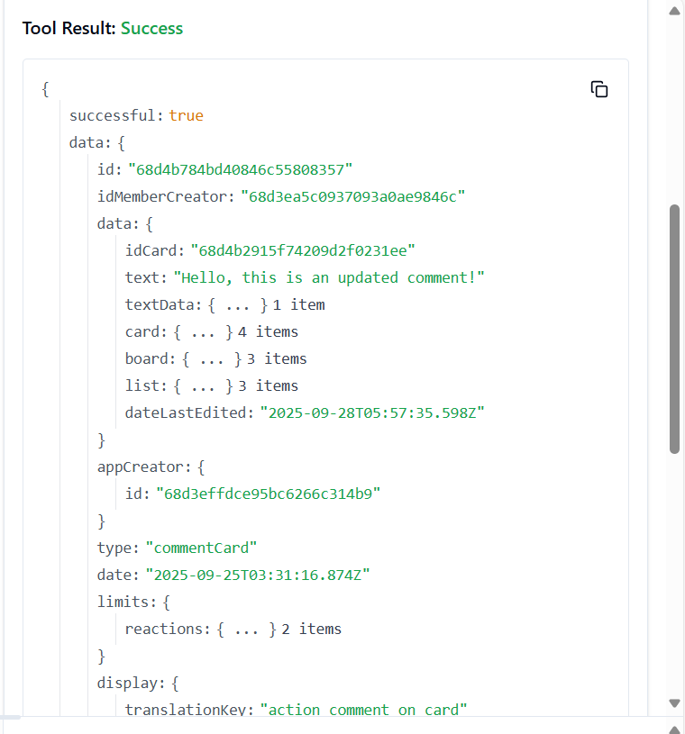

**171. TRELLO_UPDATE_BOARD_MEMBERSHIP**

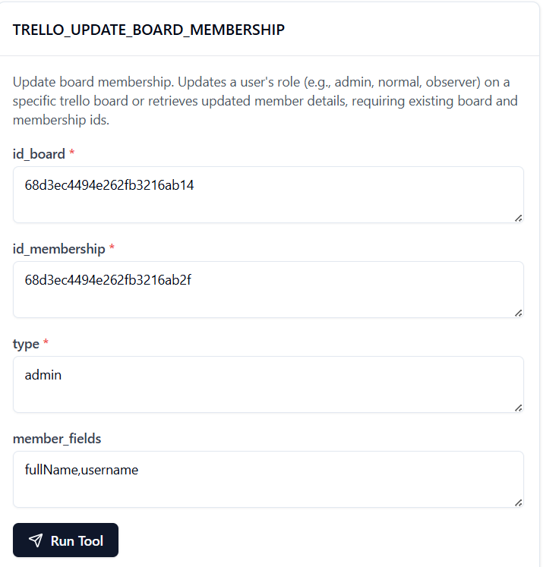

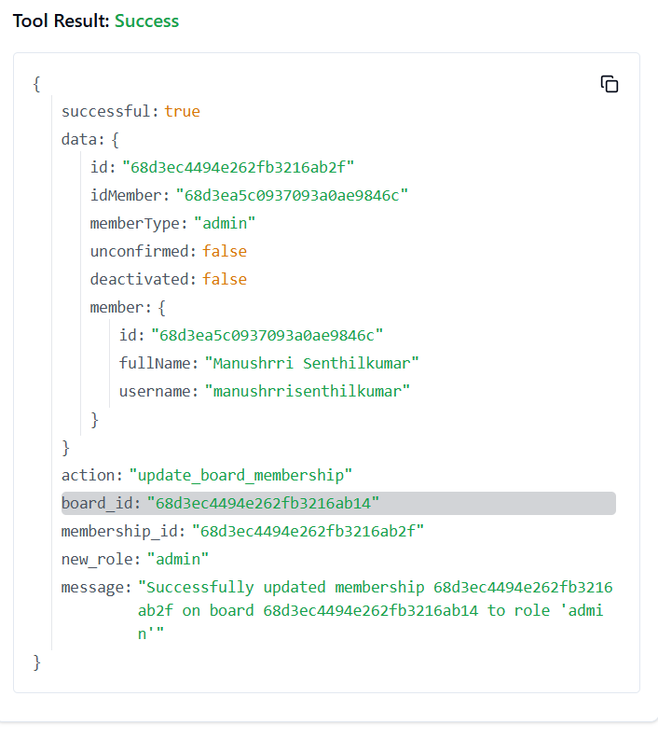

**172. TRELLO_UPDATE_BOARDS_BY_ID_BOARD**

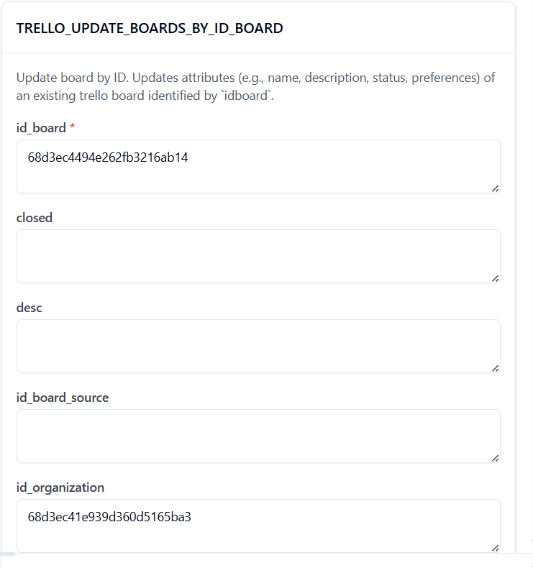

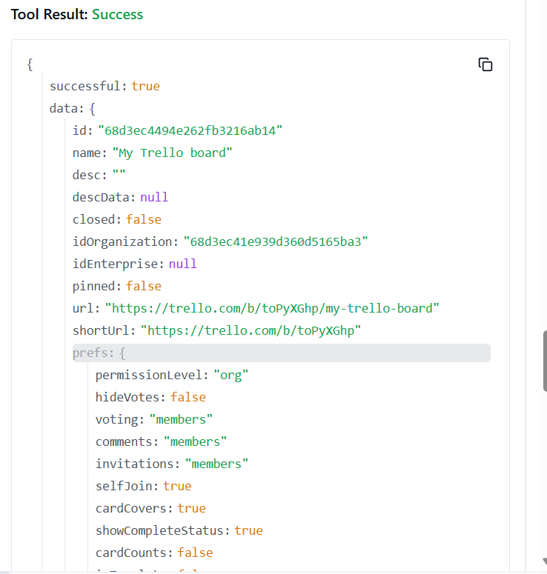

**173. TRELLO_UPDATE_BOARDS_CLOSED_BY_ID_BOARD**

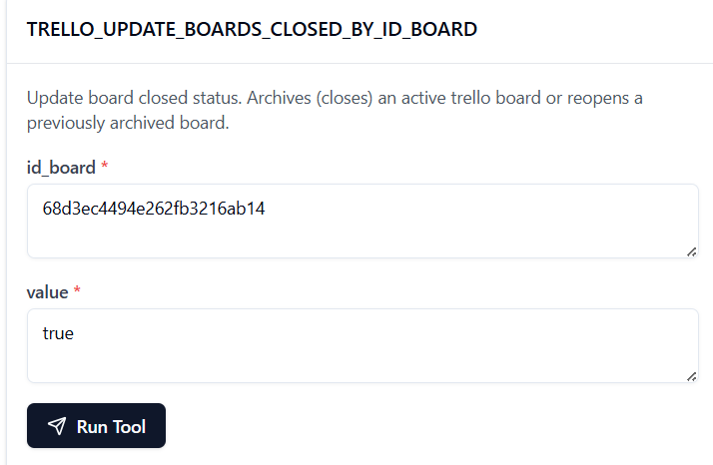

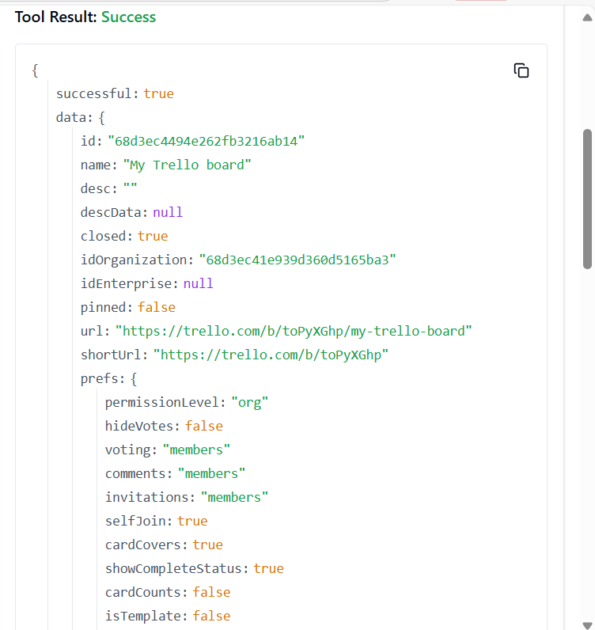

**174. TRELLO_UPDATE_BOARDS_DESC_BY_ID_BOARD**

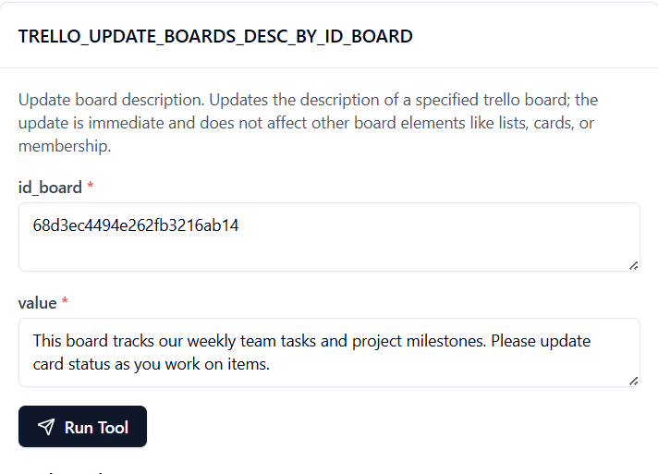 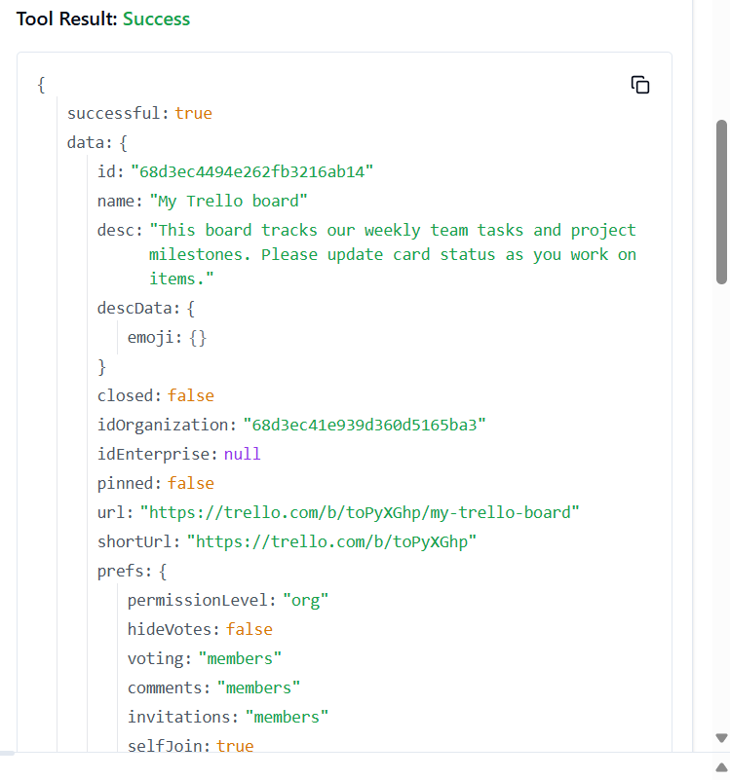

175. **TRELLO_UPDATE_BOARD_SIDEBAR_ACTIONS_PREFS**

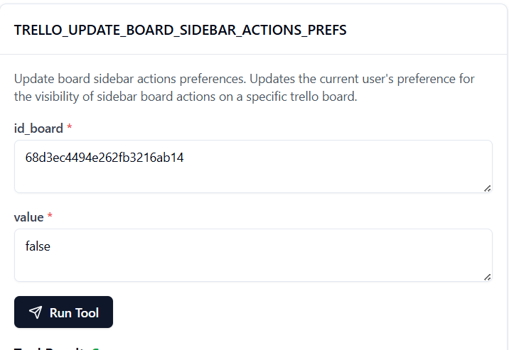

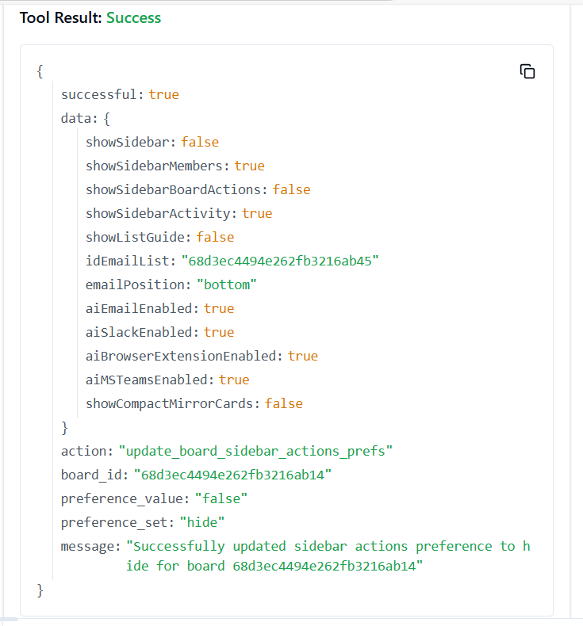

**176. TRELLO_UPDATE_BOARDS_ID_ORGANIZATION_BY_ID_BOARD**

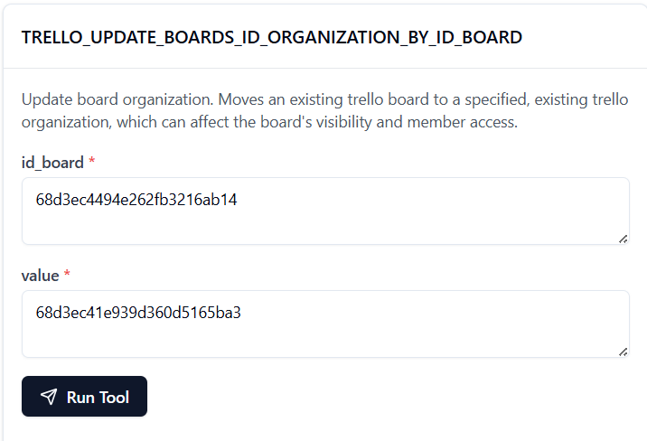

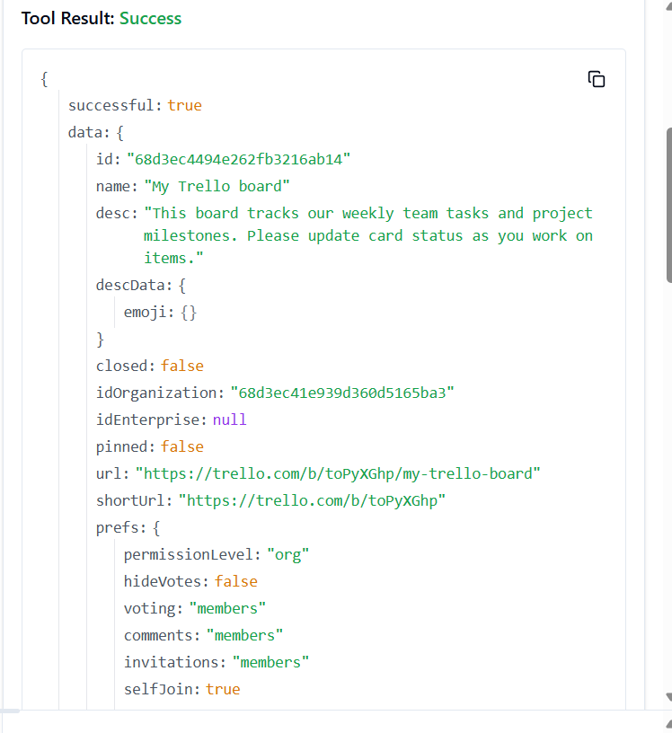

**177. TRELLO_UPDATE_BOARDS_LABEL_NAMES_BLUE_BY_ID_BOARD**

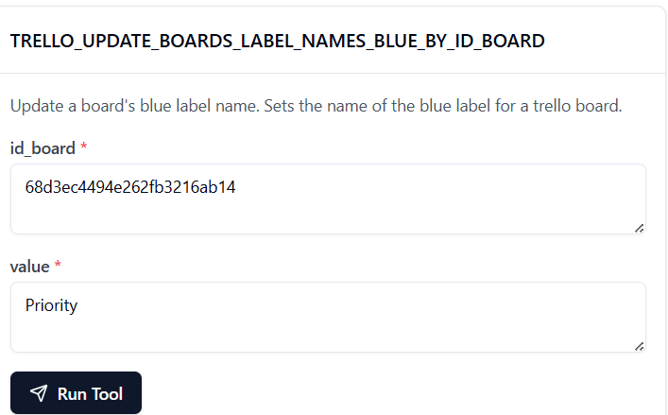 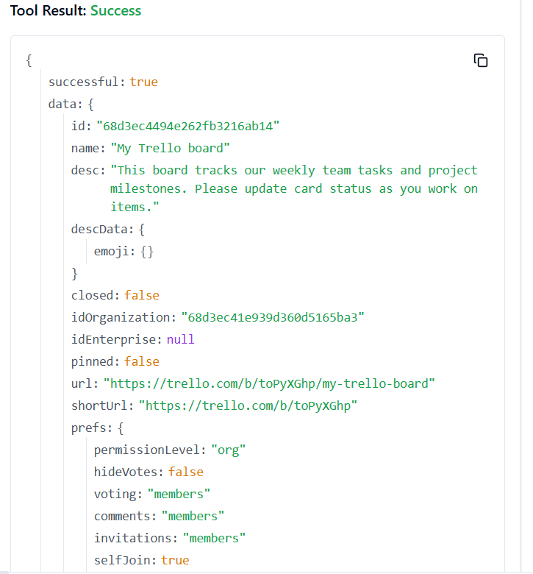

178. **TRELLO_UPDATE_BOARDS_LABEL_NAMES_GREEN_BY_ID_BOARD**

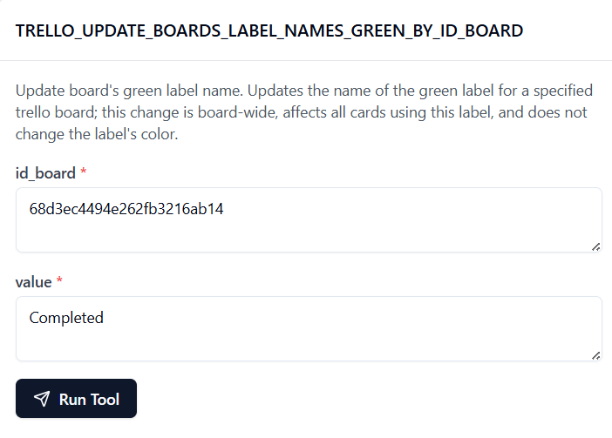

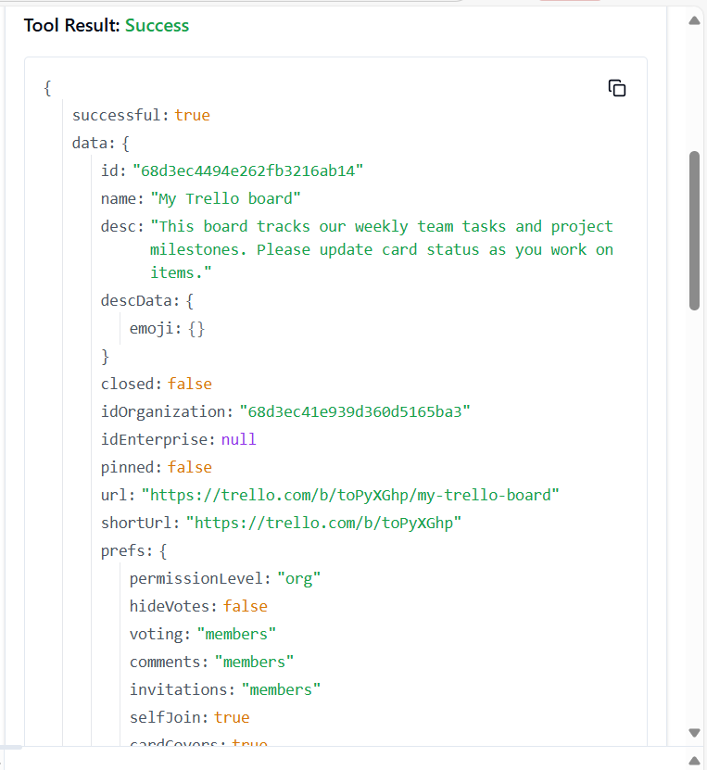

**179. TRELLO_UPDATE_BOARDS_LABEL_NAMES_ORANGE_BY_ID_BOARD**

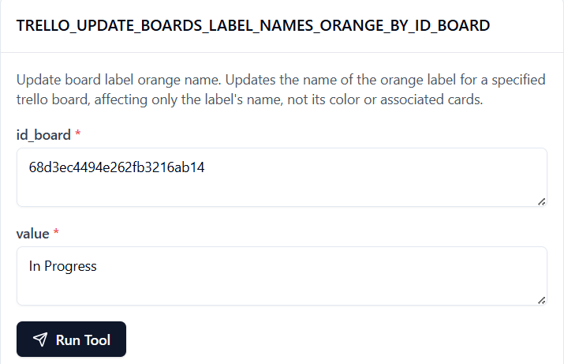

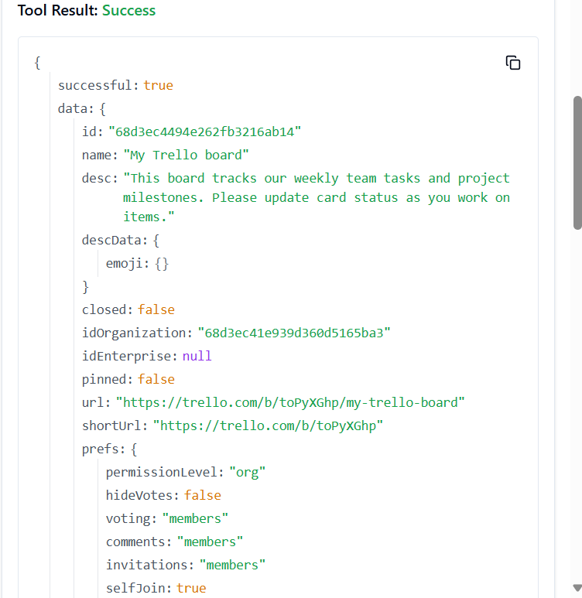

**180. TRELLO_UPDATE_BOARDS_LABEL_NAMES_PURPLE_BY_ID_BOARD**

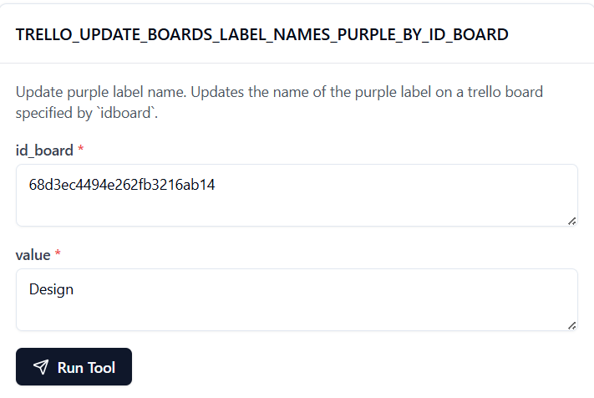

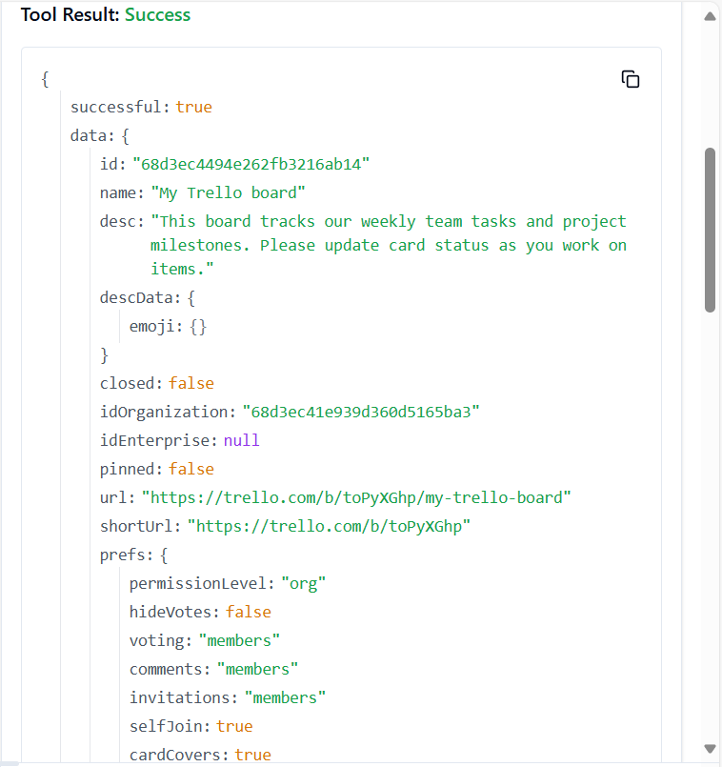

**181. TRELLO_UPDATE_BOARDS_LABEL_NAMES_RED_BY_ID_BOARD**

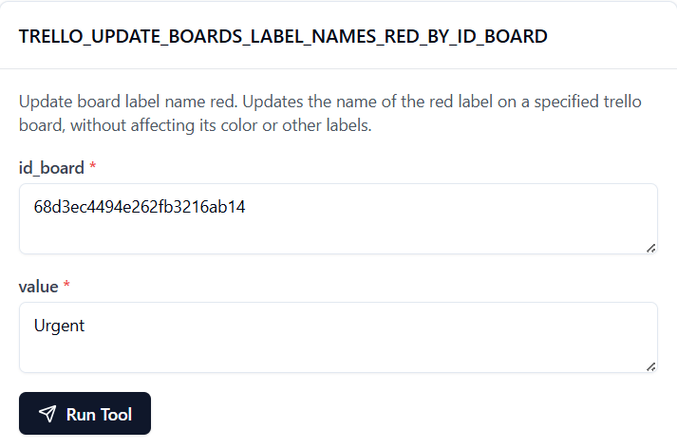

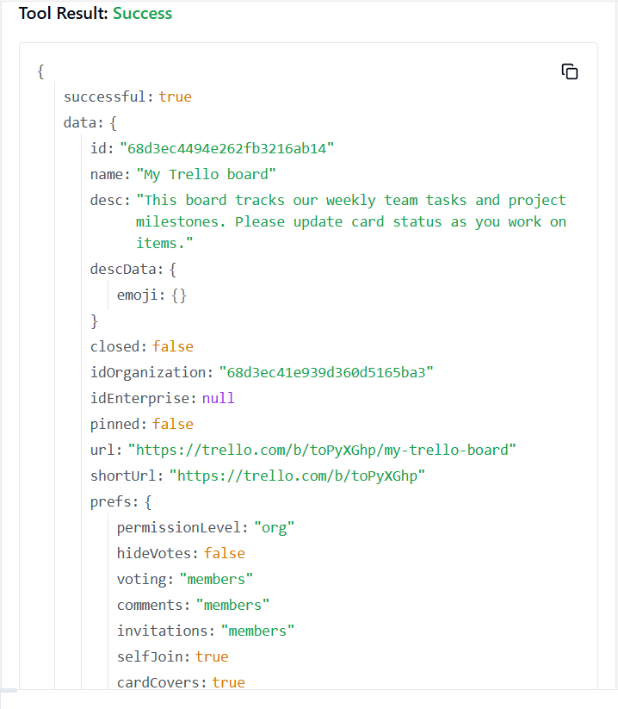

**182. TRELLO_UPDATE_BOARDS_LABEL_NAMES_YELLOW_BY_ID_BOARD**

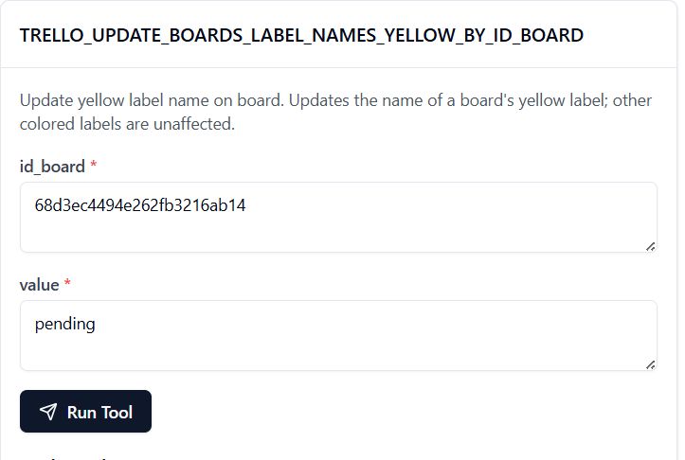

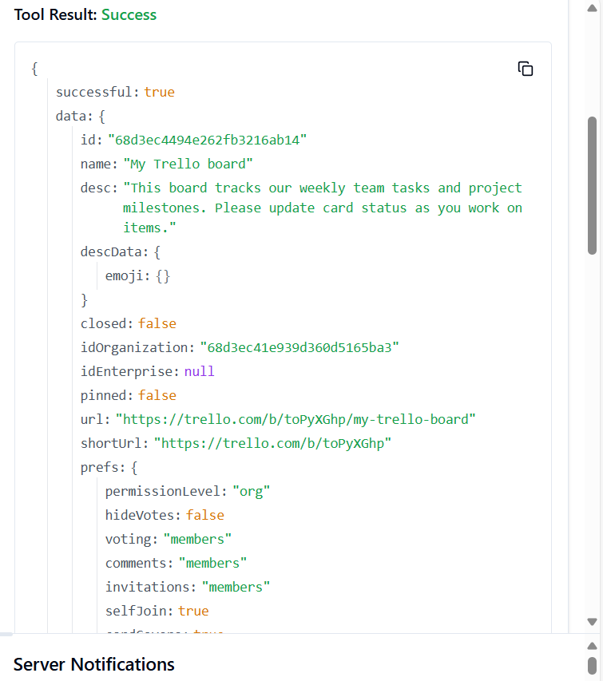

**183. TRELLO_UPDATE_BOARDS_MEMBERS_BY_ID_BOARD**

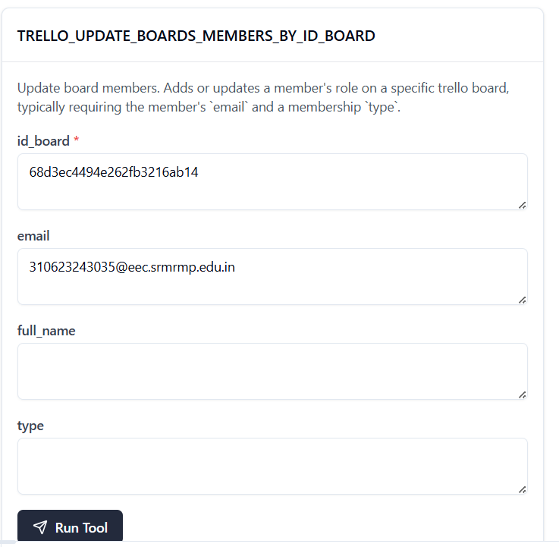 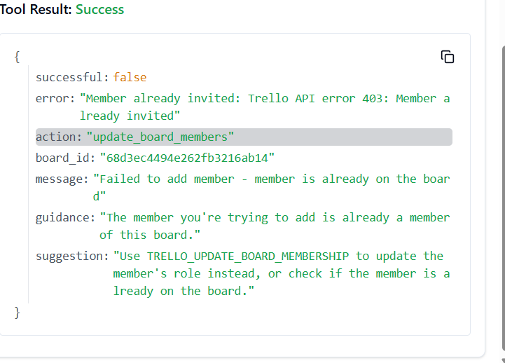

184. **TRELLO_UPDATE_BOARDS_MEMBERS_BY_ID_BOARD_BY_ID_MEMBER**

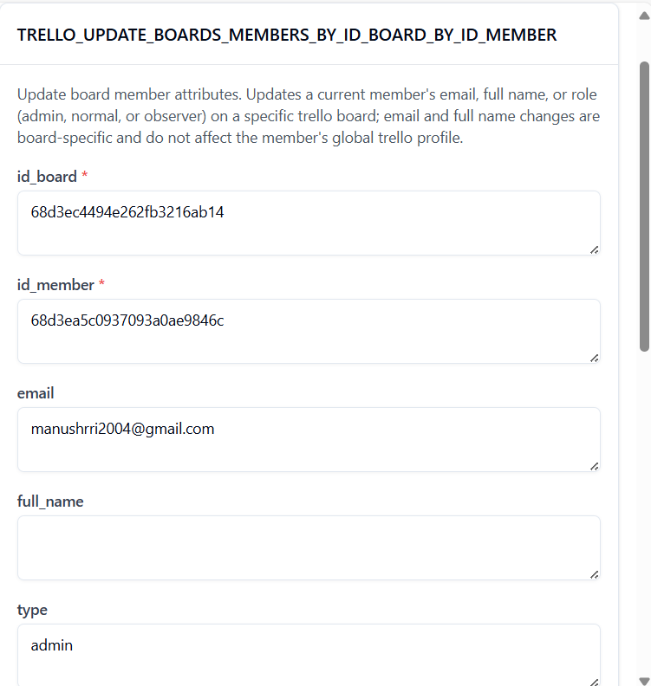

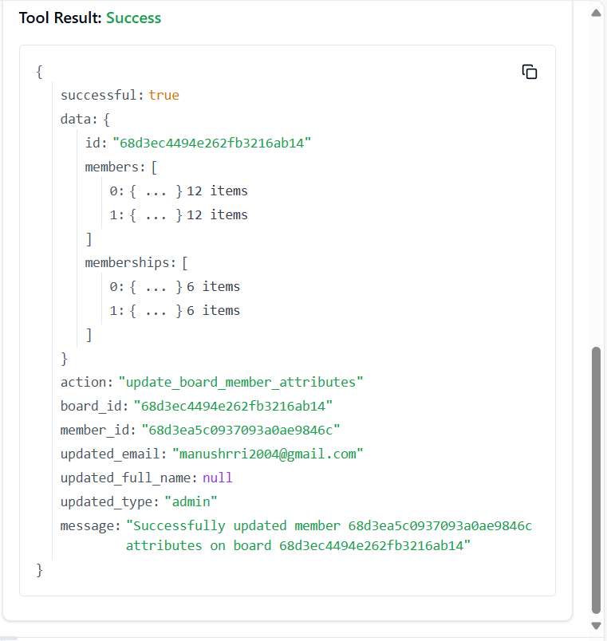

**185. TRELLO_UPDATE_BOARDS_MY_PREFS_EMAIL_POSITION_BY_ID_BOARD**

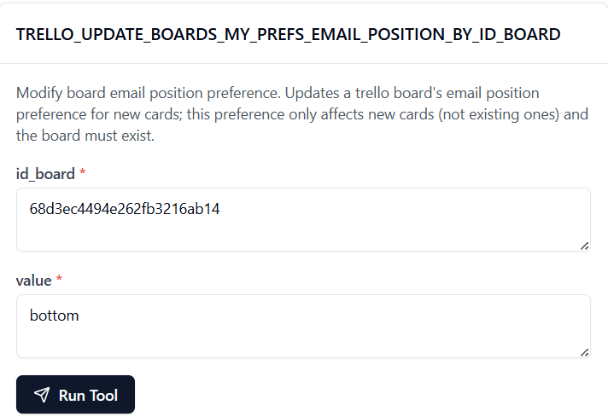

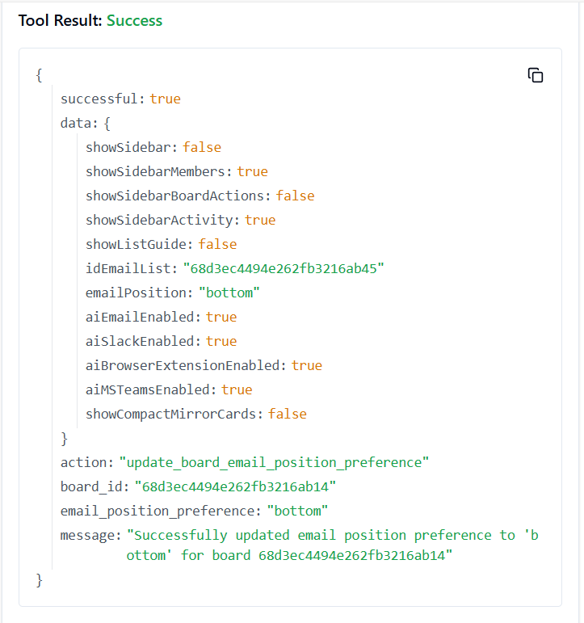

**186. TRELLO_UPDATE_BOARDS_MY_PREFS_ID_EMAIL_LIST_BY_ID_BOARD**

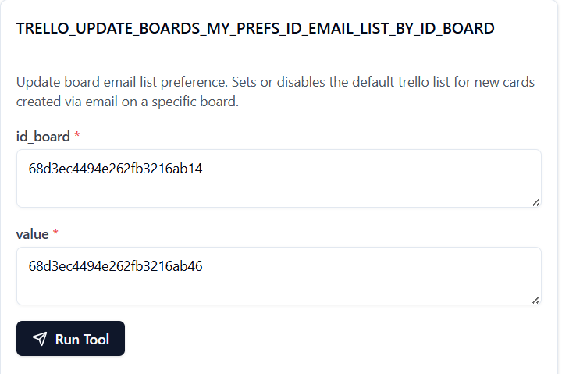

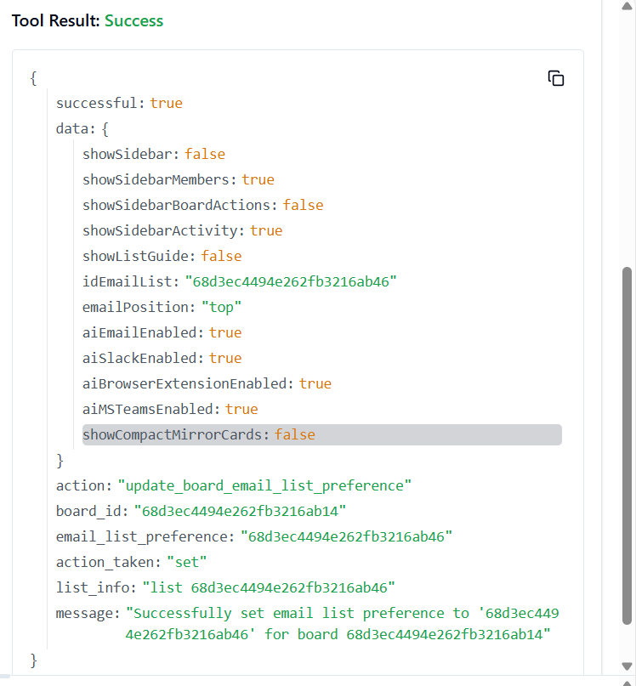

**187. TRELLO_UPDATE_BOARDS_MY_PREFS_SHOW_SIDEBAR_ACTIVITY_BY_ID_BOARD**

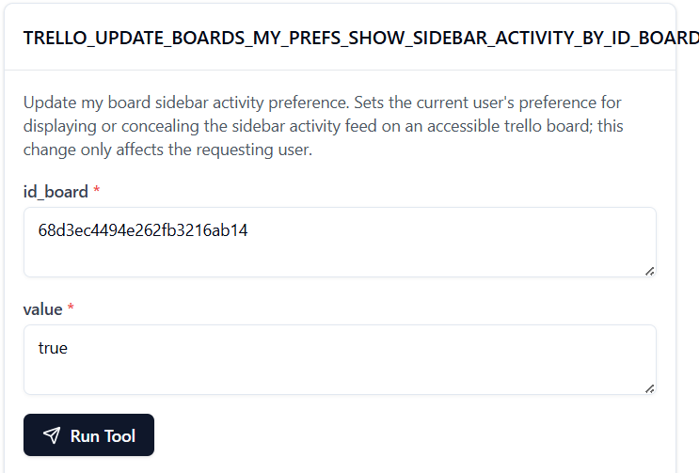

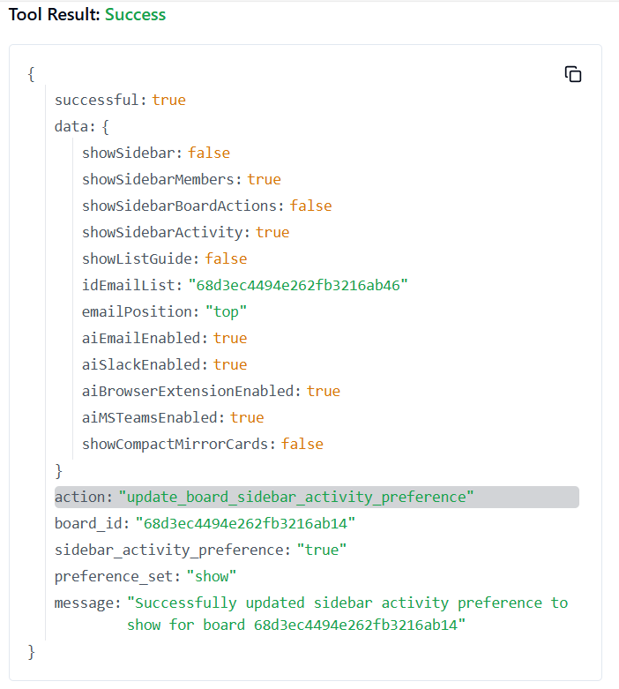

**188. TRELLO_UPDATE_BOARDS_MY_PREFS_SHOW_SIDEBAR_BY_ID_BOARD**

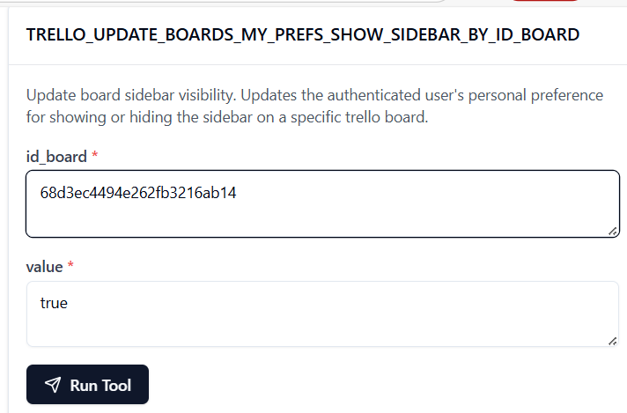

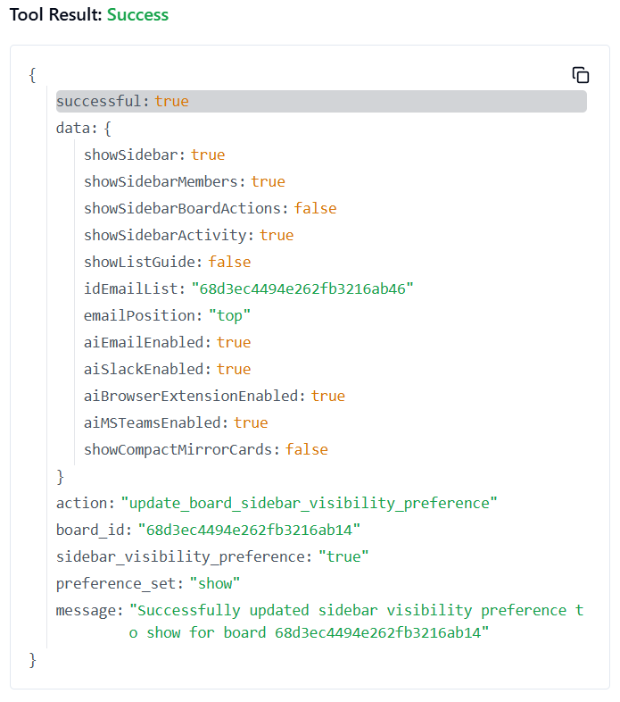

**189. TRELLO_UPDATE_BOARDS_MY_PREFS_SHOW_SIDEBAR_MEMBERS_BY_ID_BOARD**

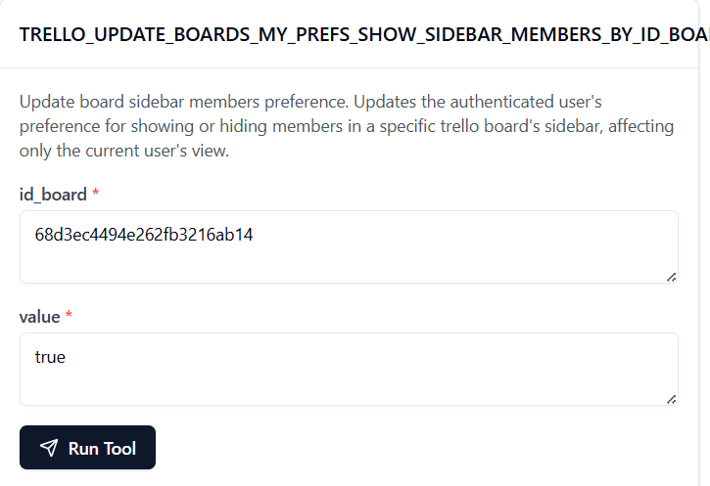

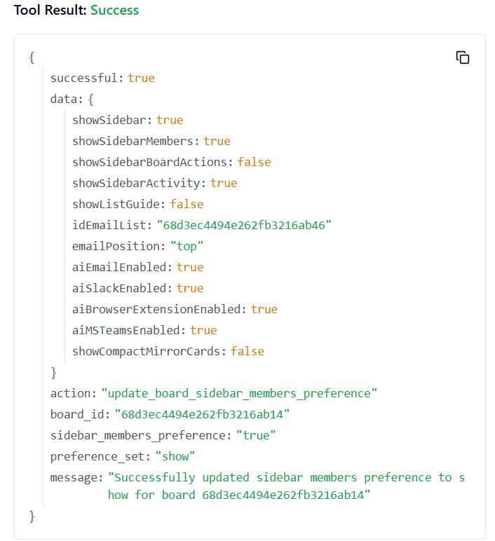

**190. TRELLO_UPDATE_BOARDS_NAME_BY_ID_BOARD**

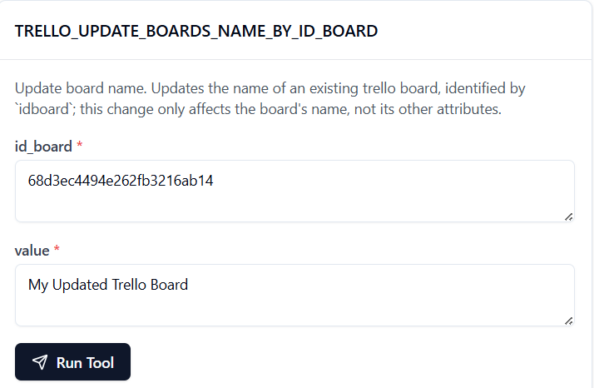

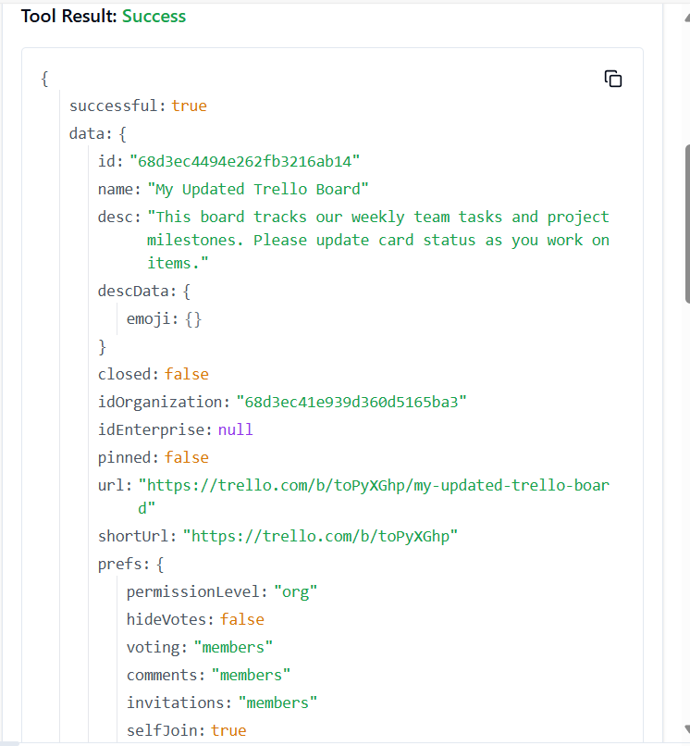

**191. TRELLO_UPDATE_BOARDS_PREFS_BACKGROUND_BY_ID_BOARD**

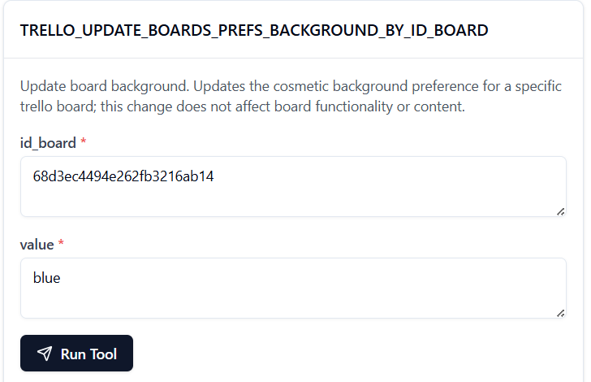

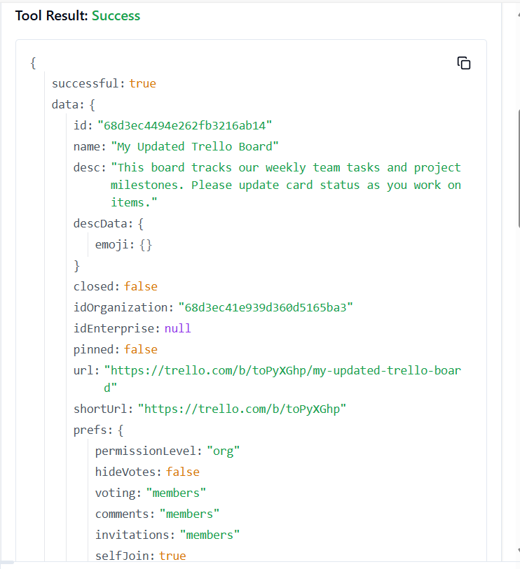

**192. TRELLO_UPDATE_BOARDS_PREFS_CALENDAR_FEED_ENABLED_BY_ID_BOARD**

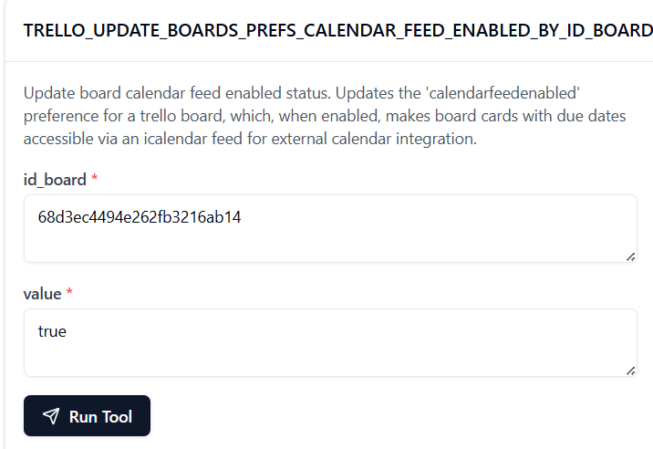

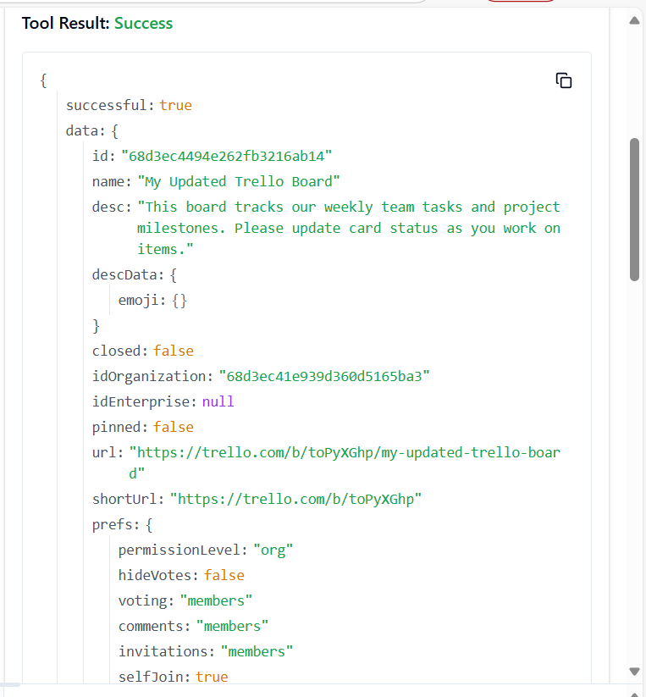

**193. TRELLO_UPDATE_BOARDS_PREFS_CARD_AGING_BY_ID_BOARD**

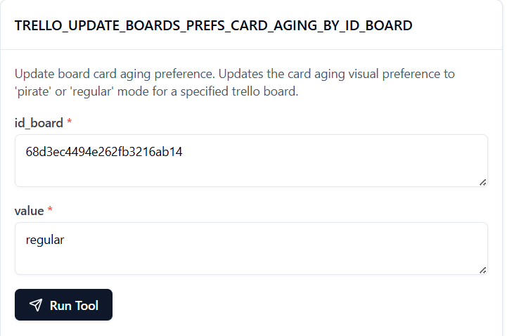

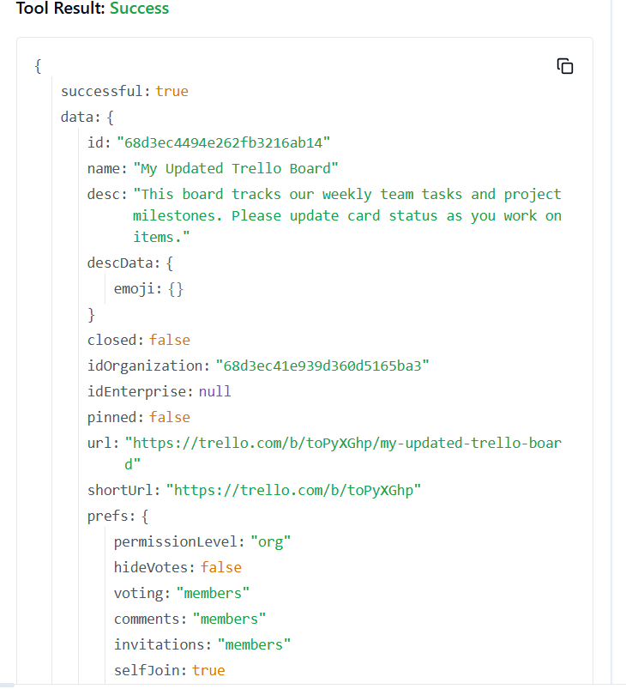

**194. TRELLO_UPDATE_BOARDS_PREFS_CARD_COVERS_BY_ID_BOARD**

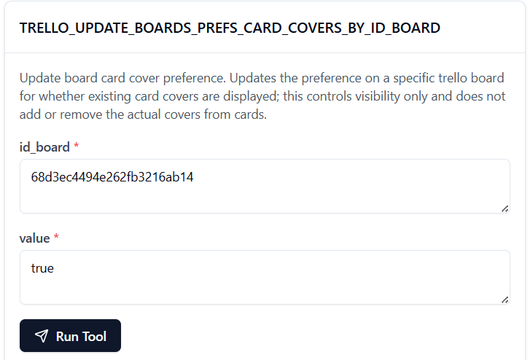

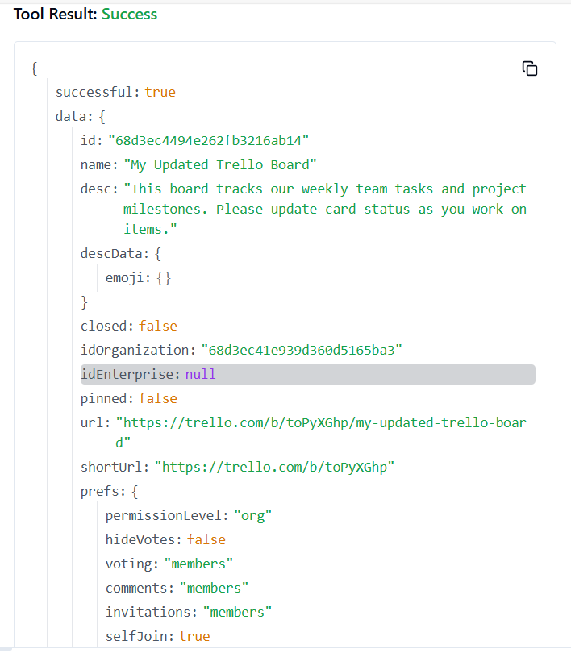

**195. TRELLO_UPDATE_BOARDS_PREFS_COMMENTS_BY_ID_BOARD**

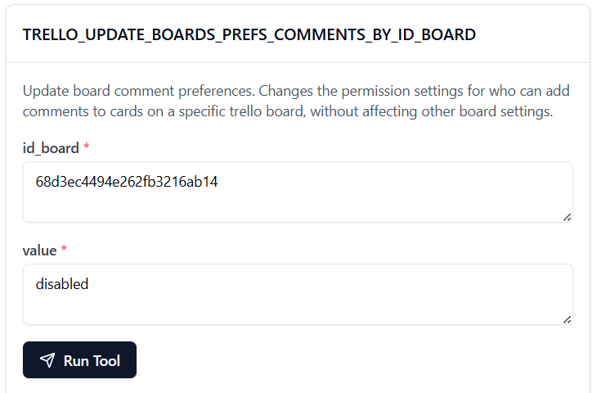 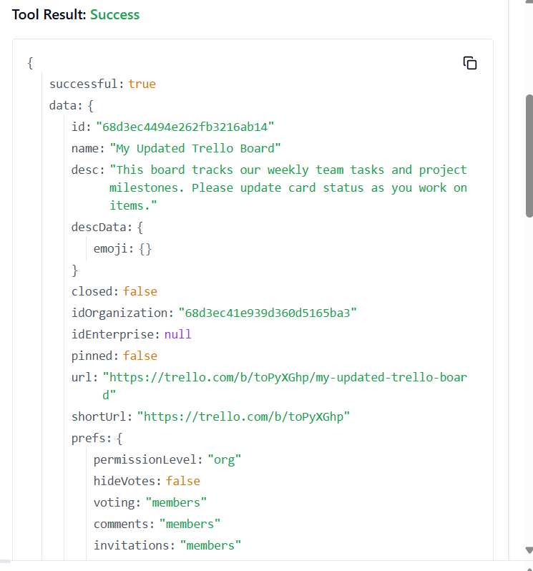

196. **TRELLO_UPDATE_BOARDS_PREFS_INVITATIONS_BY_ID_BOARD**

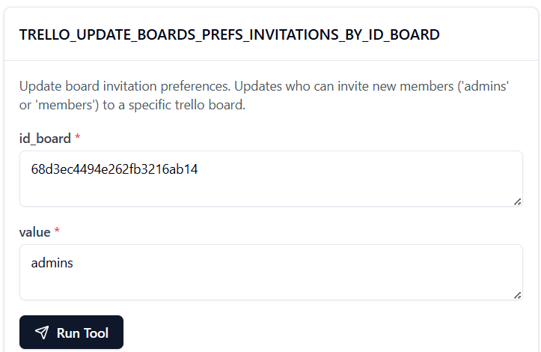

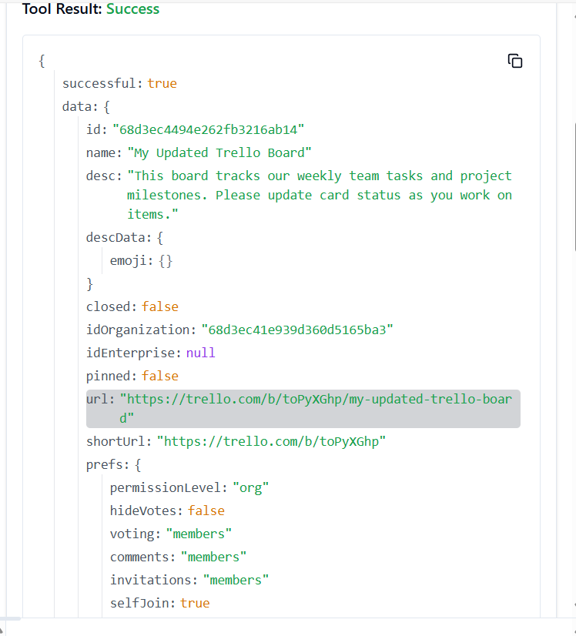

**197. TRELLO_UPDATE_BOARDS_PREFS_PERMISSION_LEVEL_BY_ID_BOARD**

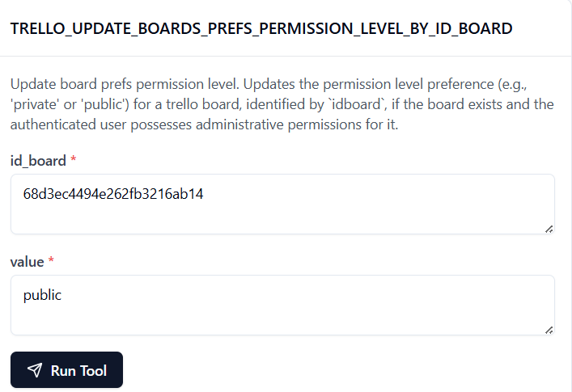

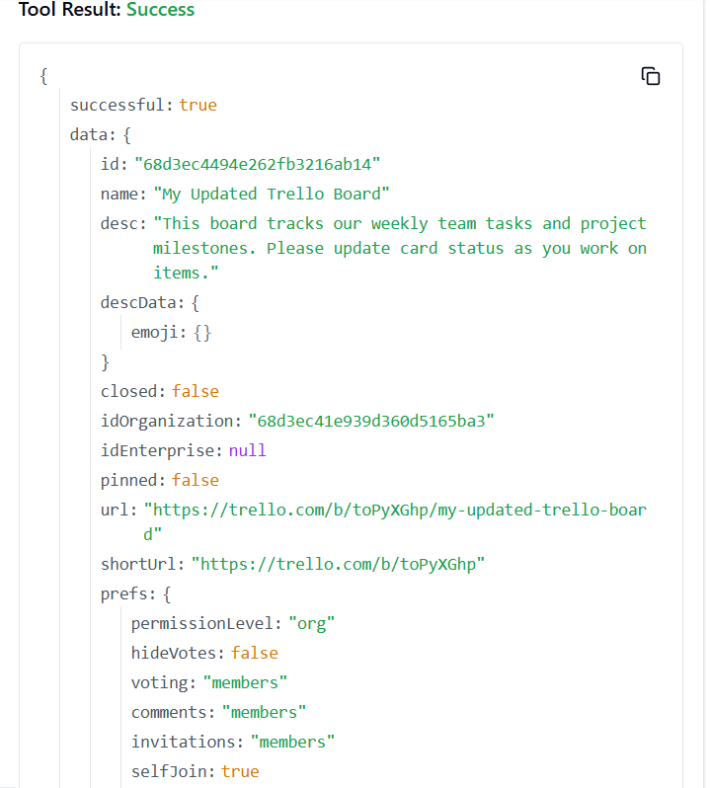

**198. TRELLO_UPDATE_BOARDS_PREFS_SELF_JOIN_BY_ID_BOARD**

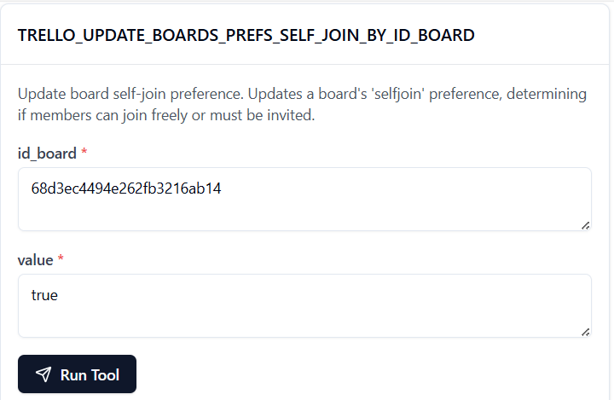

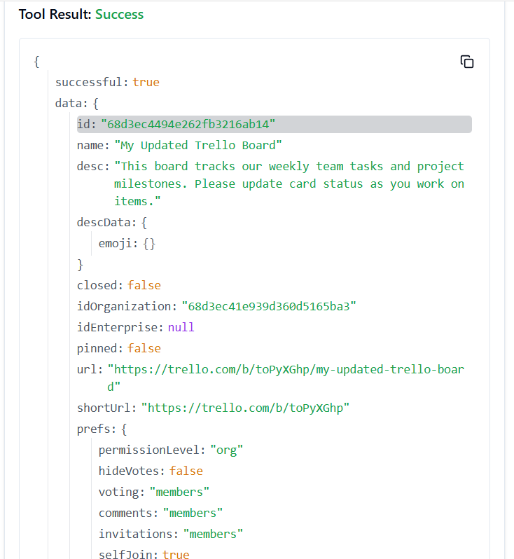

**199. TRELLO_UPDATE_BOARDS_PREFS_VOTING_BY_ID_BOARD**

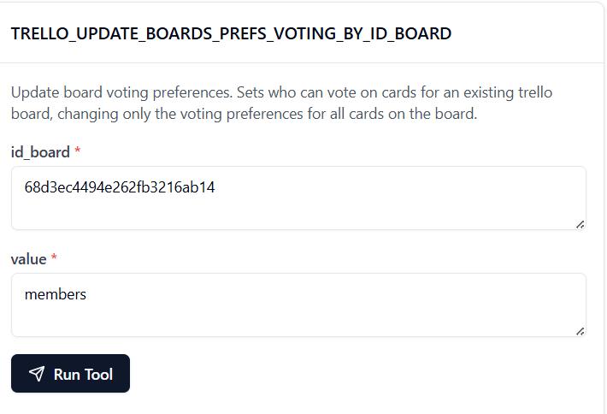

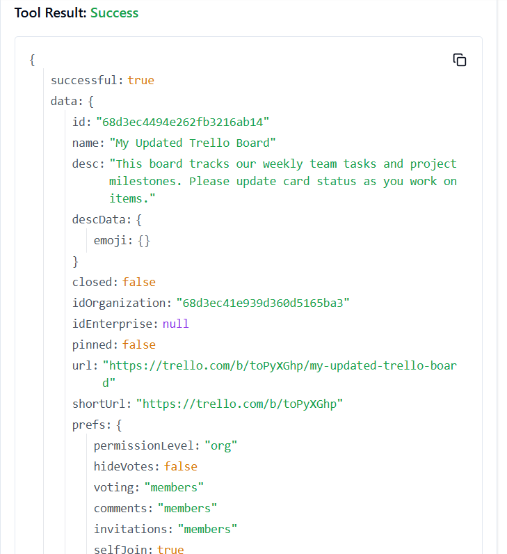

**200. TRELLO_UPDATE_BOARDS_SUBSCRIBED_BY_ID_BOARD**

